REPUBLIKA E KOSOVES
REPUBLIKA KOSOVO / REPUBLIC OF KOSOVO
KËSHILLI PROKURORIAL I KOSOVËS/ TUŽILAČKI SAVET KOSOVA/KOSOVO PROSECUTORIAL COUNCIL
Activities of Kosovo Prosecutorial Council
September 2017
MONTHLY BULLETIN

Content

1. Activities of Kosovo Prosecutorial Council 3
The hundred and thirty seventh meeting of the Kosovo Prosecutorial Council was held 3
The one hundred and thirty-eighth meeting of the Kosovo Prosecutorial Council was held 5
2. Activities of the Chairman of Kosovo Prosecutorial Council 7
Chairman Isufaj met with representatives of the European Union Crisis Management and Planning Directorate 7
Isufaj and Vukceviq have talked about strengthening cooperation in the fight against crime 8
Chairman Isufaj met with TAIEX experts 10
Follow -up Meeting of the Joint Rule of Law Coordination Board was held 11
3. Activities of Permanent Committees 13
Procedures of appointment of prosecutors are being discussed 13
4. Other activities 14
Joint Meeting of the Secretariat and KPC Unit Staff 14
Drafting of the Communications Strategy of the Prosecutorial System has continued 15
European experiences on human resources strategic planning have been discussed 16
5. Activities of the Secretariat of Kosovo Prosecutorial Council 17
6. Activities of the Unit for Review of Prosecution Performance of Kosovo Prosecutorial Council 19

Activities of Kosovo Prosecutorial Council
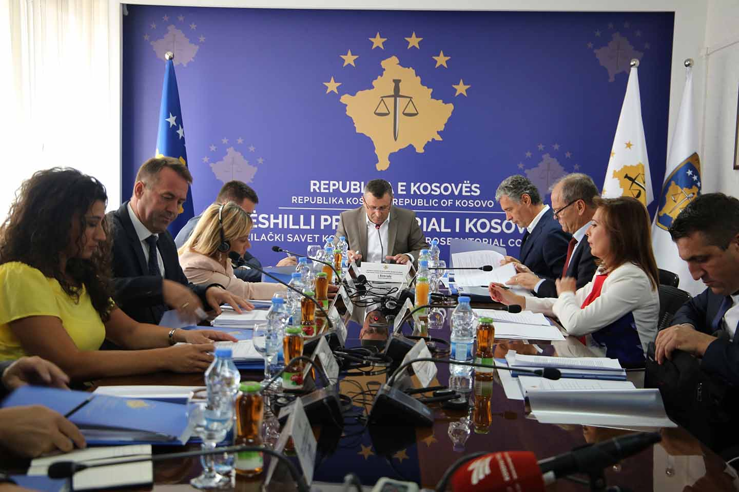

The hundred and thirty seventh meeting of the Kosovo Prosecutorial Council was held

Pristina, 4 September 2017- The one hundred and thirty seventh meeting of the Kosovo Prosecutorial Council (KPC) was held, chaired by the Chairman of this Council, Blerim Isufaj.
During this meeting, the members of the Prosecutorial Council have reviewed and discussed three important reports for prosecutorial system of Republic of Kosovo. Reviewed and analyzed were: Study regarding the load of cases for criminal characteristic offenses for years 2013-2016; Analysis for criminal characteristics offenses for years 2013- 2016, as well as the Criminal Geography Report for years 2013-2016.
After discussing each report, reviewing and analyzing them, all three reports were unanimously approved by the KPC members.
Kosovo Prosecutorial Council Chairman, Blerim Isufaj, informed the attendees that before the submission of these reports to the Kosovo Prosecutorial Council for approval, KPC members have held a working meeting where they discussed in advance the findings of the reports and have come up with common recommendations for the three reports.
Also during this meeting KPC members approved the request of the Chief State Prosecutor Aleksander Lumezi for extension of transfer of Prosecutor Agron Qalaj from Basic Prosecution Office in Ferizaj to the Office of the Chief State Prosecutor.
Also, during this meeting, KPC members approved the request of Chief State Prosecutor Aleksander Lumezi for transferring a case from the local prosecutor to a EULEX prosecutor, as in this case the suspects are EULEX staff, and therefore State Prosecutor does not have competences to conduct the investigation.

At the end of the meeting, members of the KPC reviewed the report of the commission for handling the case of former Chief State Prosecutor Hilmi Zhitija, for which unanimously decided that KPC should refuse the request of former Chief State Prosecutor Hilmi Zhitija, dated August 1 2012, for obtaining the status of former senior official, with the justification that there is no legal basis.

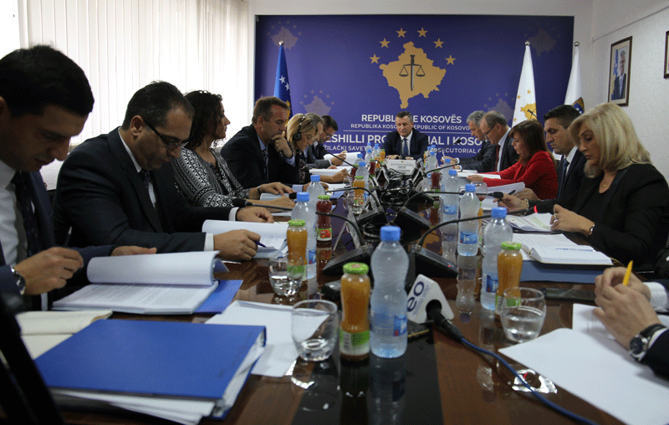

The one hundred and thirty-eighth meeting of the Kosovo Prosecutorial Council was held

Pristina, 25 September 2017 - The hundred and thirty-eighth meeting of the Kosovo Prosecutorial Council (KPC) was held, led by the Chairman of the Prosecutorial Council, Blerim Isufaj.
At the beginning of this meeting, the National Coordinator for Economic Crime Fighting presented the three-month Report, April-June 2017, which report, after the discussions, was approved by KPC members.
KPC members also discussed and approved the Report for January - June 2017 of the Oversight Committee on Combating Corruption and Economic Crimes, including seizure and confiscation of illegal property.
KPC members have established a working group for drafting the strategy for reducing the burden of all cases of characteristic criminal offenses of the inter-institutional tracking mechanism for the period of 2018-2020, as well as the working group on amending and supplementing the Administrative Instruction for annual approximate norm.
Members of the Prosecutorial Council were informed by the Committee for reviewing the eligibility of candidates nominated by civil society for a member of the Prosecutorial Council that during the period the vacancy was announced, the commission did not receive any nomination for a candidate from the civil society, and therefore the Council has taken the decision to re-announce the vacancy.
Also, the Prosecutorial Council has approved the request of the Chief Prosecutor of Special Prosecution of Republic of Kosovo for continuation of transfer of prosecutor Afrim Shefkiu for six (6) additional months.
The other point included reporting of the permanent committees’ chairmen of the Prosecutorial Council for the period of January - June 2017. Their reporting was focused on the meetings held, issues dealt with, decisions taken, as well as the challenges in the fulfillment of the mandate of the commissions.
At the end of this meeting, KPC members have taken the decision that drug offenses be included in the Strategic Plan 2016-2018, along with criminal offenses of corruption and economic crimes.

Activities of the Chairman of Kosovo Prosecutorial Council

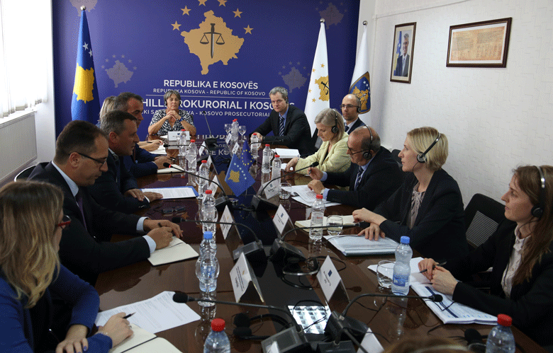

Chairman Isufaj met with representatives of the European Union Crisis Management and Planning Directorate

Pristina, 13 September 2017 - Chairman of Kosovo Prosecutorial Council, Blerim Isufaj, hosted a delegation of the European Union Crisis Management and Planning Directorate, headed by Xavier Denis, Head of this Directorate. The meeting was also attended by the officials from EULEX and European Union Office in Kosovo.
At the beginning of the meeting, chairman Isufaj informed guests about the structure of Kosovo's prosecutorial system, the work that has been done and the goals of this system in the future.
On the other hand, the delegation from the European Union Crisis Management and Planning Directorate expressed their interest for the cooperation of Kosovo's prosecutorial system with EULEX and EU Office in Kosovo.
Chairman Isufaj appraised the continuous cooperation and support of EULEX and EU Office for the prosecutorial system and added that his purpose is the continuous increase of the cooperation with the two institutions mentioned.
At this meeting it was said that increase in cooperation between the prosecutorial system with EULEX and EU Office will have an effect in strengthening the rule of law in Kosovo.

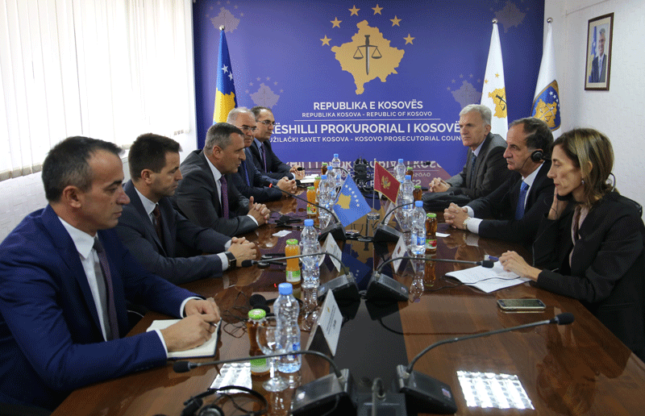

Isufaj and Vukceviq have talked about strengthening cooperation in the fight against crime

Pristina, 22 September 2017 - Chairman of Kosovo Prosecutorial Council, Blerim Isufaj, hosted a delegation of Judicial Council of Montenegro chaired by chairman Mladen Vukceviq.
At the beginning of this meeting, chairman Isufaj spoke about the organization, role, competencies and work that Kosovo Prosecutorial Council is doing, while evaluating the cooperation of the institutions of the justice system of the Republic of Kosovo and those of Montenegro.
Chairman of Judicial Council of Montenegro, Mladen Vukceviq, also spoke about the organization, competencies and work that the institution he leads is doing.
Interstate cooperation, with particular emphasis on cross-border cooperation in the fight against organized crime and other criminal offenses, was the main focus of the meeting of chairman Isufaj with chairman Vukceviq. They said that intensifying inter-state co-operation in combating illegal occurrences would benefit not only the two countries but also the region.
During the meeting, both interlocutors also talked about the agendas and the work they are doing regarding fulfillment of obligations for European integration.
Chairman of Kosovo Judicial Council, Nehat Idrizi was present in this meeting too.

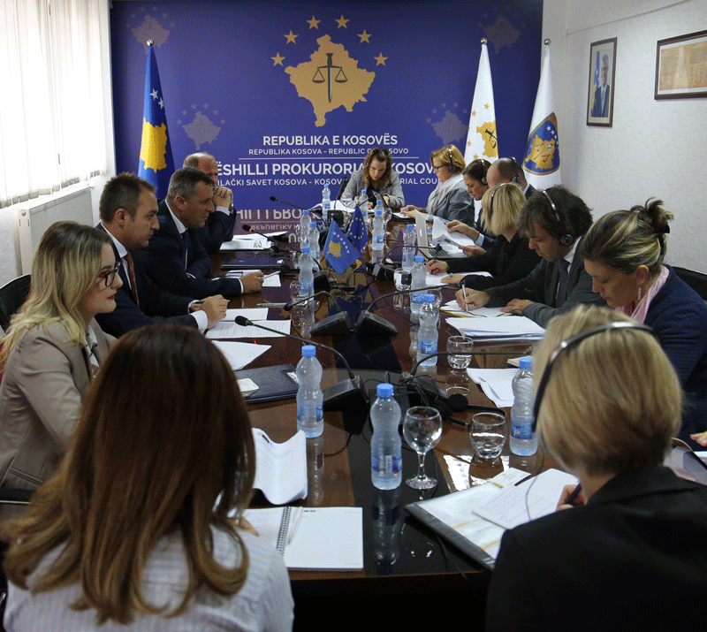

Chairman Isufaj met with TAIEX experts

Pristina, 26 September 2017 - Chairman of Kosovo Prosecutorial Council, Blerim Isufaj, accompanied by the Chief Prosecutor of the Special Prosecution Office of Republic of Kosovo, Reshat Millaku, hosted a delegation of TAIEX Evaluation Mission (Technical Assistance and Information Exchange) of the European Commission led by experts: Camelia Bogdan, Theo Byl and Maurizio Varanese.
The purpose of this meeting was to assess the capacities of the prosecutorial system in combating high level corruption and organized crime.
The KPC Chairman at the beginning of this meeting informed the guests about the organization, role, competencies and work being done by Kosovo Prosecutorial Council.
Further, chairman Isufaj responded to the matters of interest of the European Commission delegation regarding the challenges of the prosecutorial system, with special emphasis on the budget, work independence of prosecutors, criteria for the election of chief prosecutors and prosecutors, evaluation, discipline and monitoring of their work. Chairman Isufaj acknowledged the EU's contribution to Kosovo's prosecutorial system and said that they are working constantly on eliminating challenges, building capacity for efficiency in work, accountability and transparency.

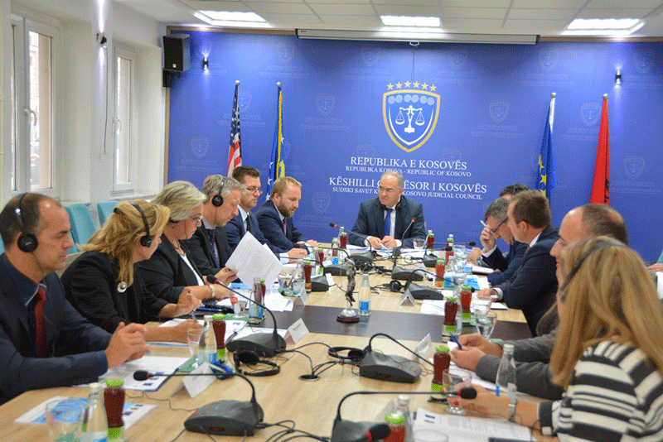

Follow -up Meeting of the Joint Rule of Law Coordination Board was held

Pristina, 26 September 2017 –The Joint Rule of Law Coordination Board held its regular meeting today that was organized for the first time by the Kosovo Judicial Council (KJC) and chaired by the KJC Chairman, Mr. Nehat Idrizi.
Minister of Justice, Abelard Tahiri, together with the Chair of the Kosovo Prosecutorial Council, Blerim Isufaj, the Head of the EU Office/EUSR, Nataliya Apostolova and the Head of EULEX Mission in Kosovo, Alexandra Papadopoulou, attended the meeting.
At the beginning of this meeting, the JRCB members were presented the Compact Progress Report. In this Report which covers the period from June 2016 to June 2017, it is said there was progress achieved in the improvement of the rule-of-law area, since Kosovo institutions’ have proven to be able to increasingly address their own rule of law challenges. However, they remain committed to the common agenda of rule of law in Kosovo, although the Institutions still need to respond effectively to the ongoing problems of political interference and corruption.
As far as Judicial Council and Prosecutorial Council are concerned, the Report puts specific emphasis on the administration of selection and recruitment process of judges and prosecutors, including in the north of Kosovo. In addition, the backlog of cases in the judicial system remains a great concern according to the Report.
While taking stock of the work done in the past year, the Joint Rule of Law Coordination Board remains committed to further develop the rule-of-law sector in Kosovo in line with European Standards and best practices, following the broader requirements set for Kosovo’s EU approximation process. With this in mind, the EU family calls upon Kosovo’s institutions to continue to take over more responsibilities for building up a rule-of-law system that is sustainable, accountable and independent”, notes the Report amongst others.

Activities of Permanent Committees

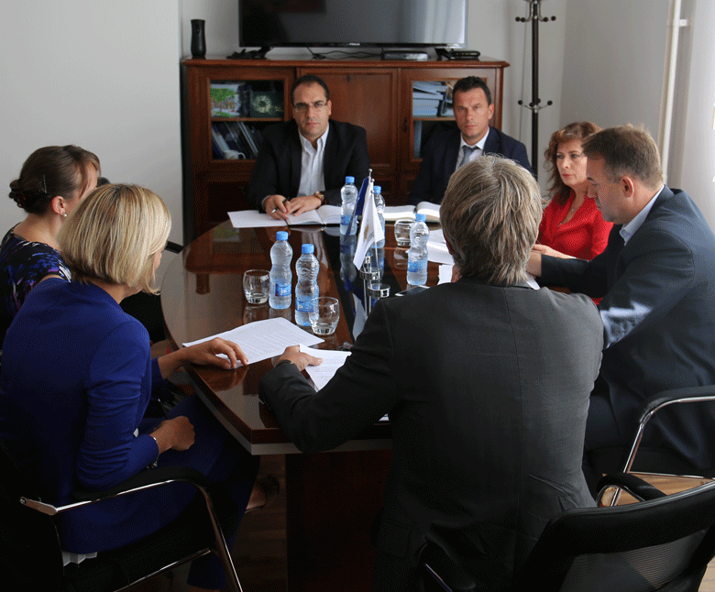

Procedures of appointment of prosecutors are being discussed

Pristina, 07 September 2017 – Commissions members of the Kosovo Prosecutorial Council and Director of the Secretariat have held a meeting with Gabriele Firoentino and Zsuzsa Mendola, Experts of the EU Twinning Project: "Strengthening of Efficiency, Accountability and Transparency of the Judicial and Prosecutorial System in Kosovo”.
During this meeting, it was discussed about the procedures of appointing, reappointing, transferring and advancing prosecutors in the prosecutorial system of the Republic of Kosovo.
Experts Firoentino and Mendola have submitted proposals for procedures of appointment, reappointment, promotion and transfer of prosecutors, which according to them can be modeled and applied in the prosecutorial system of the Republic of Kosovo.
On the other hand, members of the KPC commissions appreciated the engagement of the experts Firoentino and Mendola, but also of the project in general, in support of the prosecutorial system.

Other activities

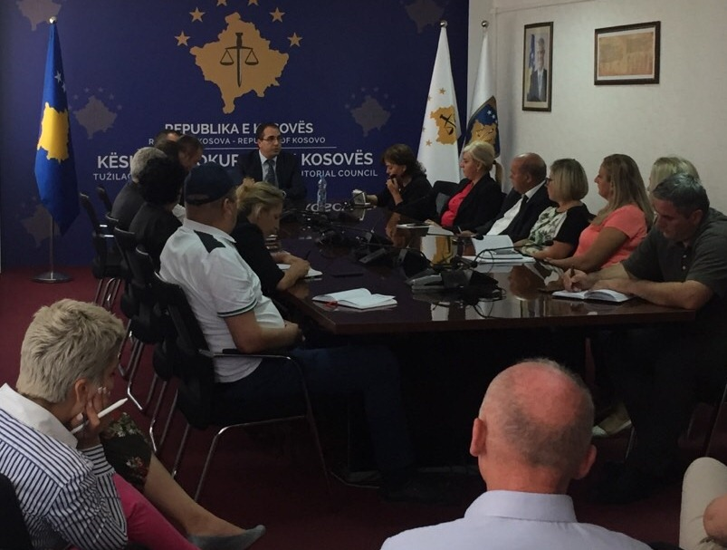

Joint Meeting of the Secretariat and KPC Unit Staff

Pristina, 06 September 2017 - Director of the Kosovo Prosecutorial Council Secretariat, Lavdim Krasniqi, held the follow up meeting with the staff of Secretariat and Prosecution Performance Evaluation Unit of the Kosovo Prosecutorial Council.
Initially, Director Krasniqi thanked the staff for the work done since the beginning of this year, while seeking continuous engagement of the staff in fulfillment of the obligations and work objectives set out in the work plan for the remainder of the year. Also, Director Krasniqi emphasized that respecting the working hours and staff coordination over the annual leave are important elements in maintaining the continuity of work.
During this meeting, the leaders of the KPC Secretariat Departments briefly presented the activities of the respective departments for the period of January - June 2017, while in the capacity of Acting Director of Prosecution Performance Evaluation Unit, Lavdim Krasniqi, has presented the activities of the Unit realized since the beginning of this year.

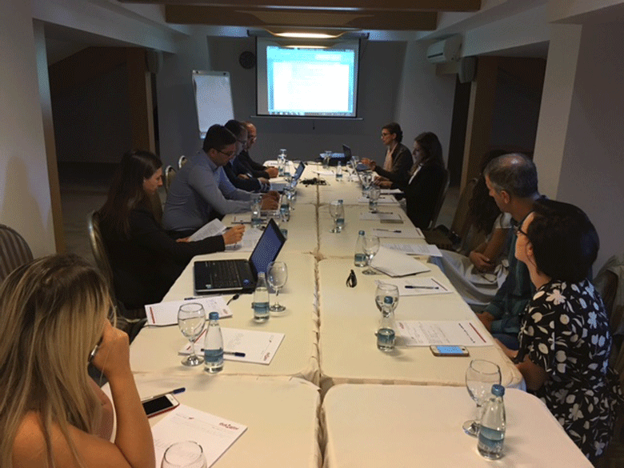

Drafting of the Communications Strategy of the Prosecutorial System has continued
Pristina, 21 September 2017 - With the support of UNDP, a two-day workshop was organized with the aim of drafting the Communication Strategy in the prosecutorial system of the Republic of Kosovo. Representatives of Kosovo Prosecutorial Council, of State Prosecutor, UNDP, OSCE, Civil Society and Association of Kosovo Journalists participated in this workshop.
Public Communication Strategy is a new initiative and effort to improve the quality of communication of the prosecutorial system of the Republic of Kosovo, encouraging citizen participation and information, and increasing accountability and transparency for public general opinion.
Through this strategy, the aim is to increase the credibility of Kosovo's prosecutorial system through concrete activities, as well as to increase cooperation with the media for the sake of prompt and accurate information delivery.

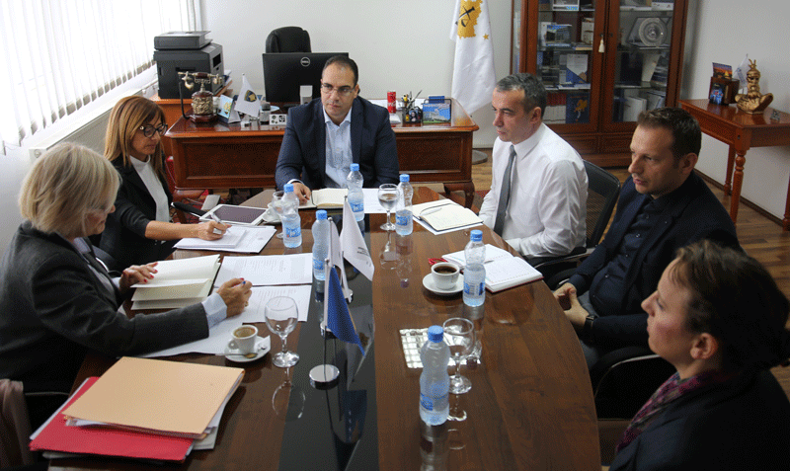

European experiences on human resources strategic planning have been discussed
Pristina, 28 September 2017 - Director of Kosovo Prosecutorial Council Secretariat, Lavdim Krasniqi, met with Chiara Maria Paolucci and Jacquemine Benhamou, experts of EU Twinning Project "Strengthening the Efficiency, Accountability and Transparency of the Judicial and Prosecutorial System in Kosovo".
In this meeting was discussed about the strategic planning of human resources in the prosecutorial system of Republic of Kosovo.
Regarding the strategic planning of human resources in Kosovo's prosecutorial system, Director Krasniqi has spoken; he presented the planning of recruitment, systematization of jobs and administrative staff in the prosecutorial system.
On the other hand, the above-mentioned project experts presented experiences of EU countries in regards to human resource strategic planning.

Activities of the Secretariat of Kosovo Prosecutorial Council

Secretariat of Kosovo Prosecutorial Council (SKPC), during September has executed different activities for the purposes of implementing rules, regulations and policies related to the management, budget and administration of Prosecutions.
Office of the Director of the Secretariat
During this month, the Office of the Director of the Secretariat has conducted different activities within its competencies.
For the purposes of coordinating Units of the Secretariat and accomplishment of objectives, Office of Director within its legal competencies has brought different decisions, has prepared documents and other bylaws for implementation of rules and policies related to the management of Secretariat and administration of Prosecutions.
Within the activities of the Office of the Director of the Secretariat, Legal Office has prepared decisions, submissions and other bylaws, and it has also supported KPC Permanent Committees.
Office for Communication with the Public has followed up all activities of KPC, KPC Chairman, KPC Committees, as well as activities of other Units of prosecutorial system, for which it has prepared Press Releases, where the latter were distributed to media and the same were also published on the official websites of KPC.
Internal Auditor, during September, has compiled the final auditing report of the Procurement Division.
Department for Human Resources, Procurement and Administration
Within this department, human resources have completed the process of selecting the Head of Public Communication at the Office of the Chief State Prosecutor, while a legal officer has started to work in the Basic Prosecution Office in Pristina. Also, five interns have started to work in the Pristina Basic Prosecution Office.
The procurement has signed a contract for "Accommodation, Food and Beverage Services for Training Participants for the Needs of the Prosecutorial Council" and has cancelled the project of "Servicing of IT Equipment in the Kosovo Prosecutorial System."

Department for Budget, Finances and General Services
Within this department, budget and finances have submitted to the Ministry of Finances the report of financial liabilities of the budgetary organization for September.
General Services have ensured maintenance of the premises through intervention, and have supplied all Prosecutions with expendable materials.
Information Technology Department
Information Technology Department has provided all requested services by the Prosecutions’ staff.

Standard Operating Procedures for Interconnection of Electronic Systems have been prepared and signed between the Kosovo Business Registration Agency (KBRA) and the Kosovo Prosecutorial Council. The purpose of this procedure is to define the data that will be copied from the KBRA system and will be placed electronically on the (SMIL) – KPC system.

A video project has been prepared for the ICT / CMIS Project, which reflects project-related information.

IT staff training has started in the ITIL module (Information Technology Infrastructure Library).

Activities of the Unit for Review of Prosecution Performance of Kosovo Prosecutorial Council

The Unit for Review of Prosecution Performance (Unit) of Kosovo Prosecutorial Council, based on its legal competencies and for the purposes of supporting the Council, during September has conducted different activities.
Office for Prosecutorial Overseeing, Analytics and Vetting
Office for Prosecutorial Overseeing, Analytics and Vetting has conducted the process of verification of candidates for prosecutors and drafted procedural planning for implementation of the Strategic Plan and Action Plan 2016-2018 for cases of corruption, economic crimes and drugs, including seizure and confiscation.
This office has finalized the project proposal for IPA 2018-2020 this month and has drafted inputs for the EC Report for the country.
Office for Statistics
The Statistics Office has prepared reports on the work of 23 prosecutors for evaluation, each one separately, according to the request of the Evaluation Committee and modified
the kriMKorr database Application by adding the criminal offenses as per Recommendation.
Office for Trainings
Office for Trainings within its cooperation with the Academy of Justice and some other Institutions has organized trainings with different topics based on the needs for professional upgrading of Prosecutors and administrative staff.

