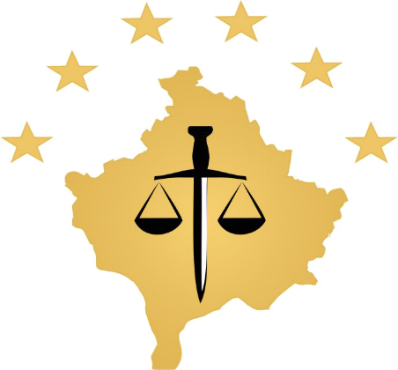

REPUBLIKA E KOSOVES
REPUBLIKA KOSOVO / REPUBLIC OF KOSOVO
KËSHILLI PROKURORIAL I KOSOVËS/ TUŽILAČKI SAVET KOSOVA/KOSOVO PROSECUTORIAL COUNCIL
Activities of Kosovo Prosecutorial Council
October 2017
MONTHLY BULLETIN

Content

1. Activities of Kosovo Prosecutorial Council 3
The one hundred and thirty ninth meeting of Kosovo Prosecutorial Council 3
was held 3
The one hundred and fortieth meeting of the Kosovo Prosecutorial Council was held 4
Inauguration of the new Data Centre of the Judicial and Prosecutorial system 6
The one hundred and forty-one meeting of the Kosovo Prosecutorial Council was held 8
Memorandum of cooperation for combating illegal trade 10
Reaction from Kosovo prosecutorial Council 11
2. Activities of the Chairman of Kosovo Prosecutorial Council 13
Chairman Isufaj hosted a delegation of General Prosecution of Turkey 13
3. Activities of Permanent Committees 14
The Committee on Normative Matters has held the follow up meeting 14
4. Other activities 15
Two day training for the staff of the Secretariat and the KPC Unit 15
Director Krasniqi has held the next meeting with the Secretariat and Unit staff 16
Workshop for Listing of Classified Documents 17
5. Activities of the Secretariat of Kosovo Prosecutorial Council 18
6. Activities of the Prosecutions` Performance Evaluation Unit of Kosovo Prosecutorial Council 20

Activities of Kosovo Prosecutorial Council
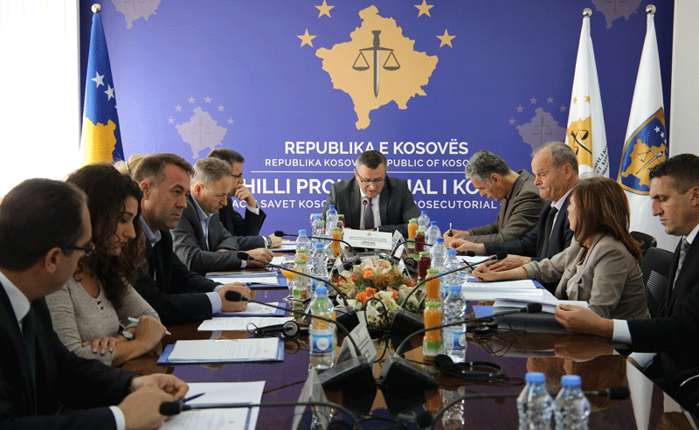

The one hundred and thirty ninth meeting of Kosovo Prosecutorial Council

was held

Pristina, 09 October 2017 - The one hundred and thirty ninth meeting of Kosovo Prosecutorial Council (KPC) was held, chaired by the Chairman of the Prosecutorial Council, Blerim Isufaj
During this meeting, KPC members, have amended and supplemented the Regulation No. 02/2015 on election of Prosecutorial Council members.
Also, KPC members have announced the election of KPC members from the Appellate Prosecution.

Final point of the agenda was the establishment of the Election Commission in the election process for KPC members from the Appellate Prosecution, where KPC members have appointed the KPC member Arben Ismajli as chairman of commission, and Sevdije Morina from Office of the Chief State Prosecutor and Valdrin Krasniqi from Secretariat of the Prosecutorial Council as members

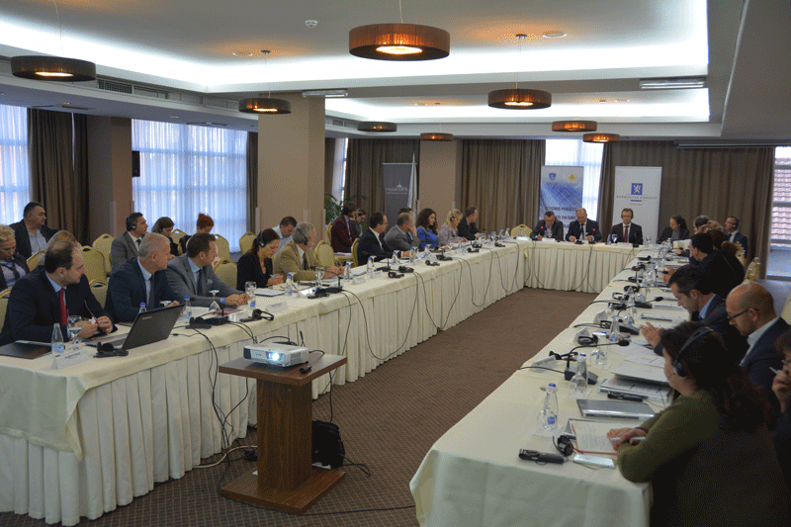

The one hundred and fortieth meeting of the Kosovo Prosecutorial Council was held

Prishtina, October 19, 2017 – On the occasion of the visit of the delegation from the Norwegian Ministry of Foreign Affairs and the Norwegian Courts Administration, the Kosovo Judicial Council and the Kosovo Prosecutorial Council organized a joint meeting.
At this joint meeting was discussed regarding the ICT/CMIS Project (ICT- Information and Communication Technology, CMIS – Case Management Information System), its progress, the work being done and what is to be done in order to implement the project which is supported and funded by the Norwegian government.
The Norwegian delegation have rated the achievements in the implementation of the CMIS Project so far, and at the same time there were provided suggestions and recommendations for the successful implementation of the project and to ensure the long term sustainability of the CMIS Project.
Also, they discussed regarding other possibilities of future assistance and cooperation between the Judicial and Prosecutorial system of Kosovo and the Norwegian Government. .
During this meeting, The KJC chairperson, Mr. Nehat Idrizi and the KPC Chairperson, Mr. Blerim Isufaj, expressed their gratitude to the Norwegian delegation for their support and funding the ICT/CMIS Project, as this project is a very important for increasing the efficiency of the Judicial and the Prosecutorial system of Kosovo.

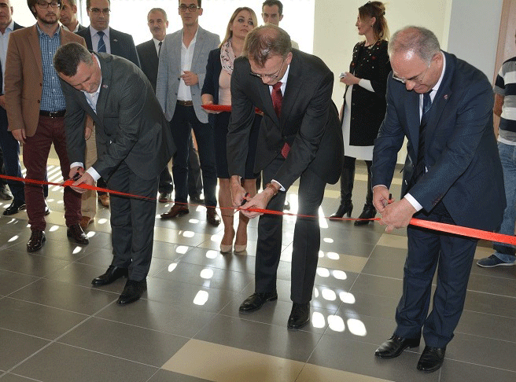

Inauguration of the new Data Centre of the Judicial and Prosecutorial system

Pristina, October 20, 2017 – The Judicial Council, the Prosecutorial Council and the Norwegian Embassy in Kosovo through an organized ceremony inaugurated the new Data Centre of the Judicial and Prosecutorial system of the Republic of Kosovo.
In the inauguration ceremony were present the heads of the judicial and prosecutorial system, representatives of other local and international institutions The Norwegian Ambassador to Kosovo, a delegation of the Norwegian Ministry of Foreign Affairs and the Norwegian Courts Administration who are funding the ICT/CMIS ( Information and CommunicationTechnology/Case Management Information System).
The new Data Centre was established as a part of ICT/CMIS Project in order to prepare the hardware infrastructure to enable the digitalization of work processes in Courts and Prosecutor’s office.
The KJC Chairperson, the KPC Chairperson and the Norwegian Ambassador to Kosovo spoke to the participants of this inauguration ceremony regarding the importance of this Data Centre and the CMIS project in general. They said that the ICT/CMIS project is a very important project which will influence in increasing transparency and efficiency of the judicial and prosecutorial system of the Republic of Kosovo.

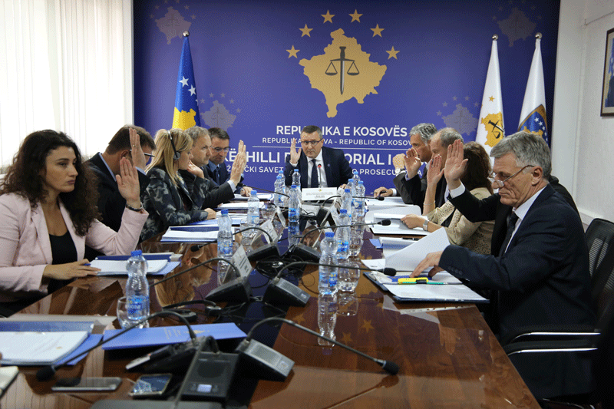

The one hundred and forty-one meeting of the Kosovo Prosecutorial Council was held

The one hundred and forty-one meeting of the Kosovo Prosecutorial Council (KPC) was held, led by the Chairman of the Prosecutorial Council, Blerim Isufaj.
During this meeting, KPC members discussed and approved the request of the National Election Coordinator, prosecutor Laura Pula, for compensating prosecutors and supporting staff that were engaged within the strategic project for protection of vote, during the local elections of 22nd October 2017, as well as for the runoff of 19thNovember 2017 for mayors.
Members of the Prosecutorial Council have taken the decision to announce the internal competition for three positions for advancement of prosecutors in the Special Prosecution of the Republic of Kosovo, as there is a lack of prosecutors in this Prosecution.
Also, members of the KPC received a decision to supplement and amend the decisions, KPC / No.459 / 2017 and CCK / No.486 / 2017.
As the last item of the agenda that was discussed and approved by members of the KPC was the reporting of the Chief Prosecutor of the Basic Prosecution of Pristina, Imer Beka, and the Chief Prosecutor of Prizren's Basic Prosecution, Admir Shala, for April / June quarterly period of 2017

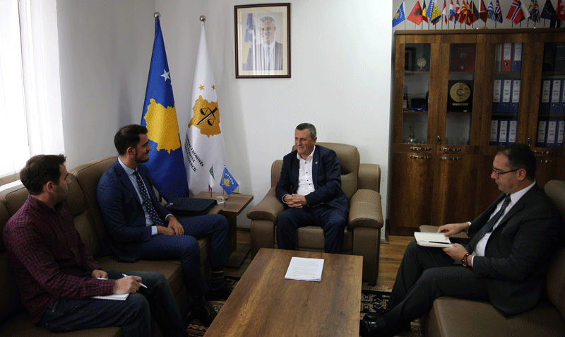

Memorandum of cooperation for combating illegal trade

Pristina, 24 October 2017 - The Kosovo Prosecutorial Council and the International Institute of Syracusa for Criminal Law and Human Rights have signed a Memorandum of Understanding.
The purpose of this memorandum of cooperation is the implementation of the project "Strengthening the fight against illegal trade in South East Europe".
The signatory parties said that through the memorandum will be specified the activities of the parties for the implementation of the aforementioned project, while evaluated it as very important in the fight against illegal trade.

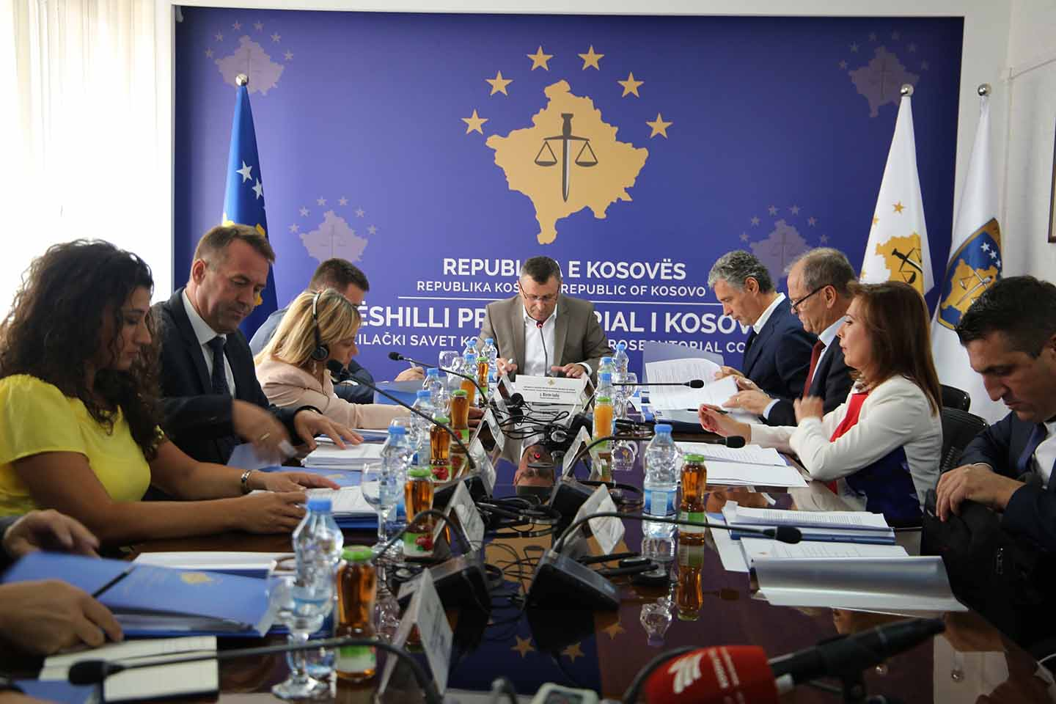

Reaction from Kosovo prosecutorial Council
Pristina, 25 October 2017 - The Kosovo Prosecutorial Council has closely followed the public screenings and writings of several portals, media and individuals regarding the allegation that the State Chief Prosecutor, Alexander Lumezi, has forged the Bar exam.

Based on the Constitutional and Legal mandate, the Kosovo Prosecutorial Council clarifies to citizens of the Republic of Kosovo that the selection process of Mr. Alexander Lumezi initially as a prosecutor, then as Chief Prosecutor of the Appellate Prosecution and ultimately as Chief State Prosecutor has gone through all the recruitment and verification procedures defined by the Constitution and Law.
Moreover, the Chief State Prosecutor, Aleksander Lumezi, has successfully passed the recruitment and verification process which was organized during the appointment and reappointment process of prosecutors and judges, a process organized and conducted in 2009-2010 by the Independent Judicial and Prosecutorial Commission. As a key part of this process was the verification of the professional and personal integrity of the candidates, including the Chief State Prosecutor Lumezi.
Of all the official data which is available to the Kosovo Prosecutorial Council, there is no dilemma that Chief Prosecutor Lumezi has provided the required documents, including a certificate for passing the Bar Exam, originality of which has never and with nothing been questioned.

Efforts to publish facts that Chief State Prosecutor, Alexander Lumezi has allegedly forged the Bar exam, the Council considers as an attempt to undermine the image of the Chief State Prosecutor and prosecutorial system, therefore we ask those who have raised these suspicions, to withdraw them publicly.

Activities of the Chairman of Kosovo Prosecutorial Council

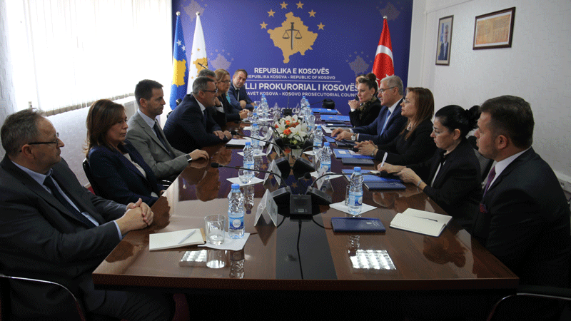

Chairman Isufaj hosted a delegation of General Prosecution of Turkey

Pristina, 03 October 2017 – Chairman of Kosovo Prosecutorial Council, Blerim Isufaj, together with the members of the Council, hosted a delegation of the General Prosecution of Republic of Turkey, led by the General Prosecutor of Republic of Turkey, Mehmet Akarca.
Chairman Isufaj welcomed the delegation of the General Prosecution of Republic of Turkey, as well as informed them about the functioning of the prosecutorial system regarding the organization, role and competencies of the Kosovo Prosecutorial Council.
Chairman Isufaj and General Prosecutor Akarca have also talked about the need to exchange experiences and strengthen inter-state cooperation between the Kosovo Prosecutorial Council and the General Prosecution of Republic of Turkey.
Meanwhile, General Prosecutor Akarca thanked the Chairman Isufaj for his hospitality, and expressed his willingness and the General Prosecutions of Turkey to assist Prosecutorial Council and State Prosecutor.

Activities of Permanent Committees

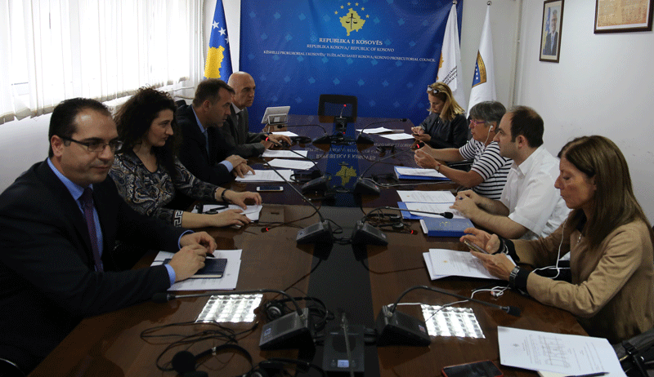

The Committee on Normative Matters has held the follow up meeting

Pristina, October 9, 2017 - The Committee on Normative Matters has held the follow up meeting where it was discussed about the Regulation No. 06/2017 on amending and supplementing Regulation no. 02/2015, for election of members of the Kosovo Prosecutorial Council.
In this meeting, apart from the members of the Commission for Normative Matters, the representatives of the US Embassy, ​​EULEX and the Twinning Project participated too, and they consistently support the work of the Committee on Normative Matters and the Council in general.

The Commission proposed that Article 8 of regulation No. 02/2015 on Election of Members of the Kosovo Prosecutorial Council, to be reformulated regarding the composition of the Election Commission, and article 15 regarding the Final Provisions to be abrogated.
Finally, the members of the Commission unanimously decided to propose this regulation to Council for approval

Other activities

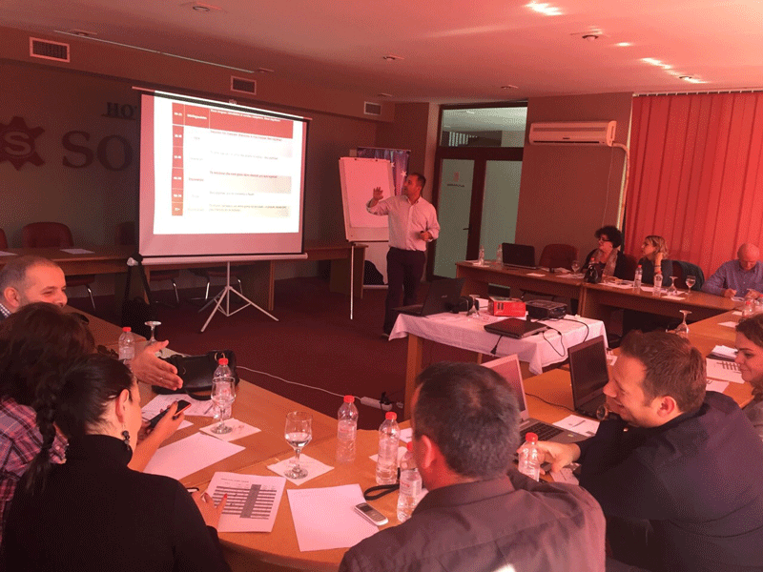

Two day training for the staff of the Secretariat and the KPC Unit
Pristina, October 10th, 2017 - The staff of the Secretariat and Prosecutorial Performance Review Unit of the Kosovo Prosecutorial Council have participated in two-day training on “Management of work and time in the office and increase of the level of communication using IT equipment ".

The objective of this training was to gain experience in the way of planning and managing the work based on the objectives of the Department and use of tools / equipment to increase the level of electronic communication for the staff.
During the training there were presented various topics related to the work of the Secretariat and Prosecutorial Performance Review Unit of the Kosovo Prosecutorial Council
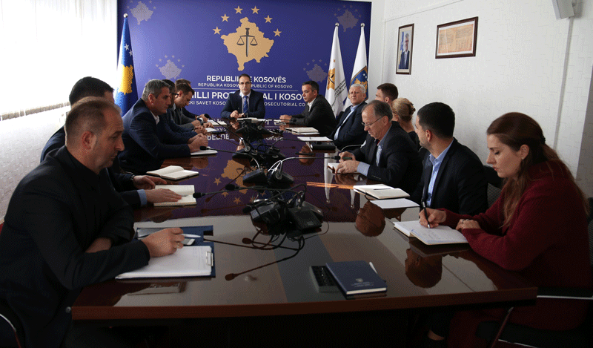

Director Krasniqi has held the next meeting with the Secretariat and Unit staff

Prishtina, 20 October 2017 - The Director of the Kosovo Prosecutorial Council Secretariat, Lavdim Krasniqi, held the next meeting with the leaders of the organizational units of the Secretariat and the Prosecution Performance Review Unit.
During this meeting, it was discussed about the activities conducted this week and those expected to be held next week by all the organizational units of the Secretariat and Unit.
Also, there were discussed the activities that are expected to be developed by the end of 2017, activities foreseen according to the work plans by all units.
Director Krasniqi has asked the Secretariat and Unit managers to start working on planning and work objectives for 2018.

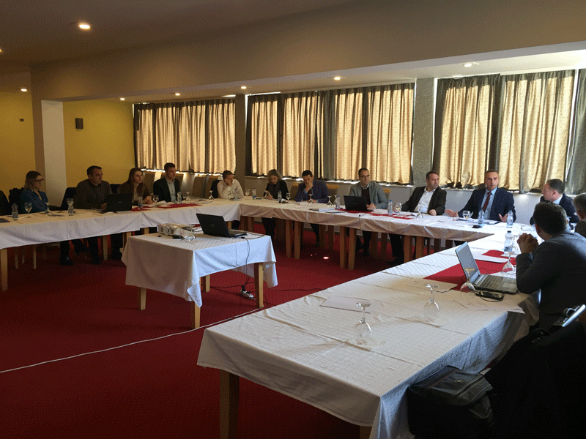

Workshop for Listing of Classified Documents
Pristina, October 31, 2017 - A working group of Kosovo prosecutorial system participated in a workshop where it was worked on compiling the list of classification of information categories for this system.
In this workshop was discussed the Regulation on Classification of Information and the listing of documents for classification was done.

Also was discussed the implementation of the abovementioned regulation, realization in practice, and classifying the information.
The Kosovo Prosecutorial System has prepared the drafting of sub-legal acts and identification of documents, information and their classification based on the legislation in force.

Activities of the Secretariat of Kosovo Prosecutorial Council

Secretariat of Kosovo Prosecutorial Council (SKPC), during month of October has executed different activities, with the purposes of implementing rules, regulations and policies related to the management, budget and administration of prosecution offices.

Office of the Director of the Secretariat
Office of the Director of the Secretariat with the purposes of coordinating the Secretariat units and meet the objectives, within its legal competencies has taken different decisions, has prepared documents and other bylaws for implementation of rules and policies related to the management of Secretariat and administration of Prosecutions
Within the activities of the Office of Director of Secretariat, the Legal Office has prepared decisions, documents and sub-legal acts, and has supported the permanent KPC commissions.
The Public Communications Office has followed the activities of the KPC, of the Chairman, of the KPC commissions and other units of the prosecutorial system, whereby has prepared communications which it has issued for media and published on the website of the KPC.
Internal Auditor during month of October has worked on drafting the three-year Strategic Plan 2018-2020 of the Internal Audit Unit.
Department for Human Resources, Procurement and Administration
Within this department, human resources have completed the selection process for the positions: Head of Infrastructure Division and Head of the Division for Electronic Systems, Head of Finance Budget and General Services Department, SPRK Administrator, as well as position of the Head of Procurement Division.
The procurement during this month based on planning has continued with the procedures for concluding some contracts for the needs of Kosovo's prosecutorial system.
Department for Budget, Finances and General Services
Within this department, the budget and finances have submitted to the Ministry of Finance the second budget request and have made the nine-month reconciliation for all programs and economic categories.
General Services have taken care of the maintenance of facilities through interventions and have supplied all prosecution offices with expendable materials. They also took care about the staff accommodation at Mitrovica Basic Prosecution Office.
Information Technology Department
Information Technology Department has provided all requested services by the Prosecutions’ staff.

A cooperation agreement was signed between the Kosovo Police and the Kosovo Prosecutorial Council for the interconnection of electronic systems, respectively sending criminal reports from police to prosecution electronically from their respective systems.

A prototype of the case management information system has been developed and presented to the working group which has approved and requested the start of system development for the third phase.

It has been prepared the planning for IT equipment supply for the period 2018-2020 for prosecutorial system needs.

Activities of the Prosecutions` Performance Evaluation Unit of Kosovo Prosecutorial Council

The Prosecutorial Performance Review Unit (Unit) of the Kosovo Prosecutorial Council, based on the legal competencies in support of the Council, developed various activities during October.
Office for Prosecutorial Overseeing, Analytics and Vetting
Office for Prosecutorial Overseeing, Analytics and Vetting within the performance evaluation of 23 prosecutors has administered cases and other information from the reports of the Chief Prosecutors, and provided technical support to the Performance Evaluation Commission;
This office during this month has coordinated the Euro-integration processes where preparation of responses to the Country Report Input of the European Commission has been made.
Office for Statistics
The Statistics Office has prepared statistical reports on the work of the prosecutor's offices for the third quarter and the nine-month period of 2017.
It has prepared reports with statistical data on civil society organizations according to their requirements and relying on legal competences.

Office for Trainings
The Training Office, through cooperation with the Academy of Justice and several other institutions, has organized trainings with various topics based on the professional development needs of prosecutors and administrative staff.

