REPUBLIKA E KOSOVES
REPUBLIKA KOSOVO / REPUBLIC OF KOSOVO
KËSHILLI PROKURORIAL I KOSOVËS/ TUŽILAČKI SAVET KOSOVA/KOSOVO PROSECUTORIAL COUNCIL
Activities of Kosovo Prosecutorial Council
November 2017
MONTHLY BULLETIN

Content

1. Activities of Kosovo Prosecutorial Council 3
The one hundred and forty two meeting of Kosovo Prosecutorial Council 3
Prosecutor Bedrije Syla - Alshiqi is elected as KPC member 4
Members of the KPC in official visit in the United States of America 5
USA in support of Kosovo's prosecutorial system 6
The one hundred and forty-three meeting of Kosovo Prosecutorial Council was held 7
2. Activities of Permanent Committees 9
The implementation of the budget of 2017 is being discussed 9
3. Other activities 10
Joint meeting of heads of Secretariat departments and administrators of prosecution' offices 10
Workshop on Standard Operating Procedures 11
4. Activities of the Secretariat of Kosovo Prosecutorial Council 13
5. Activities of the Prosecutions` Performance Evaluation Unit of Kosovo Prosecutorial Council 15

Activities of Kosovo Prosecutorial Council
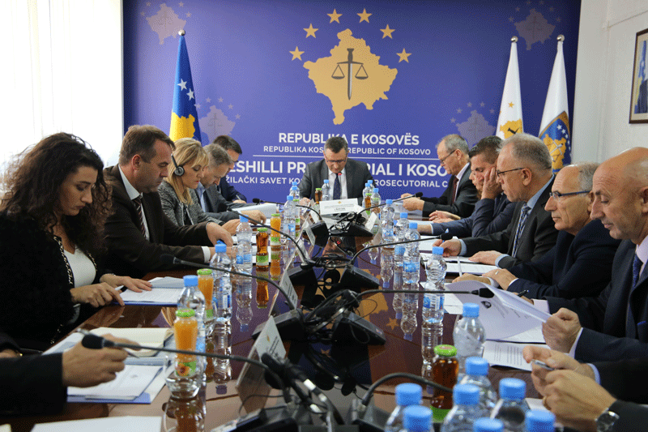

The one hundred and forty two meeting of Kosovo Prosecutorial Council
was held
Pristina, 1 November 2017 – The one hundred and forty-two meeting of the Kosovo Prosecutorial Council (KPC) was held, led by the Chairman of the Prosecutorial Council, Blerim Isufaj.
At the beginning of this meeting KPC members discussed the areas in which prosecutors and administrative staff of Kosovo's prosecutorial system need training and they proposed training topics that will be held at the Kosovo Academy of Justice, in 2018.
During today's meeting, Chief Prosecutor of the Appellate Prosecution, Prosecutor authorized by the Chief Prosecutor of the Special Prosecution of the Republic of Kosovo, Chief Prosecutors of the Basic Prosecutions in Ferizaj, Peja, Gjakova and Mitrovica and Deputy Chief Prosecutor of Gjilan Basic Prosecution have reported for the work of the prosecution offices they lead, for April-June period of 2017.
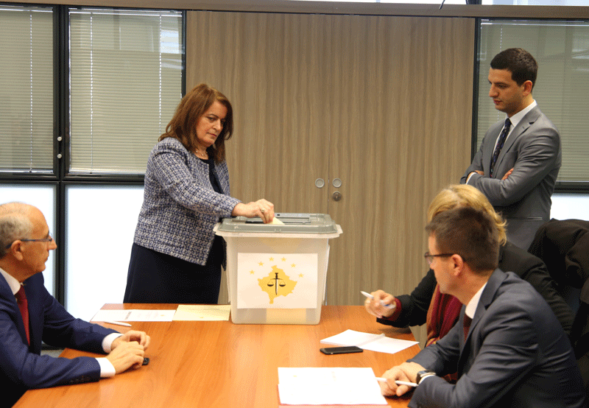

Prosecutor Bedrije Syla - Alshiqi is elected as KPC member

Pristina, 7 November, 2017 - Today, in the Appellate Prosecution of the Republic of Kosovo, the voting process for election of the Kosovo Prosecutorial Council member was conducted by the prosecution.
Based on the legal competences, the right to run for KPC member from the Appellate Prosecution Office, from 7 prosecutors this Prosecution has, it was used by Prosecutor Bedrije Syla-Alshiqi and Prosecutor Xhevdet Bislimi.
All prosecutors of this prosecution participated in the electoral process. After the voting and vote counting process, with 4 votes for, Prosecutor Bedrije Syla - Alshiqi was elected as KPC member from the Appellate Prosecution Office.
The election process in the Appellate Prosecution has been conducted based on legal deadlines, because the KPC member from this prosecution, prosecutor Idain Smailji, ends his mandate at the end of this year.

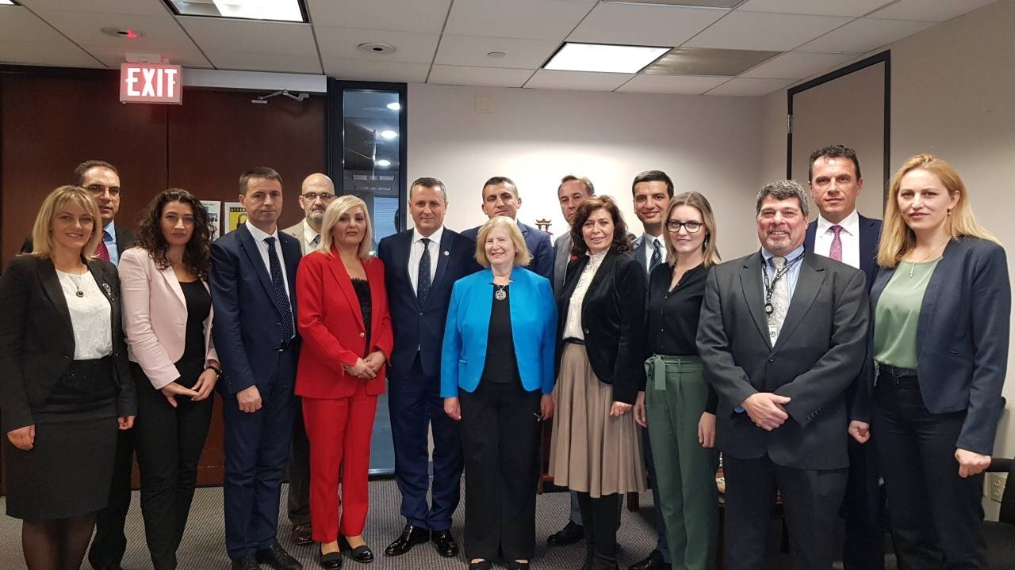

Members of the KPC in official visit in the United States of America

Pristina, November 15, 2017 - Members of the Kosovo Prosecutorial Council, in support of the United States Embassy in Pristina, have commenced a working visit to Washington DC and New York.
The Delegation of Prosecutorial Council members led by the Chairman Blerim Isufaj, held meetings at the Office of Professional Responsibility, Public Integrity Sector, Bureau of Justice Statistics, Office of Policies and Legislation and High Court in Washington DC.
During these meetings, important experiences were exchanged, which are expected to have a positive impact on the effectiveness and efficiency of the work of the Council and the prosecutorial system in general. Also, it was promised a continued cooperation and support for the work of Kosovo's prosecutorial system in the future.
For the next few days, the visit program continued in New York, where there were meetings held at the FBI, on issues related to public corruption, confiscation and seizure of property as well as terrorism issues.

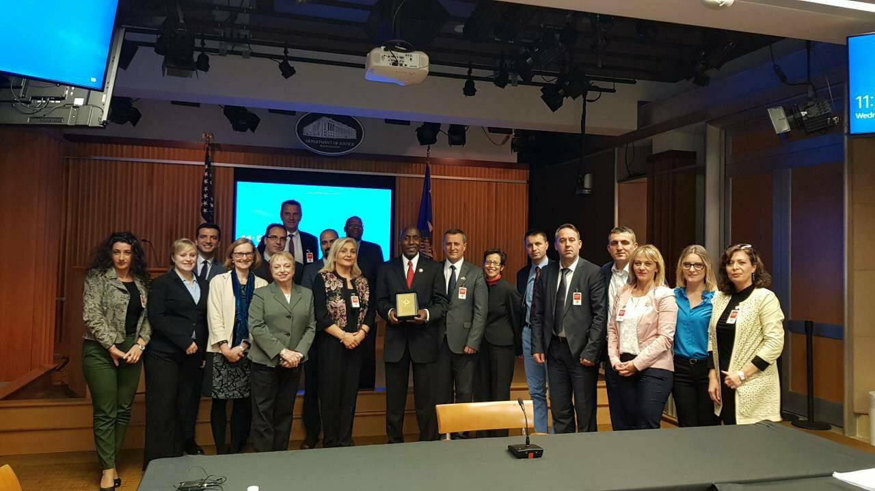

USA in support of Kosovo's prosecutorial system

Pristina, November 17, 2017 - With realization of two meetings at the FBI where topics of discussion were: public corruption, seizure, confiscation and terrorism, the delegation of the prosecutorial system of Kosovo led by the Chairman of the Prosecutorial Council, Blerim Isufaj, has successfully completed the program of several days' visit to the United States.
Even in these meetings, as in the previous days, the prosecutorial system received support for the work done, and exchanged important experiences in combating the specific criminal offenses outlined above
The delegation of the prosecutorial system was composed of members of the Council, a prosecutor from the Office of the Chief State Prosecutor, and representatives from the administration of the Council.
The implementation of the program of this visit was enabled by the US Embassy in Pristina, as a continuation of support and furtherance of the work of the prosecutorial system, in enhancing its overall capacities.

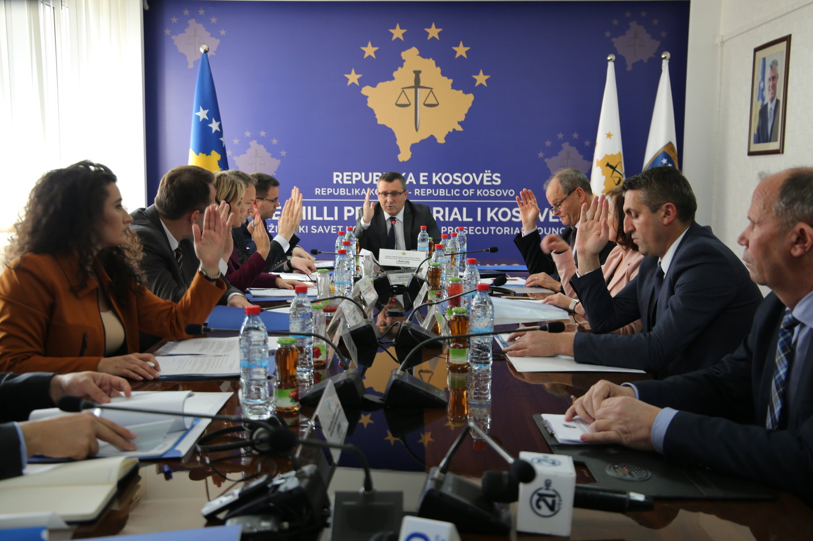

The one hundred and forty-three meeting of Kosovo Prosecutorial Council was held

Pristina, November 23, 2017 - The one hundred and forty-three meeting of Kosovo Prosecutorial Council (KPC) was held, led by the Chairman of the Prosecutorial Council, Blerim Isufaj.
During this meeting, Chief Prosecutor of the Special Prosecution of Republic of Kosovo, Reshat Millaku, reported for the period of April-June 2017 regarding the work of this prosecution.
In front of KPC members, today has reported Dëshirë Jusaj, the member of the Commission for reviewing the eligibility of candidates nominated by civil society for a member of the Prosecutorial Council. The member Jusaj said that Commission has undertaken all the actions as foreseen in the Regulation on Election of Members of the Prosecutorial Council. She informed KPC members that during the period the vacancy was open, only one candidate from the civil society was nominated, Mr. Naim Osmani.
The Commission has evaluated that Mr. Osmani met the foreseen legal conditions, but as the law envisioned nominating at least three candidates from the civil society side, they estimated that with only one candidate the procedure for electing of the Council member from among the civil society could not go on further.
Today, the chairman of the Kosovo Elections Commission of the Kosovo Prosecutorial Council, Arben Ismajli, reported on development of elections for members of the Prosecutorial Council from the prosecutors of the Appellate Prosecution. The chairman Ismajli, in front of KPC members said that during the time the vacancy was opened two prosecutors were nominated, Mrs. Bedrije Syla- Alshiqi and Mr. Xhevdet Bislimi. Whereas, on 7 November 2017, as foreseen in the Decision, the voting process was held and prosecutor Bedrije Syla – Alshiqi was elected as a member of the Council.
Also, KPC member Radica Milic from the working group for monitoring and evaluating the implementation of the Strategic Plan 2016 - 2018 of the Kosovo Prosecutorial Council, reported on the activities carried out in the reporting period, the report which was reviewed and approved by the KPC members.
Also, KPC members, with 6 votes in favor and 3 against have approved the request for transfer of Prosecutor Besart Mustafa from the Basic Prosecution in Mitrovica to the Basic Prosecution in Pristina.
As a point of today’s agenda was the Report of Commission on Advancement of Prosecutors in the Special Prosecution of the Republic of Kosovo. Member of the Commission, Dëshirë Jusaj, in front of KPC members, said that during the 15-day period of time of the opportunity to apply, 4 prosecutors have applied / candidates for promotion in SPRK, and they are Abdurrahim Islami from Basic Prosecution in Pristina; Sahide Gashi from Basic Prosecution in Peja; Afrim Shefkiu from Basic Prosecution in Gjilan and Prosecutor Habibe Salihu from Pristina's Basic Prosecution.
Therefore, the Commission has evaluated and proposed to the Prosecutorial Council that prosecutors meeting the criteria for advancement in the SPRK are: Abdurrahim Islami and Afrim Shefkiu, where KPC members approved this point.
As the last point of the agenda that was reviewed and approved was the request of the Chief Prosecutor of Prizren's Basic Prosecution, Admir Shala, to be engaged as a lecturer at the Institute for Legal-Scientific Studies in Prizren.

Activities of Permanent Committees

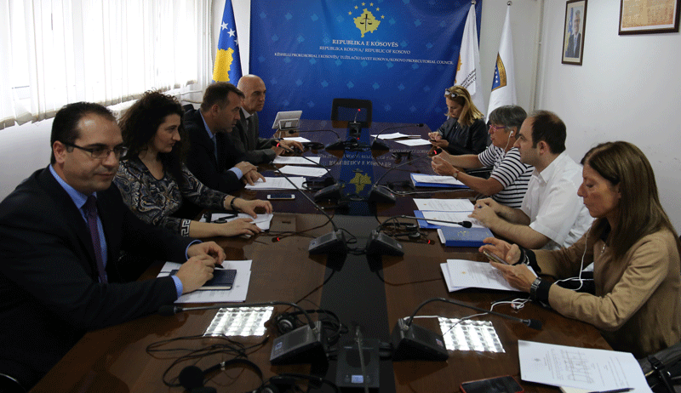

The implementation of the budget of 2017 is being discussed

Pristina, November 29, 2017 - The Budget, Finance and Personnel Committee of the Kosovo Prosecutorial Council (KPC) has held its next meeting, where it was discussed the implementation of the budget of 2017.
This meeting, chaired by the Chairman of the Committee, who is at the same time KPC member Zejnullah Gashi, besides the members of the commission, it was also participated by Director of Secretariat and Division for Budget and Finance.
The purpose of the meeting was to discuss budget implementation from the beginning of 2017 until now and budget allocations for 2018.
At this meeting, the budget obligations were also discussed, they should be completed by the end of this year.

Other activities
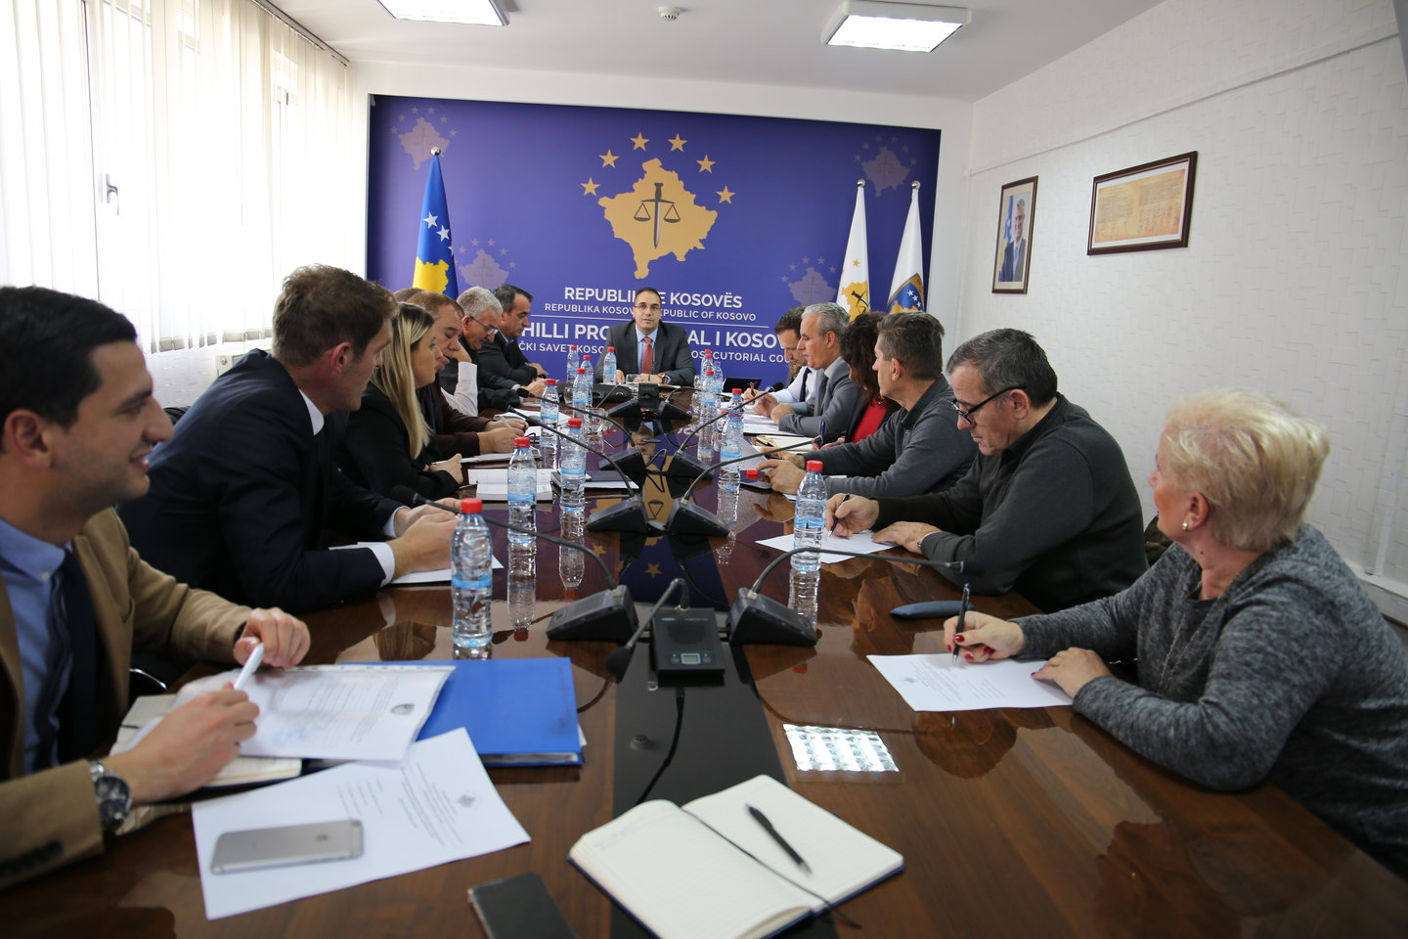

Joint meeting of heads of Secretariat departments and administrators of prosecution' offices
Pristina, November 21, 2017 - The Director of the KPC Secretariat, Lavdim Krasniqi held a joint meeting with the heads of Secretariat departments and administrators of prosecution offices.
Topics covered in this meeting include: On calls in prosecution offices, vehicle management system and planning of needs for 2018.

On this occasion, Director Krasniqi informed the participants of the meeting about the work being done to increase the efficiency of the prosecution system's vehicle management. He said it is being worked on the functionality of a database that would increase the efficiency of the vehicle management.
Also, Director Krasniqi has asked the administrators to make planning for prosecution needs for 2018.
During this meeting was also discussed about the performance evaluation of the administrative staff of prosecution offices, an assessment to be made by the administrators of the respective prosecution offices.

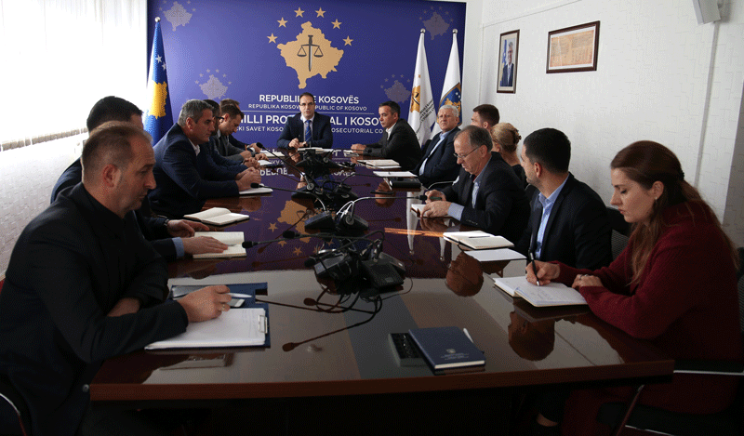

Workshop on Standard Operating Procedures

Pristina, 30 November 2017 - The Director of the Secretariat of the Kosovo Prosecutorial Council (KPC) and the heads of secretariat units were part of a workshop regarding the drafting of standard operating procedures.
During this workshop the participants have drafted standard operating procedures for all KPC Secretariat units.

The drafting of standard operating procedures is done for budget and finance, general services, procurement, personnel and information technology.

Activities of the Secretariat of Kosovo Prosecutorial Council

Secretariat of Kosovo Prosecutorial Council (SKPC), during month of November has executed different activities, with the purposes of implementing rules, regulations and policies related to the management, budget and administration of prosecution offices

Office of the Director of the Secretariat
Office of the Director of the Secretariat with the purposes of coordinating the Secretariat units and meet the objectives, within its legal competencies has taken different decisions, has prepared documents and other bylaws for implementation of rules and policies related to the management of Secretariat and administration of Prosecution.
Within the activities of the Office of Director of Secretariat, the Legal Office has prepared decisions, documents and sub-legal acts, and has supported the permanent KPC commissions.
The Public Communications Office has followed the activities of the KPC, of the Chairman, of the KPC commissions and other units of the prosecutorial system, whereby has prepared communications which it has issued for media and published on the website of the KPC.
Internal Auditor during month of November has worked on the audit of the Special Prosecution Office of the Republic of Kosovo.
Department for Human Resources, Procurement and Administration
Within this department, human resources have completed the selection process for positions: Legal Officer two positions in the Basic Prosecution Office in Pristina, Senior Referent in the Basic Prosecution in Gjakova, Victim Advocate in the Basic Prosecution Office in Gjilan.
The procurement during this month based on planning has continued with the procedures for concluding some contracts for the needs of Kosovo's prosecutorial system.

Department for Budget, Finances and General Services
Within this department, the budget and finances have submitted to the Ministry of Finance the request for reallocation of budget funds for 4 programs of Council. Also, the commitments for the category of goods and services have been completed for 4 programs.
According to the legislation in force, the received receipts for the prosecutorial system under the allocated budget have been checked, committed and spent.
General Services have taken care of the maintenance of facilities through interventions and have supplied all prosecution offices with expendable materials.
Information Technology Department
Information Technology Department has provided all requested services by the Prosecutions’ staff.

The electronic system for the management of vehicles in the prosecutorial system has been implemented, which enables the registration of all data on vehicles and as a result of this we will have a more efficient use as well as economy of expenditures for cars.

The training of Mitrovica's Basic Prosecution (Serbian minority) staff for computer use has started. The training is being held in groups on Internet, word, e-mail and windows modules

Activities of the Prosecutions` Performance Evaluation Unit of Kosovo Prosecutorial Council

The Prosecutorial Performance Review Unit (Unit) of the Kosovo Prosecutorial Council, based on the legal competencies in support of the Council, developed various activities during November.

Office for Prosecutorial Overseeing, Analytics and Vetting
The Office for Oversight, Analytical and Prosecutorial Verification has drafted a report on the recruitment process, and has also compiled the Report on the Commission for Administration of Prosecutions with the findings of the oversight of case registration of the Pristina Basic Prosecution, SPRK and Appellate Prosecution.

This office during this month has also compiled the State Prosecutor's report for the period July - September 2017.
Office for Statistics
Statistics Office has prepared statistical reports on the work of different requesting units inside and outside the system (local and international organizations).
It has prepared reports with statistical data on civil society organizations according to their requirements and relying on legal competences.

Office for Trainings
The Training Office, through cooperation with the Academy of Justice and several other institutions, has organized trainings with various topics based on the professional development needs of prosecutors and administrative staff.

