REPUBLIKA E KOSOVES
REPUBLIKA KOSOVO / REPUBLIC OF KOSOVO
KËSHILLI PROKURORIAL I KOSOVËS/ TUŽILAČKI SAVET KOSOVA/KOSOVO PROSECUTORIAL COUNCIL
Activities of Kosovo Prosecutorial Council
May 2017
MONTHLY BULLETIN

Content

1. Meetings of Kosovo Prosecutorial Council 3
The one-hundred-thirty-third meeting of Kosovo Prosecutorial Council 3
The one-hundred-thirty-fourth meeting of Kosovo Prosecutorial Council 5
2. Activities of KPC Chairman 7
Chairman Isufaj has met with representatives of KDI and Movement ‘FOL’ 7
There is appraised the cooperation between prosecutorial system of Kosova and prosecutorial system of Norway 8
There is appraised the support of American Department of Justice Programme, OPDAT 9
Chaiman Isufaj has met with representatives of EC Unit in charge of Kosova Affairs 10
3. Activities of Permanent Committees 12
Committe for Normative Acts has drafted the Regulation on Classification of Information in the prosecutorial system of Kosova 12
There is drafted the Regulation on the Committee for Budget, Finances and Staff 13
4. Other Activities 14
Roundtable on Sequestration and Confiscation of Unlawfully Acquired Assets 14
Reaction regarding threats addressed against Prosecutors Milic and Sylejmani 16
KPC and KJC have assigned Acting Director of ODP 17
UN-Women provides support and mentoring for Prosecutors dealing with War Crime Cases 18
There was discussed the budgetary planning for the Organizational Units of the prosecutorial system 19
5. Activities of the Secretariat of Kosovo Prosecutorial Council 20
6. Activities of Prosecutions` Performance Evaluation Unit of Kosovo Prosecutorial Council .............22

Kosova: Prishtina
Address: Str: Luan Haradinaj, Prishtina, no.16/1 zona II, kategoria II
Phone: 038/200 18 710
Website: www.kpk-rks.org
e-mail: Info.kpk@rks-psh.org

Meetings of Kosovo Prosecutorial Council

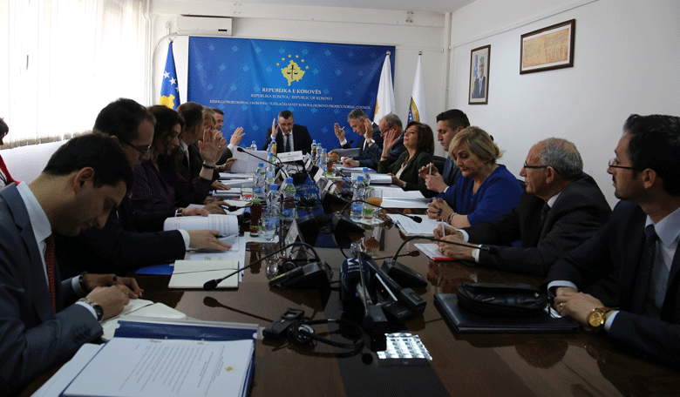

The one-hundred-thirty-third meeting of Kosovo Prosecutorial Council

Prishtina, 16th of May 2017 – There was held the one-hundred-thirty-third meeting of Kosovo Prosecutorial Council (KPC), chaired by the Chairman of Prosecutorial Council, Blerim Isufaj.

In this meeting members of Prosecutorial Council have reviewed and approved Regulation No. 03/2017 on the Committee for Administration of Prosecutions; Regulation that sets organizing, responsibilities and functioning of the Committee for Administration of Prosecutions, as a permanent Committee of Kosovo Prosecutorial Council. The scope of this Regulation is overseeing administration of Prosecutions by the named Committee.

Members of Prosecutorial Council have also reviewed the Report of the Monitoring Committee for the time period January-March 2017 regarding the implementation of the Strategic Plan in the fight against Corruption and Economic Crimes. The named Report was approved with the suggestions given by KPC members.

In this meeting was also reviewed and approved the Inter-Institutional Tracking Mechanism on Harmonization of Statistics regarding characteristic criminal offenses, presented by the Director of the Secretariat of Prosecutorial Council, Lavdim Krasniqi.

Today, members of Prosecutorial Council have also reviewed and approved the Report of the Working Group in charge of monitoring and evaluating implementation of the Strategic Plan of the Council for 2016-2018, for the time period January-March 2017.

KPC members have also taken the Decision regarding the payment of the supporting staff for engagement in additional tasks, as stipulated by Law.

The last item of the agenda was reporting of Chief Prosecutors of the Basic Prosecution in Prishtina, Prizren and Gjilan, for the time period January-March 2017. Chief Prosecutor of the Basic Prosecution of Prishtina, Imer Beka, Chief Prosecutor of the Basic Prosecution of Prizren, Admir Shala and Deputy Chief Prosecutor of the Basic Prosecution of Gjilan, Arben Kadriu, have reported before members of the Council regarding cases` assignment, registration of cases, performance evaluation, internal and inter-institutional communication, Annual Plan for Cases Management and training of Prosecutors. The named Reports were approved by KPC members.

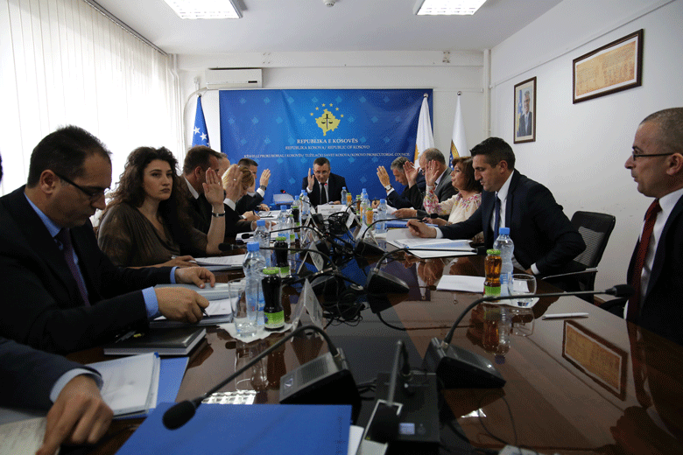

The one-hundred-thirty-fourth meeting of Kosovo Prosecutorial Council

Prishtina, 29th of May 2017 – There was held the one-hundred-thirty-fourth meeting of Kosovo Prosecutorial Council (KPC), chaired by the Chairman of Prosecutorial Council, Blerim Isufaj.

In this meeting members of Prosecutorial Council have reviewed the report of the National Coordinator in charge of fighting Economic Crimes, for the time period January-March 2017. KPC members have approved the named report with some suggestions.

KPC members have also reviewed and approved the item of the agenda regarding Standard Operating Procedures for increasing effectiveness in the treatment of Domestic Violence Cases. The respective aims increasing effectiveness for treatment of Domestic Violence cases during the proceeding of those cases in Prosecution. This effectiveness is aimed to be achieved through assignment of Prosecutors in charge of treating Domestic Violence Cases.

KPC members have also reviewed and approved Regulation no. 04/2017 on Classification of Information of prosecutorial system. The purpose behind this Regulation is classification of information of the prosecutorial system of the Republic of Kosova, which will be applied for the entire prosecutorial system.

KPC members have also approved Regulation no. 05/2017, with the provided suggestions, which Regulation shall set work organizing and responsibilities of the Committee for Budget, Finances and Staff, as a permanent Committee of Prosecutorial Council. Scope of this Regulation is activity of the Committee related to the planning, review, recommendation, management and monitoring of the KPC budget.

Request of Chief Prosecutor of the Special Prosecution of the Republic of Kosova (SPRK), Reshat Millaku on extending transfer of Prosecutor Abdurrahim Islami for six more months was approved by members of Prosecutorial Council.

Today, KPC members have also approved request of National Coordinator in charge of Elections, Laura Pula, for compensation of Prosecutors and supporting staff for their engagement in the Election Day of 11th of June 2017.

As the last item of the agenda reviewed and approved by KPC members was the request of Chief Prosecutor of the Basic Prosecution of Prishtina, Imer Beka, for assigning Prosecutor Kujtim Munishi in the position of the Head of the Serious Crimes Prosecution Department.

Activities of KPC Chairman

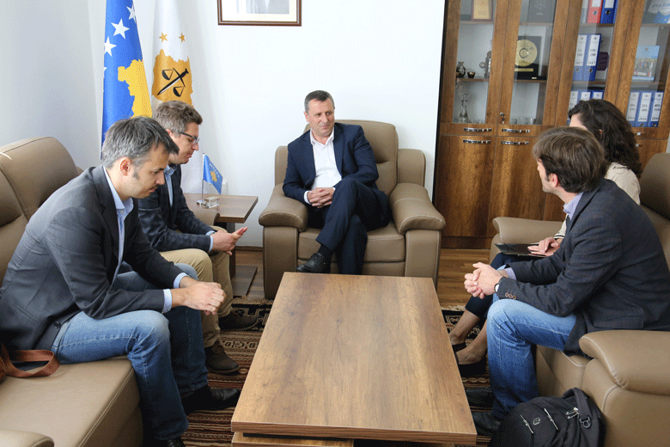

Chairman Isufaj has met with representatives of KDI and Movement ‘FOL’

Prishtina, 5th of May 2017 – Today, Chairman of Kosovo Prosecutorial Council (KPC), Blerim Isufaj, has hosted in a meeting representatives of Kosova Democratic Institute (KDI) and Movement ‘FOL’.

In this meeting, KDI and FOL representatives have informed Chairman Isufaj, that they, together with Dutch Foundation CILC (Center for International Legal Cooperation), are working in launching project “Promotion of the integrity in justice system”, which is financed by the Embassy of Netherlands in Prishtina.

They said that this project within the prosecutorial system will deal with the “Prosecutors` integrity scanning”, and they have requested cooperation and participation of KPC in execution of the part of the project that is related to the respective system.

On the other hand, Chairman Isufaj has offered his support and support of KPC in execution of the aforementioned project, whilst he has also appraised the work that Non-Governmental Organizations are doing in monitoring of the prosecutorial system of Kosova.

Chairman Isufaj has requested from KDI and Movement ‘FOL’ representatives, but also from other Non-Governmental Organizations dealing with monitoring of the prosecutorial system, to present in their reports the work, achievements, weaknesses and recommendations of/for prosecutorial system, as objectively as possible.

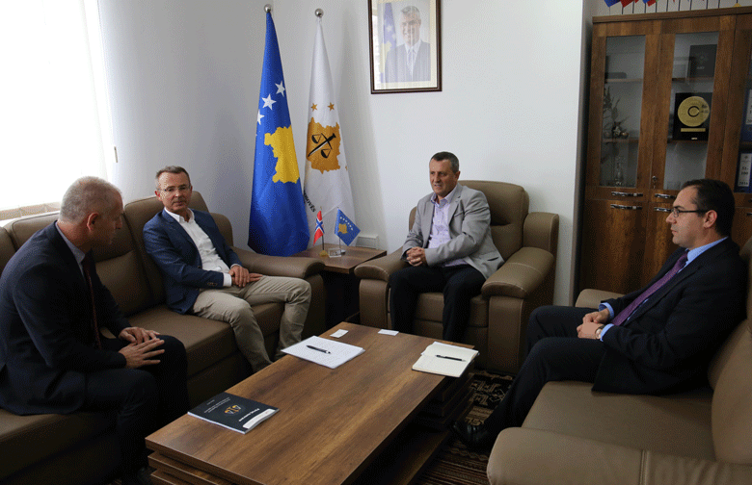

There is appraised the cooperation between prosecutorial system of Kosova and prosecutorial system of Norway

Prishtina, 17th of May 2017 – Today, Chairman of Kosovo Prosecutorial Council (KPC), Blerim Isufaj, has hosted in a meeting Sven Marius Urke, Director of the Judicial Administration in Norway.

In this meeting discussions were regarding the cooperation between the justice system of the Republic of Kosova and the one of the Republic of Norway, with a special emphasize regarding the Information and Communication Technology/Case Management Information System (ICT/CMIS) Project.
On this occasion, Chairman Isufaj has thanked Director Marius Urke for the support Norway is giving to the prosecutorial system of Kosova, and he said that ICT/CMIS Project financed by the Foreign Ministry of Norway will result with the increase of transparency.
On the other hand, Director of the Judicial Administration in Norway has appraised the cooperation with prosecutorial system of Kosova and has also promised constant support for this system.

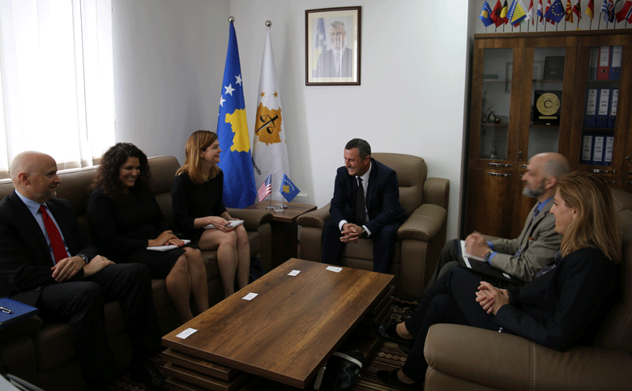

There is appraised the support of the American Department of Justice Programme, OPDAT

Prishtina, 25th of May 2017 – Today, Chairman of Kosovo Prosecutorial Council (KPC), Blerim Isufaj, has hosted in a meeting a delegation from the Bureau of International Narcotics and Law Enforcement Affairs (INL) from Washington, led by Director, Leon C. Lowder; the named Bureau supports financially Office for Overseas Prosecutorial Development Assistance and Training.

In this meeting Chairman Isufaj has appraised cooperation and importance that OPDAT Programme has for KPC. He has also presented concrete activity this program is giving for supporting KPC.

Chairman Isufaj has also spoken about the role that position of the Chairman of the Council has in the prosecutorial system, and for competencies, aims and work that is being done by Kosovo Prosecutorial Council.

At the end of this meeting, Chairman Isufaj said that continuation of the support by OPDAT Programme to KPC will be important in the further development of this Institution.

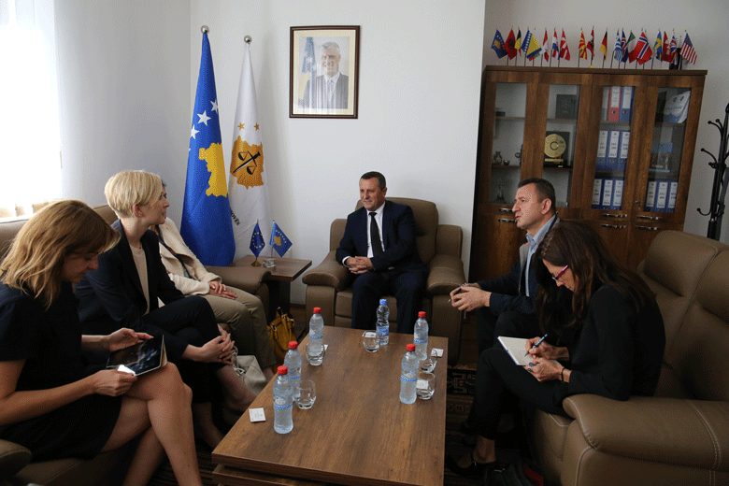

Chairman Isufaj has met with representatives of EC Unit in charge of Kosova Affairs
Prishtina, 30th of May 2017 – Today, Chairman of Kosovo Prosecutorial Council (KPC), Blerim Isufaj, has hosted in a meeting Lora Ujkaj and Julia Mueller-Hellman from the General Directorate of EU – Unit of European Commission in charge of Kosova Affairs.

At the beginning of the meeting, Chairman Isufaj has introduced guests regarding the KPC reorganizing, works that have been done, the ones expected to be in place and, challenges that prosecutorial system of Kosova is facing.

On the other hand, representatives of Unit of European Commission in charge of Kosova Affairs, following the appraisal regarding the work that is being done by KPC, have notified that from September of this year from this Directorate will start the mission of reviewing executed works by the justice system of the Republic of Kosova. They said that this mission shall be perceived by Justice Bodies of Kosova as an opportunity for discussing with representatives of EU countries for achieving progress in the areas that will be covered by this mission.

Chairman Isufaj, after appraising the support EU has given and is giving to prosecutorial system of Kosova, has expressed his readiness and readiness of the entire prosecutorial system for a full cooperation in execution of the review mission regarding the accomplished work by the justice system of the Republic of Kosova.

Activities of Permanent Committees
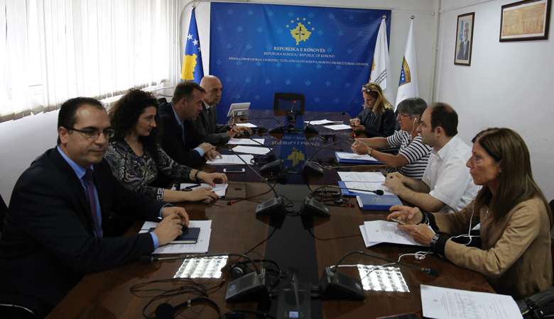

Committee for Normative Acts has drafted the Regulation on Classification of Information in the prosecutorial system of Kosova

Prishtina, 17th of May 2017 - Normative Acts Committee has held the next meeting in which took place discussions regarding the Draft Regulation on Classification of Information in the prosecutorial system of Kosova.
In addition to members of the Committee, in this meeting have participated and representatives of American Embassy, EULEX, and Twinning Project, who are continuously supporting the work of the Normative Acts Committee and the Council in general.

Following the discussions of members of the Committee and international representatives regarding the Draft Regulation on the Classification of Information in the prosecutorial system of Kosova, the same was approved by members of the Committee, and there was decided to submit the respective to Kosovo Prosecutorial Council for approval.

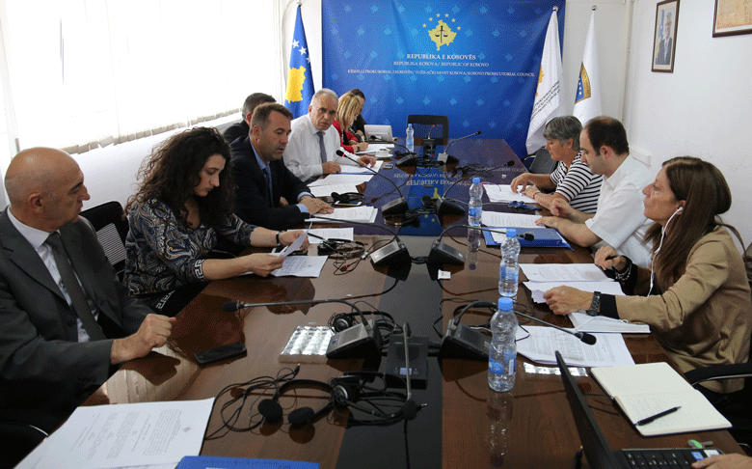

There is drafted the Regulation on the Committee for Budget, Finances and Staff

Prishtina, 17th of May 2017 – Committee for Normative Acts and Committee for Budget, Finances and Staff, have held a joint meeting in which they have discussed the Draft Regulation on the Committee for Budget, Finances and Staff.

In addition to members of both Committees, in this meeting have participated and representatives of American Embassy, EULEX, and Twinning Project, who are continuously supporting the work of the Normative Acts Committee and the Council in general.

Following the discussions of members of the Committees and international representatives regarding the Draft Regulation on the Committee for Budget, Finances and Staff, the same was approved by members of the Committees, and there was decided to submit the respective to Kosovo Prosecutorial Council for approval.

Other Activities

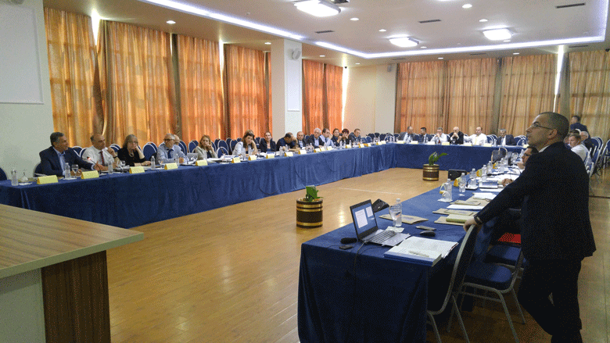

Roundtable regarding Sequestration and Confiscation of Unlawfully Acquired Assets

Prishtina, 4th of May 2017 – National Coordinator in charge of fighting Economic Crimes, with the support of EU Project “Further Support to Kosovo Institutions in the Fight against Organized Crime, Corruption and Violent Extremism”, has organized the three-day roundtable with the topic “Confiscation of Unlawfully Assets”.

In this roundtable organized in Durrës are participating and Chief State Prosecutor, Aleksandër Lumezi, Prosecutors and Judges from Kosova and Albania, representatives of American Embassy and EU Representatives in Kosova, who simultaneously are also financers of the roundtable.

Topics of discussion in this roundtable are:
• Legal Provisions on Confiscation as per CC, CPC and LEPC - challenges;
• Observations from ECHR Cases on Confiscation, and Study Cases;
• Regional cooperation and confiscation of unlawfully acquired assets in Albania;
• British practices on confiscation of unlawfully acquired assets;
• Supreme Court – CPC, with a special emphasize on Articles 69, 96 – 99;
• American Experiences on unlawful assets confiscations, types of confiscations: penal, civil, administrative, and comparisons with the practices in Kosova.

The purpose behind this roundtable was assembling main actors involved in the mechanisms of sequestration and confiscation of unlawfully acquired assets for discussing weakness of registration of confiscations in Kosova, as well as legislative and practical weaknesses, and discussions regarding the best European practices and their implementation in Kosova context.

There will also be discussions regarding finding the best possible solutions for improving this regime, and improvement of cooperation between Prosecution and Court in sequestration and confiscation of unlawfully acquired assets.

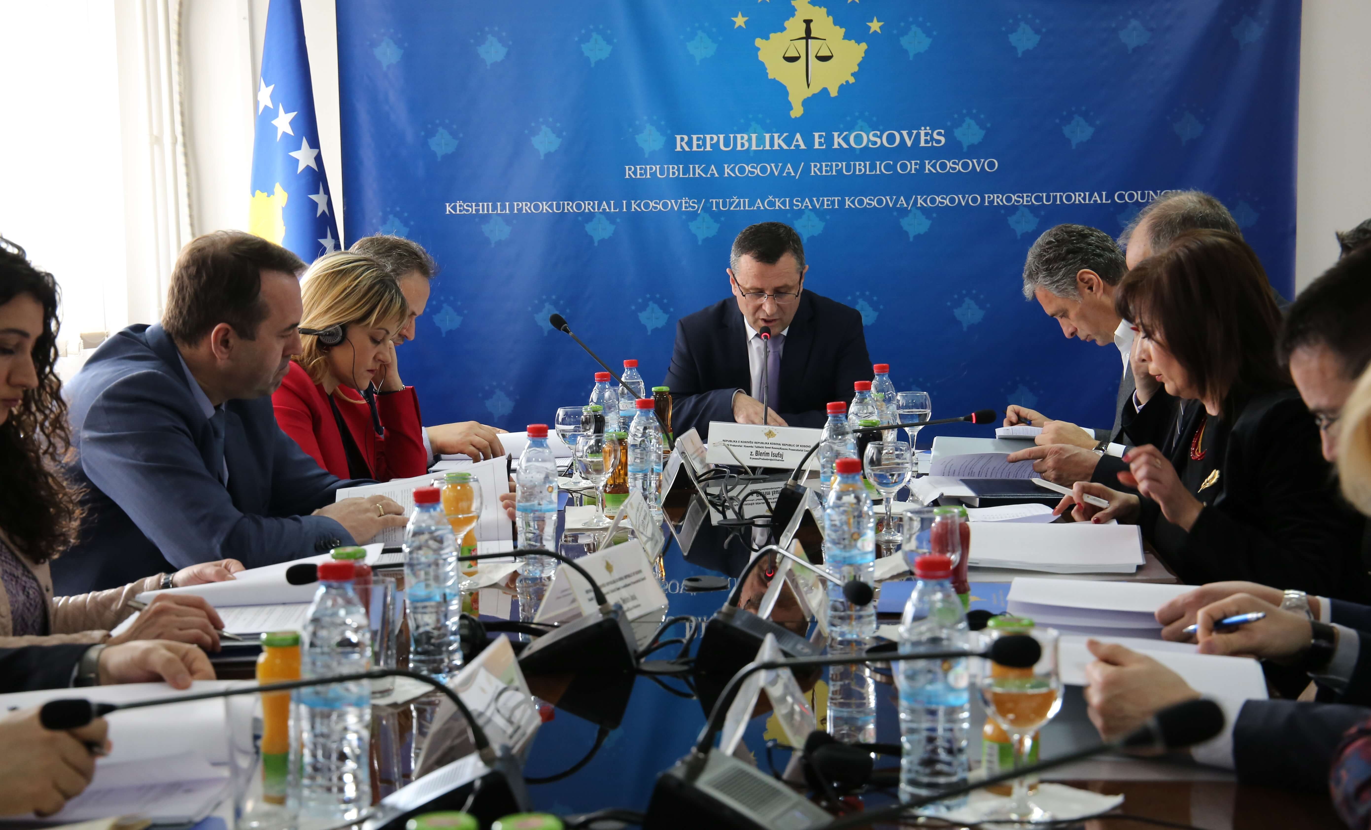

Reaction regarding threat addressed against Prosecutors Milic and Sylejmani

Prishtina, 11th of May 2017 – Kosovo Prosecutorial Council expresses its concern regarding threats addressed against Prosecutor of the Basic Prosecution in Mitrovica, Radica Milic, simultaneously Prosecutor KPC member and, Fikrije Sylejmani. The named threats were related to their official authority.

For us as a Council, such threatening acts against Prosecutors are intolerable and the same shall be taken very seriously. We strongly stand next to Prosecutors, and support them in their daily work, and we encourage them to accomplish their mission.

Kosovo Prosecutorial Council assures the public that this matter is being treated seriously and at the proper emergency level, as this situation deserves.

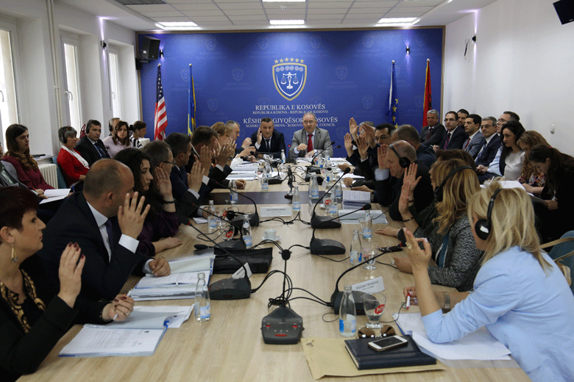

KPC and KJC have assigned Acting Director of ODP

Prishtina, 16th of May 2017 - Kosovo Prosecutorial Council (KPC) and Kosovo Judicial Council (KJC) have held a joint meeting in which they have reviewed the Decision on assigning Director of the Office of Disciplinary Prosecutor (ODP).

Following the discussions that took place among members of both Councils, they have decided to assign Zef Prendrecaj in the position of the Acting Director of the Office of Disciplinary Prosecutor.

The decision brought by both Councils today, envisages that Zef Prendrecaj shall exercise the duty of the Director of the Office of Disciplinary Prosecutor until the entry into force of the new legislation framework that stipulates responsibilities and disciplinary procedures against Judges and Prosecutors.

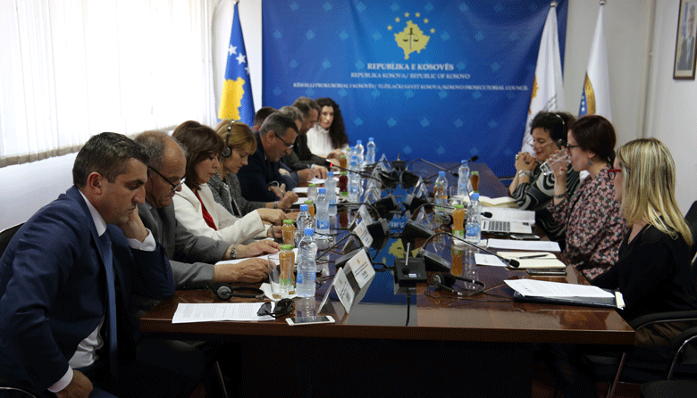

UN-Women provides support and mentoring for Prosecutors dealing with War Crimes Cases

Prishtina, 24th of May 2017 – There was held for the second time the meeting between members of Kosovo Prosecutorial Council (KPC), chaired by the Chairman of Prosecutorial Council, Blerim Isufaj, with Prosecutor and Expert of Transitional Justice, with a special focus on Wartime Sexual Crimes, Ms. Maxine Marcus, and her team, part of UN-Women-CJA Programme, Partnership for Mentoring Transforming Justice.

Chairman of the Council, Blerim Isufaj, has emphasized that Ms Marcus and her team are working on a project that provides support and mentoring for Prosecutors dealing with War Crime Cases, Crime against Humanity and Genocide. This team is providing support to Prosecutors of the Special Prosecution of the Republic of Kosova, as well as to Kosovo Prosecutorial Council.

In this meeting the discussions were regarding War Crimes Cases treated in Kosova by UNMIK and EULEX, and for the opportunity of transferring the expertise on this area to local Institutions.

At the end of this meeting, Chairman Isufaj following the appraising of the work significance this team is doing in Kosova, he has expressed dedication and readiness of KPC for strengthening mutual cooperation in the fight against this phenomenon.

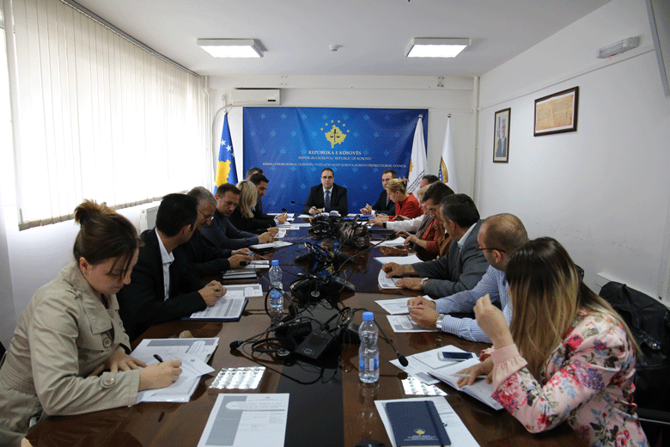

There was discussed the budgetary planning for the Organizational Units of the prosecutorial system

Prishtina, 26th of May 2017 – Today, Director of the Secretariat of Kosovo Prosecutorial Council, Lavdim Krasniqi, in a joint meeting with Heads of Departments and other Organizational Units of the Secretariat, have met with Administrators of all Kosova Prosecutions.

Purpose of this meeting was the first budgetary request for 2018 and, preliminary budgetary estimations for 2019-2020, and there was also discussed Budget Circular for 2018 and budgetary needs of Organizational Units of the prosecutorial system.

On this occasion, Director Krasniqi has requested from Heads of Organizational Units of the prosecutorial system to work in as better budgetary planning for their Units, for the purposes of meeting objectives and mandate of the prosecutorial system.

Activities of the Secretariat of Kosovo Prosecutorial Council

Secretariat of Kosovo Prosecutorial Council i (SKPC) during May, has executed different activities for the purposes of implementing rules, Regulations and different policies related to the management, budget and administration of Prosecutions.
General Services have supplied all Prosecutions with expendable materials, and they have ensured maintenance of premises through interventions in maintenance of the inventory and other equipment.
General Services have also administered all vehicles, have provided regular servicing, have overseen the crossed kilometres, and have intervened when necessary for the servicing of the respective.
General Services have also intervened by executing other tasks as well, such as: proceeding of cases for supply, registering cases on E-system of Assets, and they have held meetings with Administrations of Prosecutions and Official Vehicles Management System.
Human Resources have completed the short lists for 17 announced vacant positions, and they have also completed interviews and tests evaluations for the respective positions.
During the aforementioned procedures, there was cancelled the vacancy for three (3) positions and there was re-announced the vacancy for Officer for Budget and Finances in the Basic Prosecution in Prizren. For some positions the recruitment process was completed, and the ones obtaining the job have been informed, and the named notification was also published on websites of KPC and SP.
There was requested from Ministry of Public Administration to complete the setting of grade level for positions of Heads of the Offices as well, for which positions the coefficients were approved – for the named job positions is required to set level, grade and job code.
Budget and Finances in cooperation with Departments and Divisions have prepared the request for review of the budget. The request for review was approved by the Committee for Budget and Finances, and General Services, and the same was submitted to Ministry of Finances.
In Ministry of Finances was submitted the report on financial liabilities of the budgetary organization for April.
In compliance with the legislation in force there were also checked, committed and spent received invoices of the prosecutorial system, as per the allocated budget.
Procurement has conducted procurement procedures regarding: ”Servicing and maintenance of the generators of prosecutorial system of Kosova“, “Redesigning, reprogramming, maintenance and support for the website of State Prosecutor”, ” Supply with Hardcover Folders with Rope Binders –Size B4”, ”Supply with cartridges for the needs of prosecutorial system of Kosova”, “Development of the implementation of the Electronic Vehicles Management System - EVMS”, ”Renovation of two Offices in the SPRK Premises” and “Supply and placement of the carpets in the SPRK Offices”
Information Technology has provided all required services by the staff of Prosecutions regarding the problems that have emerged during the using of IT equipment and electronic systems.
In all Prosecutions was held the briefing regarding the ICT/CMIS Project executed activities and the ones expected to take place in the future, as well as advantages that Cases Management Information System will bring in Prosecutions.
Within the ICT/CMIS Project has continued the development of the prototype of the Cases Management Information System. There were also prepared criteria for distribution of cases from the system in automatic manner. Thus, any case that will be registered in system will be automatically distributed to Prosecutors of Prosecutions.
There has started to be in place development of the electronic system of Prosecutors` files management. Through this system is planned to take place management and administration of Prosecutors` files, disciplinary cases, Prosecutors` Performance Evaluation, trainings and Questionnaires.
Office for Communication with Public has followed up activities of KPC, Chairman and Committee for Normative Acts and other bodies of the prosecutorial system; and regarding the same it has prepared Press Releases, which were distributed to media and uploaded on the KPC website. This Office has prepared on daily basis the summary of monitoring of printed, electronic and visual media.
Internal Auditor has finalized the Report of Auditing of General Services Division.

Activities of Prosecutions` Performance Evaluation Unit of Kosovo Prosecutorial Council

Prosecutions` Performance Evaluation Unit (Unit) of Kosovo Prosecutorial Council, based on legal competencies for supporting the Council, during May has conducted different activities.
Office for Prosecutorial Overseeing, Analytics and Vetting has registered applications of the candidates for Prosecutors in compliance with the vacancy announcement published by the Council, and it has provided technical support for the Committee in charge of Recruitment through notifying candidates meeting the set criteria, and receipt of the Application, and responding to candidates who have complained to the Review Committee regarding the Decisions of Recruitment Committee.
It has also drafted the Report on Prosecutors` Performance Evaluation, as per the Decisions brought by the Prosecutors` Performance Evaluation Committee.
In cooperation with IT Experts it has worked on setting the Prosecutors` Files Electronic Management System.
Office for Statistics working within the Unit has prepared Statistical Reports as per the request of KAS for the needs of EUROSTAT, it has worked on designing and content of Statistical Reports and Registries related to Corruption cases, following the adding of new areas in the new Application of kriMKorr, in order to be able to collect necessary statistical data for reporting to SAA.
It has also identified and eliminated the problem of functionality of the application of the database of the Serious Crimes Prosecution Department (PP1), of the Basic Prosecution in Peja, and it has monitored the process of harmonization of statistical data between Prosecutions and other Law Enforcement Authorities, submitters of criminal reports and Courts.
During May this Office has held trainings with Legal Officers of the Basic Prosecution in Prishtina, for the purposes of equipping the respective with skills on using the webkriMKorr Application, which is designated for supporting the work of the Unit in charge of Fighting Corruption and Economic Crimes.
Office for Trainings, through the cooperation with American Embassy in Prishtina, ICITAP, Academy of Justice (former Kosovo Judicial Institute), have organized different trainings for professional capacities upgrading of Prosecutors and administrative staff.
Prosecutors have attended trainings provided in the area of Criminal Procedure, Indictments, Hearing Sessions in the procedure against Juveniles, Witnesses Protection.
Whereas, within the scope of the Material Law they have attended trainings regarding War Crimes, Domestic Violence, Specialized Programme for strengthening professional capacities in the fight of cybercrimes and Corruption.

