REPUBLIKA E KOSOVES
REPUBLIKA KOSOVO / REPUBLIC OF KOSOVO
KËSHILLI PROKURORIAL I KOSOVËS/ TUŽILAČKI SAVET KOSOVA/KOSOVO PROSECUTORIAL COUNCIL
Activities of Kosovo Prosecutorial Council
June 2017
MONTHLY BULLETIN
Content

1. Meetings of Kosovo Prosecutorial Council 3
The one-hundred-thirty-fifth meeting of Kosovo Prosecutorial Council 3
2. Activities of KPC Chairman 5
Chairman Isufaj has delivered a speech at the roundtable “Capacities Upgrading of Kosova Prosecutors for dealing with Corruption – with a focus on Confiscation” 5
A delegation from Supreme Justice Council of Albania has visited Kosovo Prosecutorial Council 6
Chairman Isufaj: KPC dedicated in Prosecutions` professional capacities upgrading 7
There is appraised EU Institutions` support for KPC 9
Isufaj: I appraise the support in the fight against Unlawfully Acquired Assets 10
Chairman Isufaj: Terrorism and Money Laundering is a global threat 11
3. Activities of Permanent Committees 13
Committee for Normative Acts has supplemented/amended two Administrative Directives 13
There was held the meeting of the Committee for Prosecutions` Administrations 14
4. Other activities 16
KJC and KPC have discussed with civil society regarding the ICT/CMIS Project 16
Reaction from Kosovo Prosecutorial Council 18
There was held the qualification test for candidates for Prosecutors 19
Study Visit regarding Cyber Law 20
Performance Advancement in the administration of the prosecutorial system 21
5. Activities of the Secretariat of Kosovo Prosecutorial Council 22
6. Activities of Prosecutions` Performance Evaluation Unit of Kosovo Prosecutorial Council 25

Kosova: Prishtina
Address: St: Luan Haradinaj Prishtina, nr.16/1 zona II, kategoria II
Tel: 038/200 18 710
Website: www.kpk-rks.org
e-mail: Info.kpk@rks-psh.org

Meetings of Kosovo Prosecutorial Council

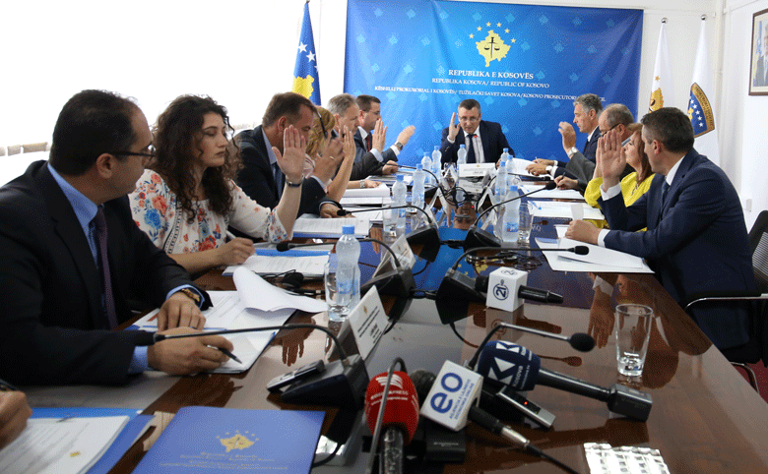

The one-hundred-fifth meeting of Kosovo Prosecutorial Council

Prishtina, 14th of June 2017 – There was held the one-hundred-thirty-fifth meeting of Kosovo Prosecutorial Council (KPC), chaired by the Chairman of Prosecutorial Council, Blerim Isufaj.

In today`s meeting, members of Prosecutorial Council have discussed the first budgetary request for 2018. Presentation of this request was done by the Head of the Committee for Budget and Finances, and Directors of the Secretariat of KPC. Upon some amendments, KPC members have approved the first Budgetary Request for 2018.

In this meeting were also approved upon some amendments and supplementing two Administrative Directives, respectively Administrative Directive no. 01/2017, on Amending and Supplementing Administrative Directive No. 01/2016 on Representation Expenses and, Administrative Directive No. 02/2017, on Amending and Supplementing Administrative Directive No. 02/2016, on Usage of Landline Phones and Cell-Phones by Kosovo Prosecutorial Council and Prosecutions of the Republic of Kosova.

KPC members in this meeting have also extended the temporary transfer for six (6) more months of Prosecutor Arben Ismajli from Basic Prosecution of Gjilan to Basic Prosecution of Ferizaj.

Today, KPC has also reviewed and approved the request of EULEX Chief of Mission in Kosova, Alexandra Papadopoulou, for approval of the appointment of Mr Marc Meslin to serve as Prosecutor in the Republic of Kosova.

At the end of this meeting, KPC members have approved the Report of the Committee in charge of Prosecutors` Evaluation, regarding performance evaluation of 16 Prosecutors.

Activities of KPC Chairman

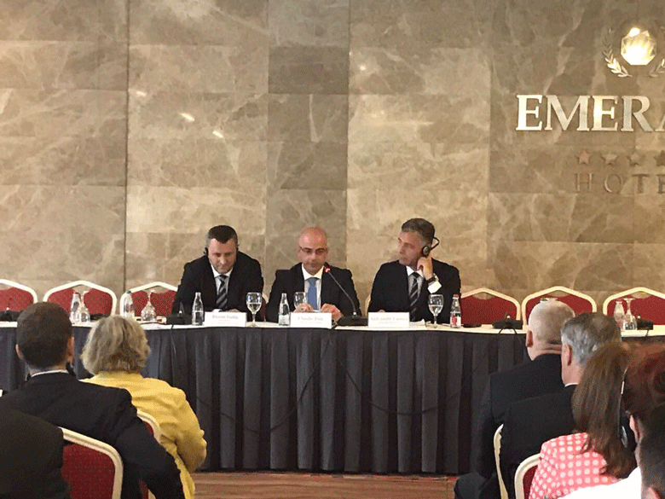

Chairman Isufaj has delivered a speech in the roundtable “Capacities upgrading of Kosova Prosecutors for dealing with Corruption – with a focus on Confiscation”
Prishtina, 2nd of June 2017 - Today, Chairman of Kosovo Prosecutorial Council (KPC), Blerim Isufaj, has delivered a speech at the roundtable organized by EULEX, with the topic: “Capacities Upgrading of Kosova Prosecutors for dealing with Corruption – with focus on Confiscation”. In this roundtable has participated and Chief State Prosecutor, Aleksandër Lumezi.

At the beginning of his speech, Chairman Isufaj has thanked EULEX for the support provided in the capacities upgrading of the prosecutorial system in the fight against corruption. He has also added that Corruption, Economic Crimes, Assets Freezing, Sequestration and Confiscation shall be treated through an uncompromised fight against them.

Furthermore, Chairman Isufaj said that KPC and SP have undertaken all actions for increasing the level of the fight against Corruption. In this regard, he said, there were drafted special strategies, were established special mechanisms, there were recruited new Prosecutors and, there was done work for setting adequate policies for performance evaluation, disciplining and Prosecutors` training for the purposes of capacities upgrading in the fight against corruption.

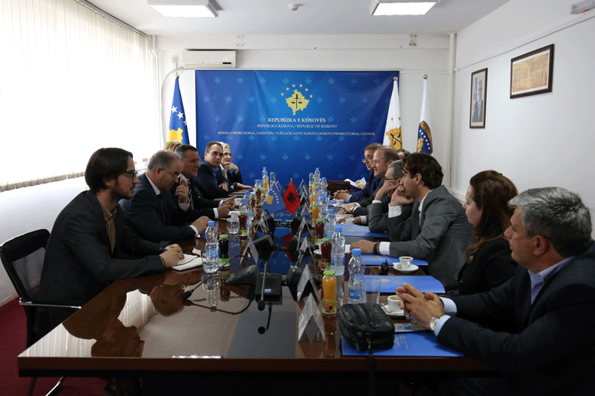

A delegation of Supreme Justice Council of Albania has visited Kosovo Prosecutorial Council

Prishtina, 2nd of June 2017 - Today, Chairman of Kosovo Prosecutorial Council (KPC), Blerim Isufaj, has hosted in a meeting a delegation from the Supreme Justice Council of Albania, headed by Gjin Gjoni, member of the respective Council. In this meeting were present and Deputy Chief State Prosecutor, Sevdije Morina and Head of Kosovo Judicial Council, Nehat Idrizi.

At the beginning of the meeting, Chairman Isufaj has notified guests regarding the functioning of the prosecutorial system of Kosova, in particular regarding the reorganizing this system went through. He said that upon the latest legal changes, prosecutorial system of Kosova has a new organizational and functional structure.

On the other hand, member of the Supreme Justice Council of Albania, Gjin Gjoni, has presented reforms that are taking place in the justice system of the Republic of Albania.

Both interlocutors have spoken about the cooperation that was in place so far and for the opportunities for increasing inter-state cooperation between the justice systems of both countries. They have appraised the cooperation that was in place so far, and they have stressed the areas in which both States can increase cooperation and exchange of their experiences for the purposes of increasing effectiveness of both systems.

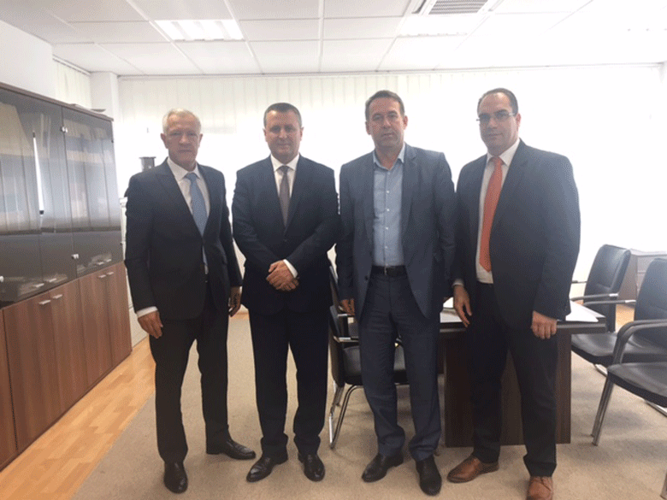

Chairman Isufaj: KPC dedicated in Prosecutions` professional capacities upgrading

Mitrovica/Ferizaj, 9th of June 2017 - Chairman of Kosovo Prosecutorial Council (KPC), Blerim Isufaj, accompanied by the Director of the Secretariat, Lavdim Krasniqi, within the initiation of visits in all Prosecutions of the Republic of Kosova, have visited Basic Prosecution of Mitrovica and Basic Prosecution of Ferizaj, where they have met with Chief Prosecutors, Prosecutors and administrative staff of the respective Prosecutions.

Chairman Isufaj during those visits was briefed regarding the work that is being done by the respective Prosecutions, challenges they face and, general working conditions of both Prosecutions.

Chairman Isufaj was also closely introduced about the needs that Departments of both aforementioned Prosecutions have.

KPC Chairman said that Prosecutorial Council is continuously working in ensuring as better work conditions and in increasing human capacities. He said that recruitment of 25 new Prosecutors that took place in the last year and vacancy announcement for selecting 18 more Prosecutors shall result with performance effectiveness increase throughout Prosecutions.

Chairman has mentioned and KPC engagement in recruitment that is taking place for the supporting staff that will be supporting work of Prosecutors.

KPC Chairman, Blerim Isufaj, will carry on with visiting all instances of Prosecutions of the Republic of Kosova.

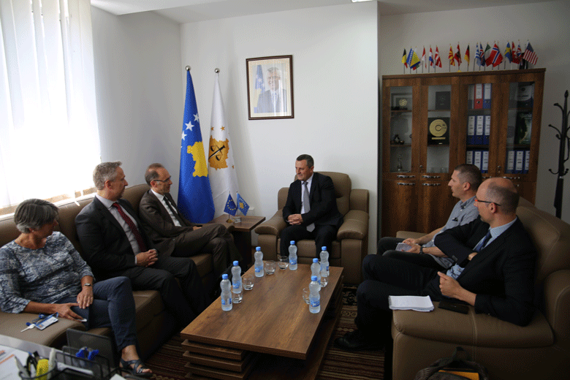

There is appraised EU Institutions` support for KPC

Prishtina, 13th of June 2017 – Today, Chairman of Kosovo Prosecutorial Council (KPC), Blerim Isufaj, has hosted in a meeting a delegation from the Civilian Planning and Conduct Capability (CPCC) from EU, that had the following composition: Jean Marc Pisani, Head of Division – Operational Sector and Holger Osterrieder, Head of the Sector for Europe – Operational Sector.
At the beginning of this meeting, Chairman Isufaj has presented new KPC structure as per later legal amendments, and he has also spoken about the work that is being done and, planning for the future.
On this occasion, Chairman Isufaj has appraised the cooperation and support of EU Institutions in general, as well as the ones with mission in Kosova, such as EULEX, for the support given to prosecutorial system of Kosova.
On the other hand, EU delegation representatives following the appraisal of the work that is being done by KPC have expressed their readiness for further supporting of prosecutorial system for the purposes of increasing performance effectiveness.
In this meeting the discussions were also regarding the number of backlog cases, and in terms of this topic, Chairman Isufaj said that increase of the number of Prosecutors has resulted with increasing number of solved old cases. He said that prosecutorial system has set as priority solving old cases for the purposes of not allowing having those cases reach their status of limitation.

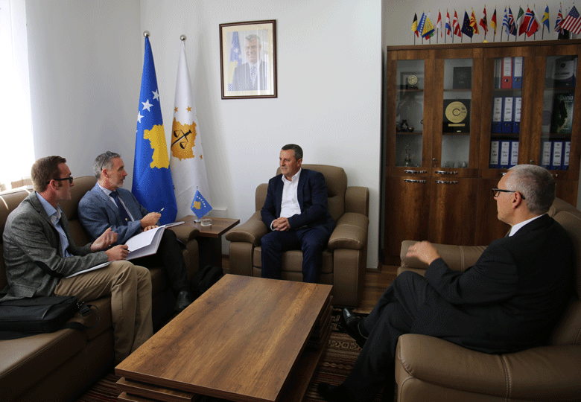

Isufaj: I appraise the support in the fight against Unlawfully Acquired Assets

Prishtina, 15th of June 2017 – Today, Chairman of Kosovo Prosecutorial Council (KPC), Blerim Isufaj, has hosted in a meeting Ian McDonald, Head of the Project “Further Support to Kosovo Institutions in the Fight against Organized Crime, Corruption and Violent Extremism”.
Chairman Isufaj has informed Mr McDonald regarding the functioning of the prosecutorial system of Kosova, in particular regarding the reorganizing that took place in this system upon the latest legal amendments, due to which now prosecutorial system of Kosova has a new organizational and functional structure.

Head of the Project, Mr McDonald, said that the purpose behind the project he leads is supporting prosecutorial system in the fight against organized crime and corruption, with emphasize in confiscation of unlawfully acquired assets.

On the other hand, Chairman Isufaj said that there is work being done in this regard, and he has expressed his will for further engagement of the prosecutorial system in the fight against unlawfully acquired assets.

In regard to confiscation of unlawfully acquired assets, both interlocutors have spoken about the legislation regulating this area, and they have agreed there is need the supplementing/amending of the respective, for the purposes of increasing effectiveness in confiscation of unlawfully acquired assets.

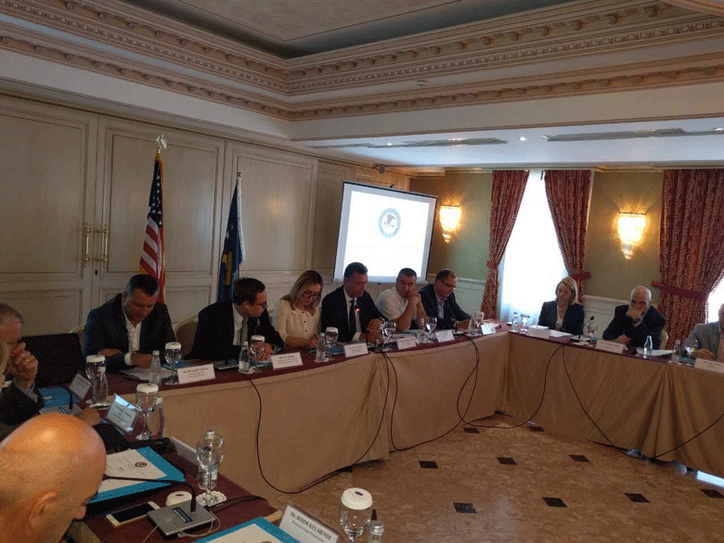

Chairman Isufaj: Terrorism and Money Laundering is a global threat

Prishtina, 28th of June 2017 – Today, Chairman of Kosovo Prosecutorial Council, Blerim Isufaj, has attended the workshop with the topic: “Terrorism Financing and Money Laundering”, organized by the US Department of Justice, International Crime Investigative Training Assistance Program (ICITAP), and Overseas Prosecutorial Development, Assistance and Training (OPDAT), in Kosova.

Before the attendees of this workshop, Chairman Isufaj said: “Initially I thank US Department of Justice, ICITAP and OPDAT, for the invitation to be part of this workshop that has on focus prevention and combating terrorism financing and money laundering.

Ladies and Gentlemen, nowadays terrorism financing and money laundering is a global threat, and there is not even one country that is entirely protected from this phenomenon. In this regard, in the last years Kosova has also been evidently challenged from this form of criminality, where as a result of socio-political context and separate competencies, and often due to lack of proper coordination between International and local institutions in charge of Law Enforcement, has been created an environment for the spread of this phenomena in our country as well.

Consequently, initially through financing from different organizations there were promoted fundamentalist/conservatize ideas, which have gradually evolved in extremist violent ideas and participation in terrorist activities.

Local institutions in charge of Rule of Law in the last years have engaged themselves with all their capacities in fighting and preventing this form of crime. In this regard, through a better coordination between Police, Prosecution and other institutions have been achieved concrete results, by significantly preventing this phenomenon in our country.
\
Nevertheless, Rule of Law Institutions, in particular prosecutorial system still has huge needs for increasing professional capacities through obtaining contemporary practices, as well as increasing international cooperation in the effective fight and prevention of this phenomenon.

Being aware for the seriousness of this form of crime and threatening it represents for our country and broader, prosecutorial system within its Action Plans has set as priority increasing Prosecutors` capacities for effective fighting of terrorism financing and money laundering.

Therefore, Your support through trainings and infrastructure, is very important and key factor for our success in this mission.
We are grateful for Your support and we have hopes that we will carry on with the excellent cooperation in the future as well.

Lastly, allow me to wish you success in this workshop and to express my full dedication for cooperation with US Justice Institutions.”

Activities of Permanent Committees

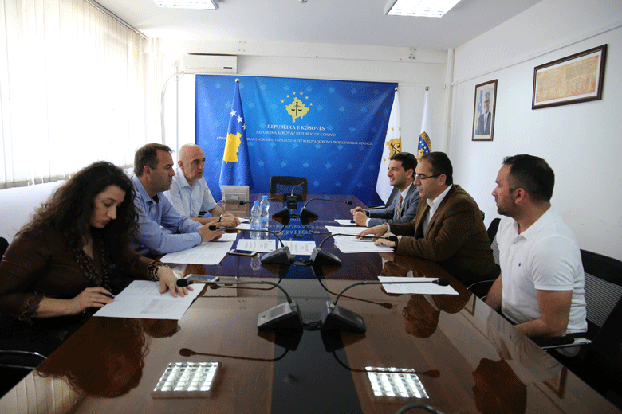

Committee for Normative Acts has made the amending/supplementing two Administrative Directives

Prishtina, 9th of June 2017 – Normative Acts Committee has held the next meeting in which it has discussed regarding the Administrative Directive No. 01/2017 on Amending and Supplementing Administrative Directive No. 01/2016 on Setting Representation Expenditures and, Administrative Directive No. 02/2017 on Amending and Supplementing Administrative Directive No. 02/2016 on Usage of Landline Phones and Cell Phones by Kosovo Prosecutorial Council and Prosecutions of the Republic of Kosova.

Participants in this meeting were three members of the Committee for Normative Acts, Director of the Secretariat as representative from Administration, and representative from the Division for Budget and Finances.

Head of the Committee has initially informed the attendees for the purposes of supplementing and amending respective Directives, and which are related to changes that have taken place within the Secretariat of Kosovo Prosecutorial Council following its reorganization, and also another purpose behind amending and supplementing the aforementioned Directives are related to diminishing expenditures of representation and, cell phones and landline phones expenditures in the entire prosecutorial system.

Following the discussions regarding the height of representation amounts and landline phones and cell phones expenditures, members of the Committee have approved both Directives and have recommended submitting the respective to the Council for approval on its next meeting.

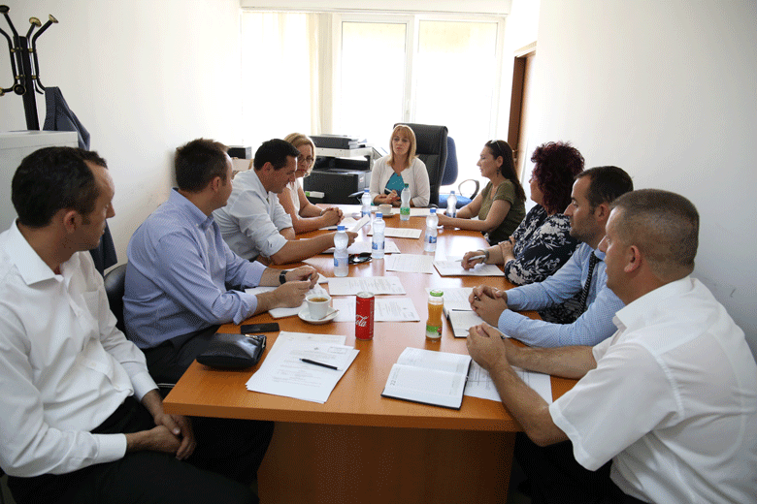

There was held the meeting of the Committee for Prosecutions` Administration

Prishtina, 23rd of June 2017 - Today, the Committee for Administration of Prosecutions, has held the first meetings since its establishment by Kosovo Prosecutorial Council in the last meeting of the later (the 135th meeting of KPC).

In this meeting, except the Head of the Committee, Prosecutor Radica Milic and Committee members, have participated and members of the Working Group established by the Committee, and who are representatives of the administrative staff.

Discussions in this meeting were regarding the competencies of the Committee as well as defining the work methodology, which were said have for purpose harmonization and unification of administrative tasks in State Prosecutor.

Discussions were also regarding the embracing of the best performance practices and their application in the prosecutorial system of Kosova.

In this meeting was decided to set the work priorities of the named Committee, and there was also said that there shall take place monitoring of the workload and registration of cases in all Prosecutions of the Republic of Kosova.

Other activities

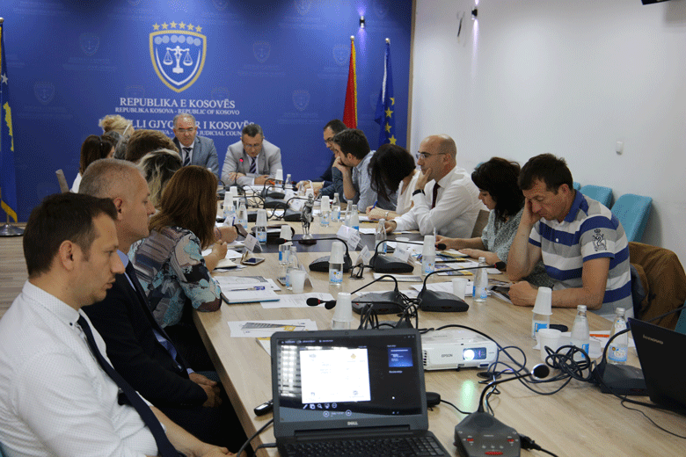

KJC and KPC have discussed with civil society regarding the ICT/CMIS Project

Prishtina, 5th of June 2017 - Kosovo Judicial Council (KJC) and Kosovo Prosecutorial Council (KPC), within the reforms that are undertaking are also working in incorporating Information Technology and Case Management Information System.
ICT/CMIS Project is a joint project of KJC/KPC, and it is being executed with the financial support of Norwegian Ministry of Foreign Affairs.
For the purposes of providing information regarding the executed activities and the on-going activities that are within the ICT/CMIS Project, as well as for discussing with the named Project, today was held a roundtable with representatives of Non-Governmental Organizations that mainly deal with justice system in Kosova.
In this roundtable were present and KJC Chairman, Nehat Idrizi and Chairman of KPC, Blerim Isufaj, who have appraised the ICT/CMIS Project to be very significant for both systems, and they have also thanked Norway Government for financing the named project.
They said that through the project is aimed replacement of the manual work done by judicial and prosecutorial system with the electronic one, from which consequently will be in place higher effectiveness, transparency and accountability at work.
On the other hand, Manager and Deputy Manager of the ICT/CMIS Project, Fatmir Rexhepi and Nexhat Haziri, have presented the work they are doing and what is expected to be done for the purposes of executing the named Project.
Bajram Bojku has presented Cases Management Electronic System that has been developed so far, system that shall carry on to be developed onwards.
NGOs representatives that have participated in this roundtable were interested in different features of the project, and simultaneously have given their opinions as well.
At the end of the named roundtable, there was said that cooperation between KJC, KPC and NGOs in the further steps of executing the given project, shall be useful for as successful execution of the ICT/CMIS Project.

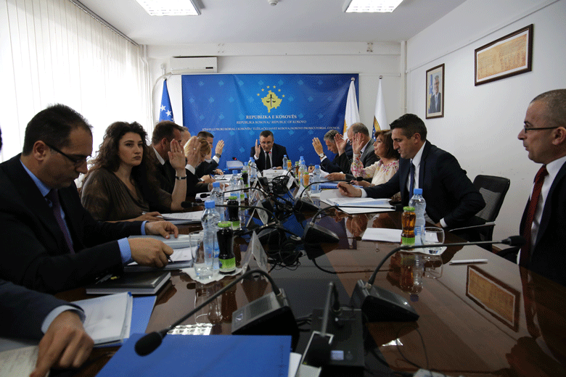

Reaction from Kosovo Prosecutorial Council

Prishtina, 14th of June 2017 – Kosovo Prosecutorial Council is concerned regarding threats addressed against Prosecutor of the Basic Prosecution in Prizren, Mr Besim Susuri, and which threats were related to his official authority.

For us as a Council, such threatening acts against Prosecutors are intolerable and the same are taken very seriously. We strongly stand next to Prosecutors, and support them in their daily work, and we encourage them to accomplish their mission.

Kosovo Prosecutorial Council assures the public that this matter is being treated seriously and at the proper emergency level, as this situation deserves.

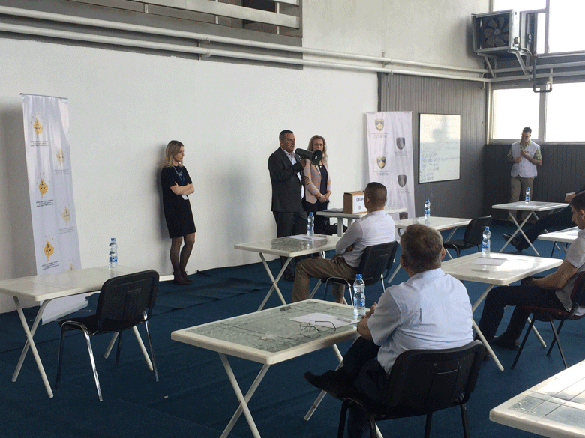

There was held the qualification test for candidates for Prosecutors

Prishtina, 24th of June 2017 – Today was held the qualification test for candidates for Prosecutors, which was organized by Kosovo Prosecutorial Council (KPC) within the recruitment process of 18 State Prosecutors.

The qualification test process was overseen by the Chairman of KPC, Blerim Isufaj, and member of the Recruitment Committee, Prosecutor Lulzim Sulejmani.

KPC Chairman, Blerim Isufaj, has wished successes to the candidates being subjected to the Exam, and he has also appraised the significance that this process has for the prosecutorial system, also emphasizing that KPC has undertaken all actions to have this process executed as professionally and based on meritocracy.

To today`s mentioned test have been subjected 125 candidates, within which number, six (6) of them were from non-majority communities.

The named test has taken place in the Kosovo Academy for Public Security in Vushtrri.

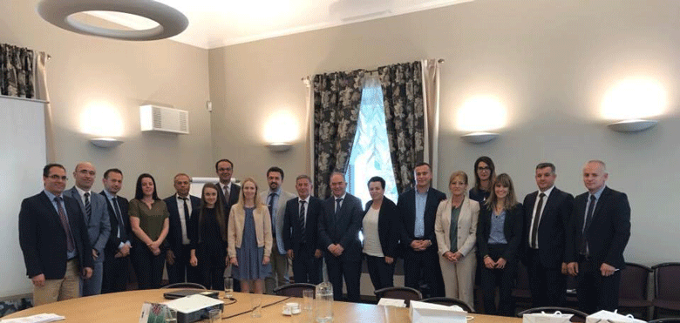

Study Visit regarding Cyber Law

Tallinn/Estonia, 29th of June 2017 – Within the project “Strengthening Justice Quality and Effectiveness in Kosova”, representatives of prosecutorial system and judicial system of Kosova are in a study visit regarding Cyber Law in Estonia.

The purpose behind this study visit is seeing how Prosecutions and Courts in Estonia use informational system in their daily work.

They will also have the opportunity to see how Estonia has achieved to successfully develop and implement such an advanced system within a short time period.
During this study visit, participants from Justice Institutions of the Republic of Kosova will be introduced with the role and activities of the Centre for Registration of Estonian Informational Systems, electronic solutions used in the judicial system, “no-paper” judicial process, access to Judicial Statistics, digital access to Justice and digital judicial procedures, as well as other functioning practices of the electronic system in the Estonian Justice system.

In this study visit, prosecutorial system of Kosova is being represented by the Director of the Secretariat of Kosovo Prosecutorial Council (KPC), Lavdim Krasniqi, and Acting Head of the Department of Informative Technology in KPC, Nexhat Haziri.

Performance Advancement in the administration of the prosecutorial system

Prishtina, 1st of June 2017 – Kosovo Prosecutorial Council in cooperation with Academy of Justice have organized training with the topic: “Performance Advancement in the administration of the prosecutorial system”.

The purpose behind this training was increasing awareness of the beneficiaries regarding new management concepts obtained in the spirit of legal amendments and restructuring of the Secretariat of Prosecutorial Council, and which has created a new vision in the process of drafting policies and services providing within the prosecutorial system.

Through Working Groups and discussions were elaborated principles, such as: proactive approach in providing services and, on time, effective and efficient planning, including and discussions regarding proposition of policies for advancement of effective administration of the prosecutorial system.
Furthermore, on the focus of the training was and further advancement of performance evaluation system which presents one of the crucial aspects in effective administration of the justice system and which also directly affects accountability and motivation of the staff for providing qualitative services.

Beneficiaries of this training were Heads of Organizational Units of the Secretariat (Departments, Divisions and Offices), and Administrators of Prosecutions.

Activities of the Secretariat of Kosovo Prosecutorial Council

Secretariat of Kosovo Prosecutorial Council (SKPC), during June has executed different activities in the spirit of implementing rules, Regulations and policies related to the management, budget and administration of Prosecutions.
General Services have supplied all Prosecutions with expendable materials, and they have ensured maintenance of premises through interventions in maintenance of the inventory and other equipment.
General Services have also administered all vehicles, have provided regular servicing, have overseen the crossed kilometres, and have intervened when necessary in the maintenance of the respective.
General Services have also intervened by executing other tasks as well, such as: proceeding of cases for supply, registering cases on E-system of Assets, and they have held meetings with Administrations of Prosecutions regarding Official Vehicles Management System.
Human Resources have completed the recruitment process for 17 announced vacant positions in May. Out of 17 published positions were selected nine (9) most successful candidates from the interviewing process (written test and interview), whereas based on by-laws into force, the recruitment process for eight (8) other positions is carrying on to be in place.
In this month, for Prosecutions` needs were also published vacancies for two (2) Legal Officers.
There were also published internal vacancies for positions: Head of the Department for Budget, Finances and General Services and Head of the Department for Information Technology, both Departments functioning within the Secretariat of the Prosecutorial Council. Whereas, in the Office of Chief State Prosecutor was published internal vacancy for the position: Head of the Office for Communication with the Public in the Office of Chief State Prosecutor.
Budget and Finances in cooperation with Departments and Divisions has prepared the first budgetary request for 2018, as well as preliminary estimations for 2019 and 2020.
First budgetary request was approved by the Committee for Budget, Finances and Staff, and Kosovo Prosecutorial Council. In the first budgetary request were presented necessities of the prosecutorial system of Kosova, such as increasing number of employees, as well as increase of the category of salaries, goods and services, as well as capital projects.
There was also submitted to the Ministry of Finances, the Report on Financial Liabilities of the budgetary organization for month of May.
There also, in compliance with the legislation in force, were checked, committed and spent received invoices for/of the prosecutorial system as per the allocated budget.
Procurement has conducted procurement processes for projects: “Supply with printer cartridges for the needs of the prosecutorial system of Kosova”, “Development and implementation of the electronic management system of vehicles “EMSV”) of the prosecutorial system of Kosova, “Servicing and maintenance of generators of the prosecutorial system of Kosova”, “Re-designing, reprogramming and maintenance of the website of State Prosecutor”, “Accommodation and catering services for participants of the trainings for the needs of Kosovo Prosecutorial Council – Region of Peja, Prizren, Gjakova”.
Information Technology has provided all requested services by the Prosecution staff, which emerged during the usage of IT equipment and electronic systems.
There were prepared and signed Standard Operating Procedures regarding the interconnection of electronic systems between IT Department at the SKPC and Civil Registration Agency; respectively the respective is regarding the Case Management Information System of Prosecutions in which are registered data of persons, and upon the respective SOPS, data of the registered physical persons will be copied by the electronic system of the Civil Registry.
There was held a seminar organized by ICITAP, with the topic ‘Cyber Safety’, lecturer of which was Ms Laura Galante, analyst in the area of Cyber Safety from United States of America.
In cooperation with American Embassy were visited Basic Prosecutions in Peja, Prizren, Gjilan, Ferizaj and Prishtina, since in those Prosecutions were installed simultaneous equipment – donation from American Embassy.
There was also prepared the document for development of the electronic system for Management of the Emergency Alarm. The purpose behind this system is increasing security level in every premise of Prosecutions.
There has started development of the electronic system of vehicles management in the prosecutorial system. This system shall enable management of all vehicles, starting from registration, servicing, maintenance, fuel, securing of the vehicles, and other expenditures.
Office for Communication with the Public has followed up activities of KPC, Chief State Prosecutor, Chairman and, Normative Acts Committee, as well as other bodies of the prosecutorial system, upon which it has prepared Press Releases and has published the same on the official websites of KPC and SP. This Office has on daily basis prepared monitoring of printed, electronic and visual media.
Internal Auditor during month of June has started with regular auditing of the Division for Budget and Finances.

Activities of Prosecutions` Performance Evaluation Unit of Kosovo Prosecutorial Council

Prosecutions` Performance Evaluation Unit (Unit) of Kosovo Prosecutorial Council, based on legal competencies for supporting the Council, during June has conducted different activities.
Office for Prosecutorial Overseeing, Analytics and Vetting has worked on concept-paper regarding the protection of the Right to Vote during the preliminary Elections of 2017, and drafting of all necessary documents and bylaws.
It has also made all technical preparations for conducting qualification Exam for Prosecutors and administration of this Exam.
It has offered technical support to the Committee for Recruitment, in controlling of tests, and it has also notified the candidates regarding the test results.
It has prepared list of candidates for Prosecutors, who have passed the preliminary selection, including notifying non-qualified candidates via e-mail, and it has also received the complaints addressed to the Committee for disputes` and solving and appeals, whereas it has also received requests of candidates for review of tests.
It has also coordinated reports and drafting of project-proposals within the Euro-integration processes.
Office for Statistics has prepared the statistical-informational reports, as per the request of: KPC Information Office, and Office of Chairperson regarding the informational systems applied by the prosecutorial system. It has prepared statistical reports regarding application of alternative procedures, starting from 2015, as per the requests of the media Koha Vision and one candidate for PHD Thesis.
It has monitored the process of statistical data harmonization between Prosecutions and Agencies, as well as monitoring of cases and actions registered with delay in the Application webkriMKorr, in the Basic Prosecution in Prishtina.
Office for Trainings within its cooperation with Academy of Justice and KIPA have organized different trainings for upgrading professional skills of Prosecutors and administrative staff of the prosecutorial system.
Prosecutors have attended trainings in the area of Criminal Procedure, Financial Investigations and Unlawfully Assets Sequestration and Confiscation.
Administrative staff has participated in the trainings of increasing performance area in the administration of the prosecutorial system, access to public documents as well as protection of personal data.

