REPUBLIKA E KOSOVES
REPUBLIKA KOSOVO / REPUBLIC OF KOSOVO
KËSHILLI PROKURORIAL I KOSOVËS/ TUŽILAČKI SAVET KOSOVA/KOSOVO PROSECUTORIAL COUNCIL
Activities of Kosovo Prosecutorial Council
July 2017
MONTHLY BULLETIN

Content

1. Activities of Kosovo Prosecutorial Council 3
KPC members were for an official visit in Italy 3
2. Activities of Chairman of Kosovo Prosecutorial Council 4
There was held the next meeting of Rule of Law Joint Coordination Board 4
Regional cooperation in the fight against illicit trade 5
There was discussed the Report of National Auditor 7
3. Activities of Permanent Committees 8
KPC Permanent Committees have held a meeting for analyzing bylaws 8
Prosecutors` Performance Evaluation Committee has held its next meeting 9
4. Other activities 11
The process for selection of new Prosecutors carries on being in place 11
5. Activities of the Secretariat of Kosovo Prosecutorial Council 12
6. Activities of Prosecutions` Performance Evaluation Unit of Kosovo Prosecutorial Council 14

K

Os

ovë: Prisht

Activities of Kosovo Prosecutorial Council

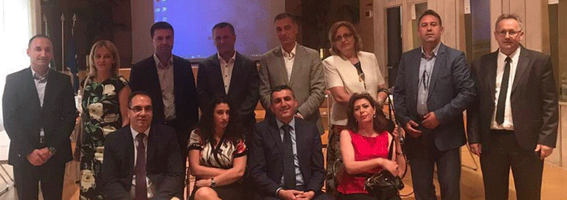

KPC members were for an official visit in Italy

Rome/Italy, 4th of July 2017 – Kosovo Prosecutorial Council led by the Chairman Blerim Isufaj and accompanied by Chief State Prosecutor Aleksandër Lumezi, are paying an official visit in the Supreme Judicial Council in Italy.

The purpose behind this visit is exchanging experiences related to the functioning ways of the Italian Supreme Justice Council. During this visit, there are also taking place meetings with senior representatives of the named Council, and there are being discussed different topics related to appointment, performance evaluation, transfer, promotion and disciplining of Prosecutors.
There is also taking place exchange of experiences regarding the functioning ways of the performance of different Council`s Committees, decision-making and criteria assessment methods applicable for appointments of Presidents of Courts and Chief Prosecutors of Prosecutions.

During their staying in Italy, members of Kosovo Prosecutorial Council will also visit General Prosecution, Supreme Court and a Prosecution of the basic level.

This visit was enabled by the Twinning Project (financed by EU), which is supporting Kosovo Prosecutorial Council.

Activities of the Chairman of Kosovo Prosecutorial Council

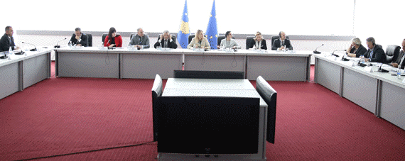

There was held the next meeting of the Rule of Law Joint Coordination Board

Prishtina, 4th of July 2017 – On 11th of May 2017 was held meeting of the Rule of Law Joint Coordination Board. In this meeting has participated and Chairman of Kosovo Prosecutorial Council, Blerim Isufaj.
In this meeting Minister of Justice has presented the package of laws for judiciary, which is being finalized by the Ministry of Justice, and the named package consists: Law on KJC, Law on KPC, Law on State Prosecutor, Law on Disciplinary Liability of Judges and Prosecutors, Law on Courts and, Law on Bar Exam.

As far as Law on Disciplinary Liability of Judges and Prosecutors is concerned, Mr Isufaj has emphasized that it is a good law and in compliance with standards, yet it only needs to take into account the status of the current OPD staff.
Justice Integration in North (KJC) (KPC)
Chairman of KJC and Chairman of KPC have informed the attendees regarding the process of function initiation of the Institutions in north, and they stated that the preparing by KJC and KPC are completed. KPC has provided information that it has submitted a document to the Prime Minister of the country upon which were requested necessary funds for integration of north, however, no respond was received yet. Minister of Justice has expressed her dedication for assisting in terms of the requested funds for KPC, and to have acceleration of the integration process.
Judiciary (KJC, KPC, EULEX and EUSR)
KPC Chairman Blerim Isufaj has emphasized lack of the staff with which KPC is facing, and possibilities for requesting more funds for category of goods and services. Mr Isufaj has also emphasized the KPC need for recruiting Legal Associates, and has requested assistance of all for addressing the need for budgetary increase for KPC.

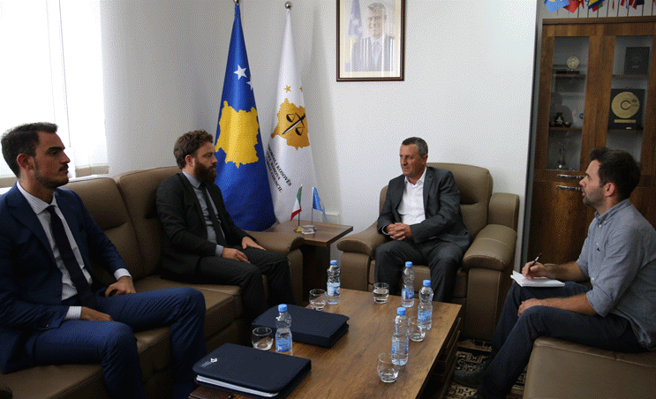

Regional Cooperation in the fight against illicit trade

Prishtina, 19th of July 2017 – Chairman of Kosovo Prosecutorial Council, Blerim Isufaj, has met with representatives of the Siracusa International Institute for Criminal Justice and Human Rights Institution in Italy, Tobias Freeman and Filippo Musca, with whom he has spoken about expanding cooperation in the fight against illicit trade.

At the beginning of this meeting, Chairman Isufaj has spoken about the organizing, role, competencies and work that Kosovo Prosecutorial Council is doing. He said that any cooperation that may increase Rule of Law in Kosova is of huge significance for the prosecutorial system of Kosova.

On the other hand, representatives of the Siracusa International Institute for Criminal Justice and Human Rights Institution in Italy said that this Institute shall launch a new two-year project “Strengthening Fight against the Illicit Trade in South-Eastern Europe”, through a comprehensive scientific study on illicit trade in the 12 countries of the region, including Kosova.

According to them this project aims identification and addressing of specific national needs related to the illicit trade, as well as ensuring a coordinated and harmonized regional approach, through international legal cooperation.

Chairman by appraising the aims of the project has expressed the readiness of the prosecutorial system of Kosova regarding the cooperation in execution of this project, which in his view, in addition to internal effects, the successful execution of the named project would increase more the regional cooperation in the fight against illicit trade.

In this meeting took place and discussions regarding other areas in which prosecutorial system of Kosova may cooperate with the Siracusa International Institute for Criminal Justice and Human Rights Institution in Italy.

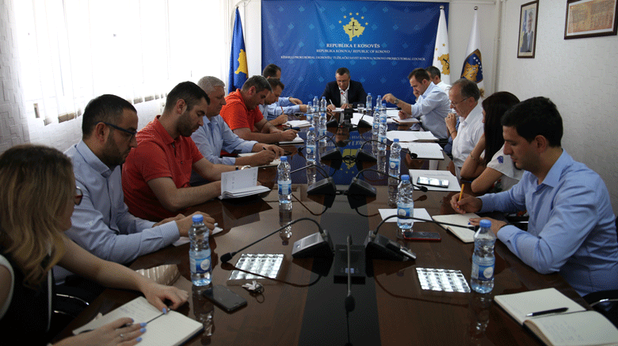

There was discussed the Report of National Auditor

Prishtina, 20th of July 2017 - Chairman of Kosovo Prosecutorial Council (KPC), Blerim Isufaj, and Director of the Secretariat, Lavdim Krasniqi, have held a meeting with Heads of all Units of the KPC Secretariat.

Topic of this meeting was Report of the National Audit regarding Annual Financial Report of Kosovo Prosecutorial Council for 2016, and recommendations deriving from the named report.

In this meeting, Chairman Isufaj has discussed for all items and recommendations the named report consists, whilst he has requested from the staff to engage themselves in meeting all recommendations given by the National Auditor.

He said that although this report does not contain a finding in terms of material violations, yet all given recommendations are of procedural nature, adding that with joint engagement those recommendations will be accomplished.

Activities of Permanent Committees

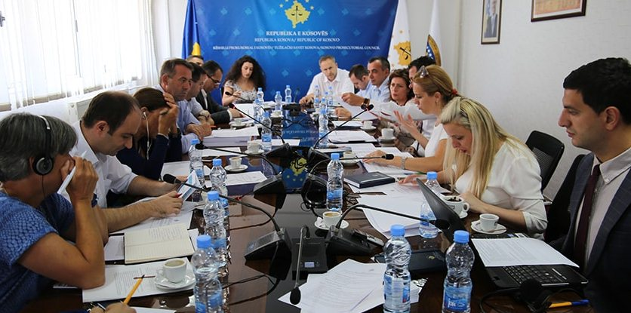

KPC Permanent Committees have held a meeting for analysing bylaws

Prishtina, 14th of July 2017 – Committee for Normative Acts of Kosovo Prosecutorial Council (KPC) has held a joint meeting with permanent Committees of Kosovo Prosecutorial Council.

Item of the agenda of the respective meeting was analysis on harmonization of bylaws of the Council and respective recommendations, as an activity of the Committee for Normative Acts, which is already foreseen by the Action Plan of the Committee for 2017.

Participants in this meeting were Heads and members of the permanent Committees, representatives from administration of the Council, including Director of the Secretariat as well as representatives of American Embassy, EULEX, and Twinning Project.

Initially, Head of the Normative Acts Committee, Bahri Hyseni, has informed the attendees about the analysing process of the bylaws that need to be supplemented and amended, on which occasion he has informed the attendees to give their propositions regarding which acts need to be amended.

Heads of permanent Committees of the Council have appraised this initiative of the Normative Acts Committee, and they also stated they will contribute with their propositions for bylaws they judge need reviewing.

At the end of the meeting, the agreeing in principle was to:

- Carry on with analysing normative acts of Kosovo Prosecutorial Council;
- Every Committee of the Council shall send their concrete propositions regarding eventual amending and supplementing of bylaws no later than at the beginning of September 2017, and they have also agreed that following the propositions of the Committees regarding the amending and supplementing of the bylaws, the Committees shall draft draft-bylaws which shall then be submitted to Prosecutorial Council for approval.

Prosecutors` Performance Evaluation Committee has held its next meeting

Prishtina, 21st of July 2017 – Committee for Prosecutors` Performance Evaluation chaired by Prosecutor Idain Smailji has held its next meeting.

The agenda of this meeting was performance evaluation of Prosecutors assigned on initial mandate.

As already known, the Committee for Prosecutors` Evaluation Unit has competencies regarding the performance evaluation of Prosecutors assigned on initial mandate and regular evaluation of Prosecutors in general, as stipulated by procedures foreseen by Law, Regulations and other bylaws approved by KPC.

Other activities

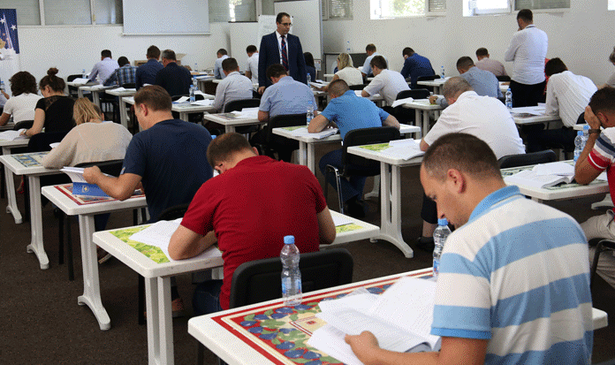

The process for selection of new Prosecutors carries on being in place
Prishtina, 29th of July 2017 – There was held the written exam for candidates for new Prosecutors, who have successfully passed the qualification test.

This process has been monitored by the Recruitment Committee of Kosovo Prosecutorial Council (KPC), and International Observers from OSCE and EULEX.

All candidates who will successfully pass the written exam will have the right to be subjected to the interview, prior to having Kosovo Prosecutorial Council recommend names for new Prosecutors.

The test in written was held in the premises of Kosovo Academy for Public Safety, and the total number of candidates subjected to the named test was 90 candidates.

Activities of the Secretariat of Kosovo Prosecutorial Council

Secretariat of Kosovo Prosecutorial Council (SKPC), during July has executed different activities for the purposes of implementing rules, Regulations and policies related to the management, budget and administration of Prosecutions.
Office of the Director of the Secretariat
During this month, Office of the Director of the Secretariat has conducted different activities within its competencies.
For the purposes of coordinating Units of the Secretariat and accomplishment of objectives, Office of Director within its legal competencies has brought different Decisions, has prepared documents and other bylaws for implementation of rules and policies related to the management of Secretariat and administration of Prosecutions.
Within the activities of the Office of the Director of the Secretariat, Legal Office has prepared Decisions, submissions and other bylaws, and it has also supported KPC Permanent Committees.
Office for Communication with the Public has followed up all activities of KPC, Chief State Prosecutor, KPC Chairman, and activities of Normative Acts Committee, as well as activities of other Units of prosecutorial system, for which it has prepared Press Releases, where the latter were distributed to media and the same were also published on the official websites of KPC and SP. This Office has prepared monitoring of the printed, electronic and visual media on daily basis.
Internal Auditor during July has completed the auditing of the Division for Budget and Finances.
Department for Human Resources, Procurement and Administration
Within this Department, Human Resources have re-announced the vacancy for nine (9) positions and one position announcement, out of which one position was annulled again, whereas the others are in the process.
There was also announced the vacancy for three (3) positions for a limited time period – replacement of the ones on maternity leave.
The internal announcement for promotion in career for the annulled position Head of the Department for Budget, Finances and General Services, took place for the second time, yet no candidate has applied.
Procurement has completed tender procedures for supply of the Office of Chief State Prosecutor; it has opened the bidding for services providing for participants of the trainings that will be organized.
It has selected winning companies for training of the Information Technology staff and, renovation of the Meeting Room of KPC and SP.
Department for Budget, Finances and General Services
Within this Department, Budget and Finances have executed bi-annual reconciliation with Ministry of Finances for all economic categories of the programs of Prosecutorial Council, and there was also reported the progress regarding all capital projects of Prosecutorial Council.
In the Ministry of Finances was submitted the report of financial liabilities of the budgetary organization for June.
In compliance with the legislation in force, there were also checked, committed and spent the received invoices for the system.
General Services have ensured maintenance of the premises through intervention, and have supplied all Prosecutions with expendable materials.
There was also executed the proceeding of cases from E-assets system into the internal procedures management for execution of services and cases.
General Services have carried on with their work on completion of the Project for Vehicles` Management of the prosecutorial system.
Information Technology Department
Information Technology Department has provided all requested services by the Prosecutions` staff regarding the problems they have faced when using IT equipment and electronic systems.
It has separated and installed WAN network from Kosovo Judicial Council throughout all Prosecutions, and it has completed the re-designing of the official website of Kosovo Prosecutorial Council.

Activities of the Prosecutions` Performance Evaluation Unit of Kosovo Prosecutorial Council

Prosecutions` Performance Evaluation Unit (Unit) of Kosovo Prosecutorial Council based on the legal competencies and for the purposes of supporting the Council, during July has conducted different activities.
Office for Prosecutorial Overseeing, Analytics and Vetting
Office for Prosecutorial Overseeing, Analytics and Vetting has supported work of the Committee in charge of selection of new Prosecutors.
It has finalized the list of identified cases for the Evaluation Mission conducted by the European Commission, and it has prepared the draft of the Regulation for Protection of Persona Data.
It has also prepared researches and analysis regarding the requests and needs of prosecutorial system of Kosova, and it has also provided inputs for KPC in drafting the document for the Sectorial Planning of the European Union.
Office for Statistics
Office for Statistics has prepared statistical reports for Prosecutions` performance during the second quarter and first bi-annual period of 2017.
It has integrated/populated statistical data from the kriMKorr database from all Prosecutions, and it has completed statistical reports for characteristic criminal offenses.
For the purposes of transparency, Office for Statistics has prepared different reports and Registries based on the requests of different Non-Governmental Organizations, namely: Kosovo Law Institute, Movement ‘Fol’ and Movement ‘Çohu’.
It has prepared a statistical report regarding types of Court Rulings concerning accusatory instruments employed by Prosecutions, and criminal reports submitted by the Anti-Corruption Agency (ACA), as per the request of ACA Matrix.
Office for Trainings
Office for Trainings within its cooperation with the Academy of Justice and some other Institutions has organized trainings with different topics based on the needs for professional upgrading of Prosecutors and administrative staff.

