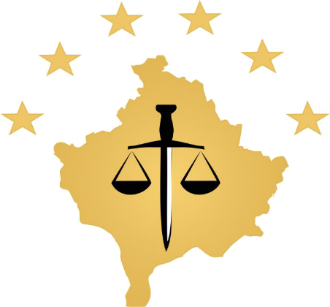

REPUBLIKA E KOSOVES
REPUBLIKA KOSOVO / REPUBLIC OF KOSOVO
KËSHILLI PROKURORIAL I KOSOVËS/ TUŽILAČKI SAVET KOSOVA/KOSOVO PROSECUTORIAL COUNCIL
Activities of Kosovo Prosecutorial Council
December 2017
MONTHLY BULLETIN

Content

1. Activities of Kosovo Prosecutorial Council 3
The hundred and forty-forth meeting of the Kosovo Prosecutorial Council was held 3
Meeting of the Joint Rule of law Coordination Board was held 4
The KPC Work Plan for 2018 is drafted 6
Chairman Isufaj: Digitalization of prosecution offices will raise efficiency, accountability and transparency 7
The one hundred and forty fifth meeting of the Kosovo Prosecutorial Council was held 9
Chairman Isufaj has presented the activities carried out during 2017 by the Kosovo Prosecutorial Council 11
2. Aktivitetët e Kryesuesit të KPK-së 19
Chairman Isufaj visited the Basic Prosecution of Mitrovica 21
3. Aktivitetet e Komisioneve të Përhershme 22
The Commission on Normative Issues held the next meeting 22
The Commission for Administration of Prosecutions has held a meeting with offices of the registry leaders 23
4. Aktivitetet tjera 24
5. Activities of the Secretariat of Kosovo Prosecutorial Councils 26
6. Activities of the Prosecutions` Performance Evaluation Unit of Kosovo Prosecutorial Council 28

Activities of Kosovo Prosecutorial Council
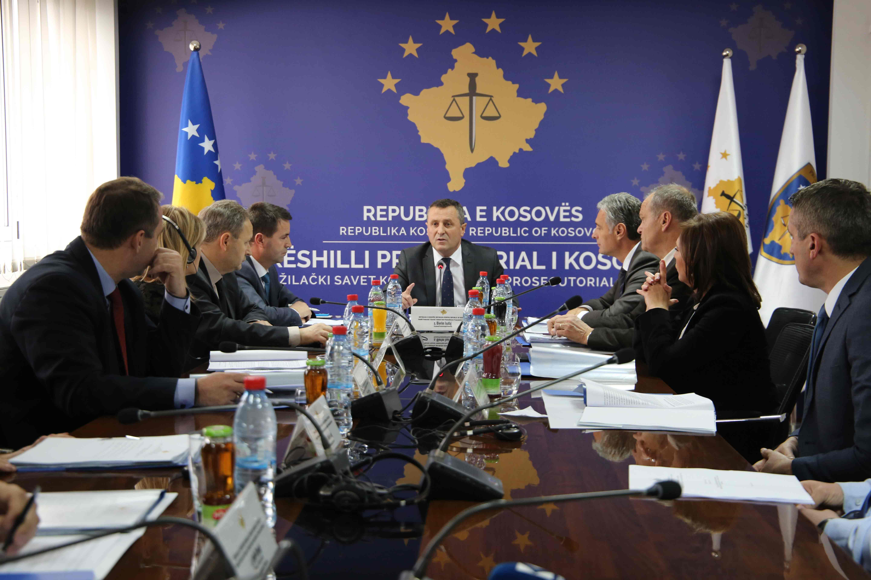

The hundred and forty-forth meeting of the Kosovo Prosecutorial Council was held

Prishtina, 04 December 2017 - The hundred and forty-forth meeting of the Kosovo Prosecutorial Council (KPC) was held, led by the Chairman of the Prosecutorial Council, Blerim Isufaj.

During this meeting the National Coordinator for Combating Economic Crime, Shqipdon Fazliu, has reported for the period of July-September 2017, report which was reviewed and approved by KPC members.

Also, KPC members discussed about the USAID Memorandum, where it was recommended to the Kosovo Prosecutorial Council to appoint 7 officers for referral of cases to the mediation procedure in the Kosovo Basic Prosecution Offices.

KPC members rejected the proposal of prosecutor Arben Ismajli for handling the request of two prosecutors for permanent transfer.

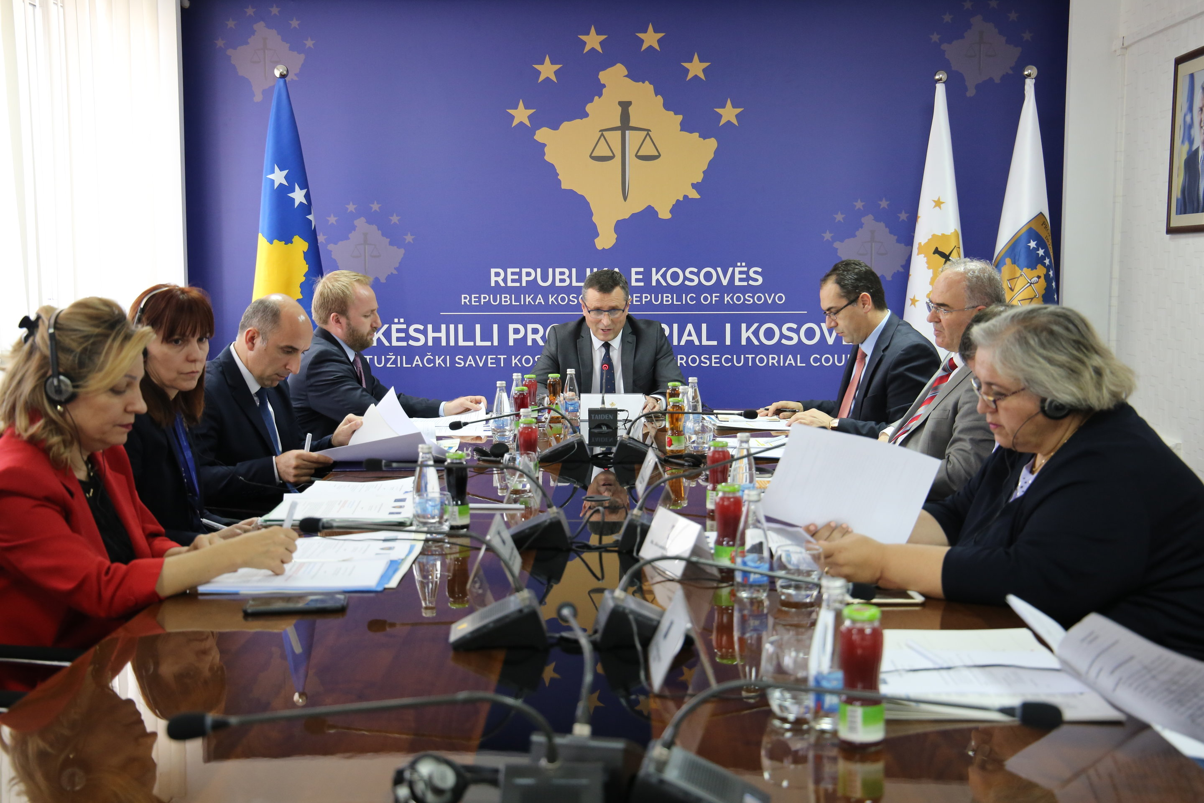

Meeting of the Joint Rule of law Coordination Board was held

Pristina, 12 December 2017 - Today, the Joint Rule of Law Coordination Board held its regular meeting that was organized for the first time by the Kosovo Prosecutorial Council (KPC) and chaired by the Chair of the KPC, Mr. Blerim Isufaj.

Minister of Justice (MoJ), Abelard Tahiri, together with the Chair of the Kosovo Judicial Council (KJC) Nehat Idrizi, the Head of the EU Office/EUSR, Nataliya Apostolova and Head of EULEX Mission in Kosovo Alexandra Papadopoulou attended the meeting.
Chairman Isufaj welcomed the JRCB meeting and considered the Board to be a mechanism that provides the opportunity to discuss about the challenges of the justice system, as well as providing opportunities for their solution including monitoring and checking efforts towards these solutions. He said the Board was important because it brings together the key stakeholders from local and international rule of law institutions. Chairman Isufaj once again reiterated his commitment and the commitment of the KPC to continued and further cooperation with all local and international partners from justice system institutions for the purpose of enhancing the efficiency, transparency and accountability of this system.

In the capacity of the chairman of this meeting and as this was the last meeting held by the Board this year, Chairman Isufaj presented a summary of key points discussed in the meetings of the Board held in 2017 and progress made.

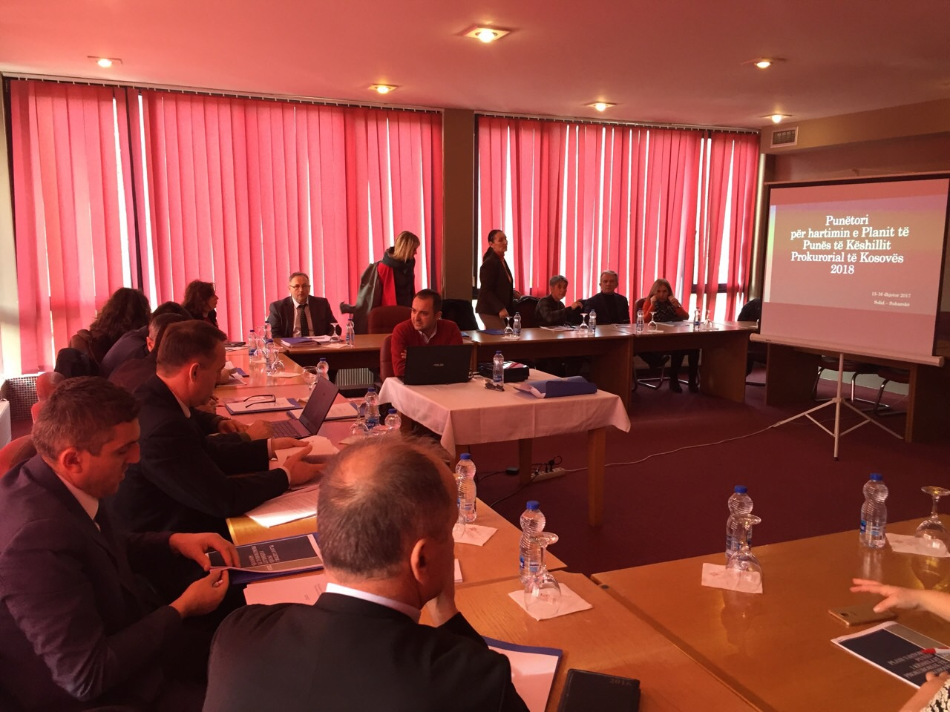

The KPC Work Plan for 2018 is drafted

Pristina, December 18, 2017 - Members of the Kosovo Prosecutorial Council in an organized workshop have drafted the Work Plan of the Kosovo Prosecutorial Council for 2018.

During the drafting of the Work Plan for 2018, KPC members have set objectives, goals and action plan for the realization of the Kosovo Prosecutorial Council's work during 2018.

In the work plan for 2018, KPC members have prioritized the establishment of administration, oversight, efficiency and transparency enhancement in Kosovo's prosecutorial system.

KPC's Work Plan will be submitted for approval at the next meeting of the Kosovo Prosecutorial Council.

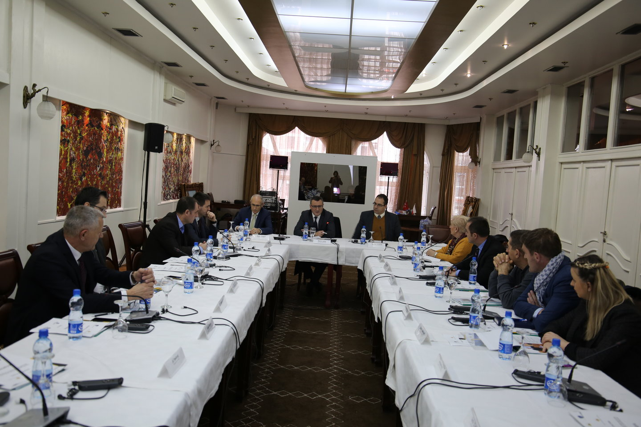

Chairman Isufaj: Digitalization of prosecution offices will raise efficiency, accountability and transparency

Pristina, December 20, 2017 - The Kosovo Prosecutorial Council (KPC) in cooperation with the TIK / SMIL Project has organized a working table on the topic "Information Management System (SMIL) for the prosecutor".
The purpose of this roundtable was to notify SMIL activities, its general concepts, the criteria for the allocation of subjects automatically, the SMIL liaison with other systems of law enforcement institutions.
The KPC Chairman, Director of the Secretariat, Chief Prosecutors, Prosecutors and Administrators of Prosecutions of Republic of Kosovo participated in this round table.
The Chairman of KPC Blerim Isufaj, spoke about the project, who said in front of the participants that the digitization of prosecution offices is one of the objectives of the Kosovo Prosecutorial Council, as it will increase the efficiency, accountability and transparency.

Chairman Isufaj speaking about the importance of the SMIL Project said that the successful implementation of this project means a general success of the prosecutorial system, but not only that, according to him, it also means increasing the citizens' credibility in the work of the prosecutorial system.
The participants discussed the case allocation system, with particular focus on the criteria for their separation. During this workshop was presented the prototype of the system - SMIL for the prosecution offices.

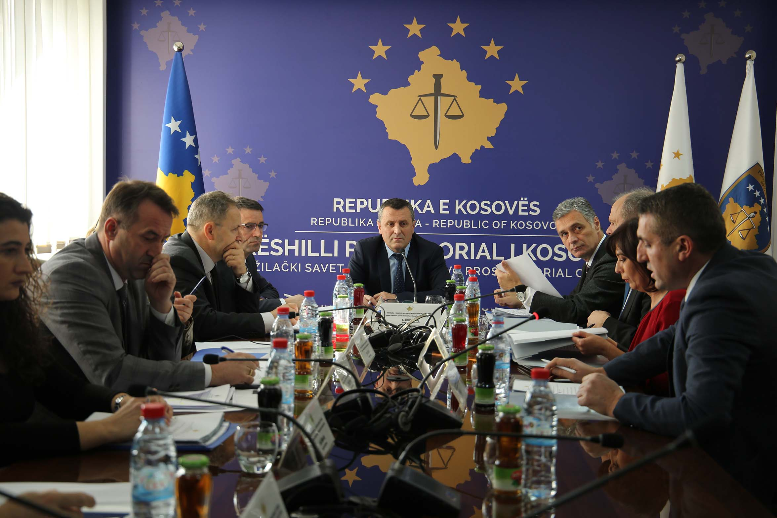

The one hundred and forty fifth meeting of the Kosovo Prosecutorial Council was held

Pristina, December 26, 2017 - The one hundred and forty fifth meeting of the Kosovo Prosecutorial Council (KPC) was held today and which is the last one for this year, led by the Chairman of the Kosovo Prosecutorial Council, Blerim Isufaj.
During this meeting, members of the KPC have reviewed and approved the Report of the Oversight Committee on the implementation of the strategic plan and action plan in combating corruption and economic crimes 2016 - 2018 for the period January - September 2017.

The Chairman of the Prosecutorial Council, Blerim Isufaj, in front of the members of the Council presented the work plan of KPC for 2018, a plan containing the introductory part describing the mandate and organizational structure of the Prosecutorial Council, with particular emphasis on the vision and his mission. Also, Isufaj said that this plan sets the objectives of the Council for 2018, which are specific measurable and achievable. The plan includes the objectives and activities of the Secretariat of the Council and the Prosecution Performance Evaluation Unit (PPEU), pointing out that the plan concretizes objectives through activities, indicators, responsible bodies and timeframes.

Today, KPC members have reviewed and approved the Communication Strategy of the Kosovo Prosecutorial System, which is a new initiative and effort to improve the quality of communication of the prosecutorial system of the Republic of Kosovo, encouraging participation and information of citizens, and increasing accountability and transparency for public opinion.
Members approved the list of prosecutors to be evaluated during 2018.
Prosecutor Bahri Hyseni, reported today on the implementation of the recommendations of the Prosecutorial Council, as the supervisor of these recommendations.
KPC members reviewed and approved the list of candidates proposed for state prosecutors.
The final point of the agenda was the reports of the Performance Evaluation Commission for 12 and 23 state prosecutors.

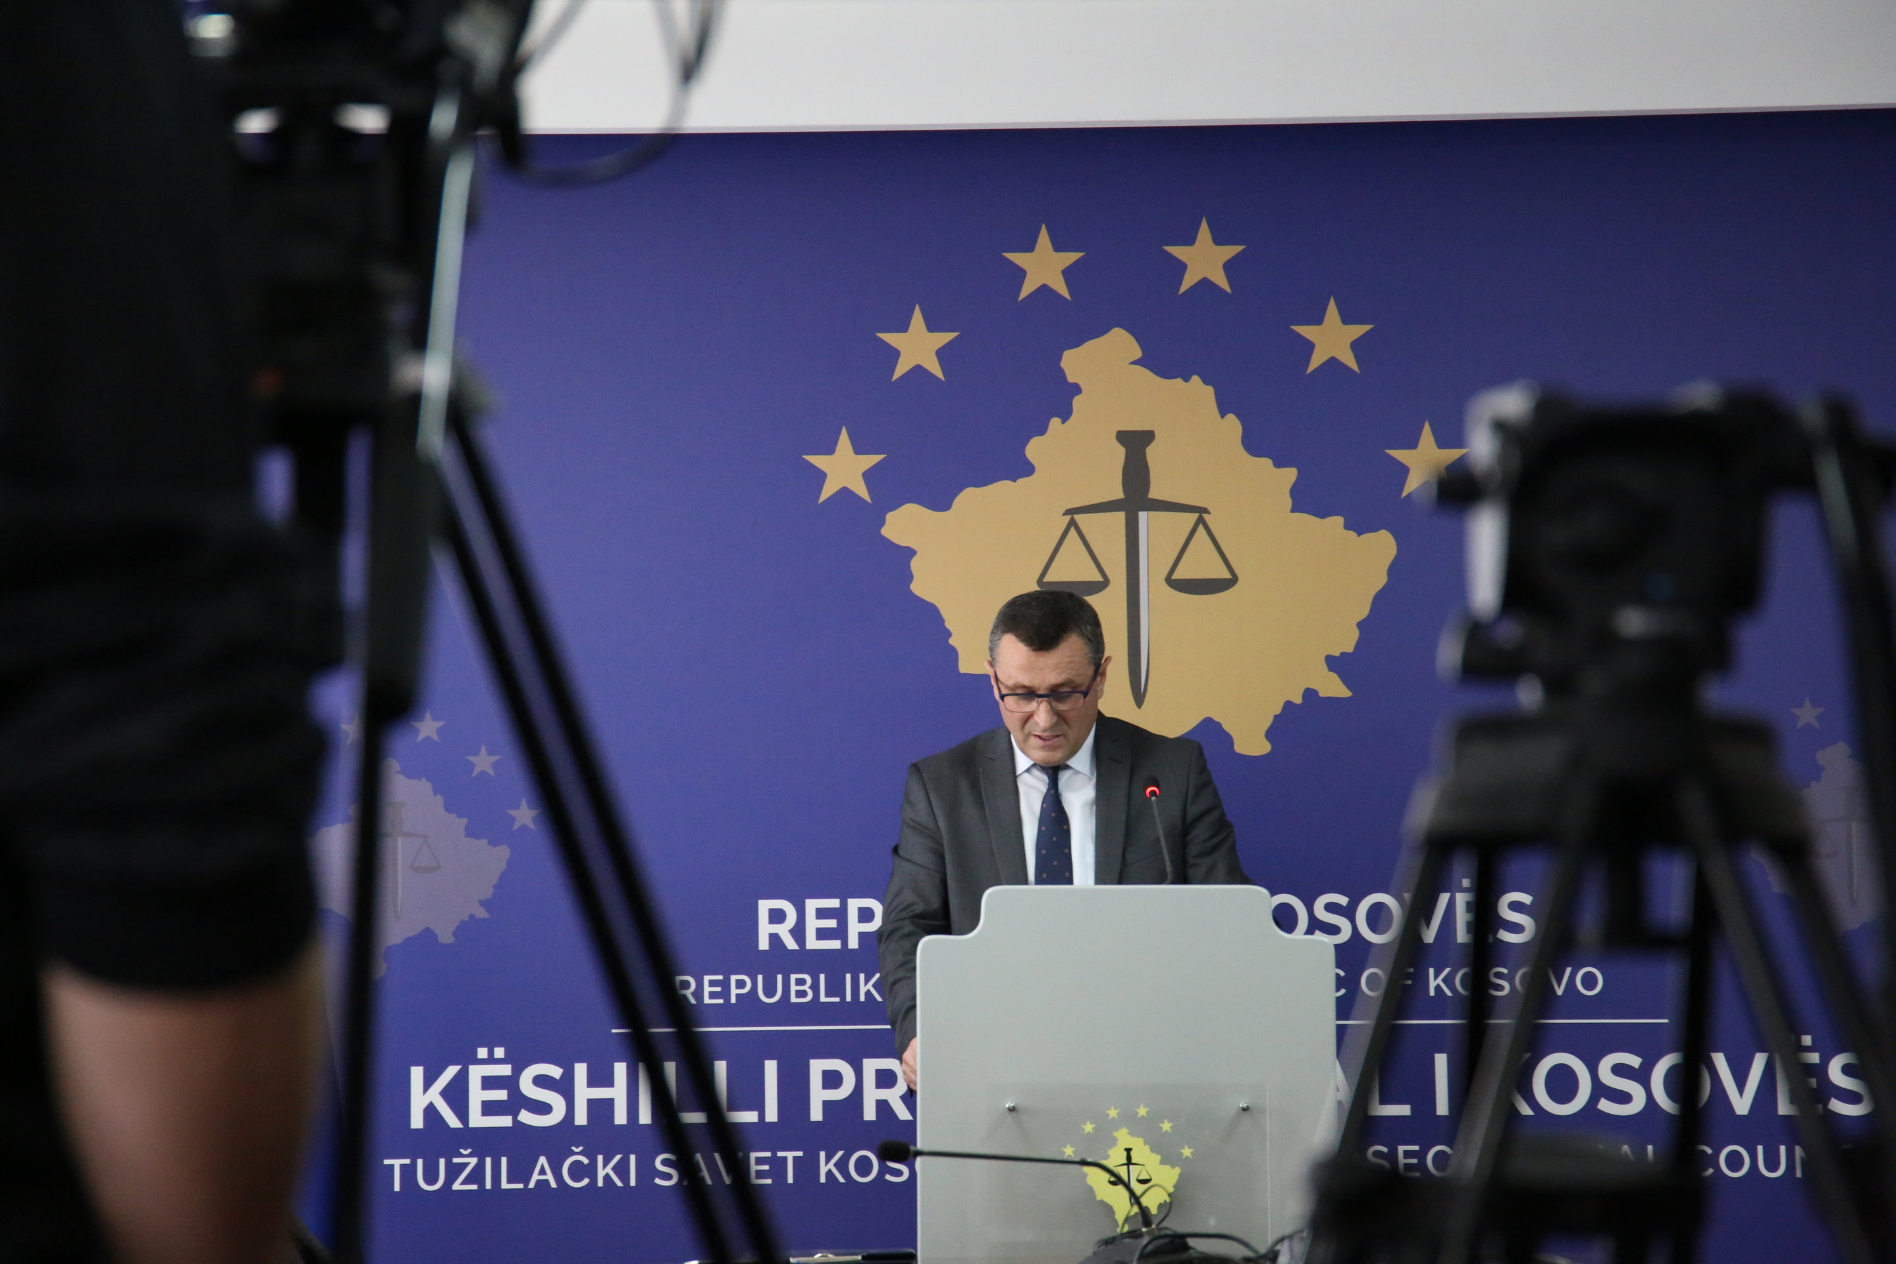

Chairman Isufaj has presented the activities carried out during 2017 by the Kosovo Prosecutorial Council

Pristina, 27 December 2017 - The Head of Kosovo Prosecutorial Council, Blerim Isufaj, at the annual press conference held today, has presented the activities carried out during 2017 by the Kosovo Prosecutorial Council.
In the report presented to the media, Chairman Isufaj said: "Honorable representatives of the media, honorable members of the Prosecutorial Council, honorable participants, welcome to the last conference of the year organized by the Kosovo Prosecutorial Council where it will be reflected the Council's one-year work, the outcomes and challenges we faced during the year that we are leaving behind.
- Legal basis - composition of KPC
Kosovo Prosecutorial Council is an independent institution and its mandate is defined by constitution and by law.
The council consists of thirteen (13) members, ten (10) of them prosecutors, three non-prosecutors.
During the year we are leaving behind the Council functioned with 10 members, while despite our efforts we have not yet fulfilled the three non - prosecutor members.
During 2017, all Council commissions were functional and they acted according to a pre-determined planning.
- Mandate
The core mandate of the Council is the recruitment of prosecutors and their proposal for appointment and reappointment, evaluation, promotion, transfer, discipline, provision of support for the training of prosecutors. The Council also manages the annual budget for the Council and Prosecutions independently and is responsible for overseeing expenditures, allocating funds, maintaining accurate accounts and financial audits.
As you may know, the Council is chaired by the Chairman who is elected from the Council of Prosecutors and according to his / her mandate, the Chairman of the Council submits at least once in year the reports on the performance, actions, costs and budgetary needs of the prosecutorial system .
Based on this mandate, I am pleased to present to public the report on annual activities of the Council.
- KPC's main activities for 2017
Based on the legal competencies and based on the work plan set for 2017, the Council has succeeded in successfully completing several important processes for further advancement of the prosecutorial system.
The Prosecutorial Council has held 19 meetings during 2017, one of which was a joint meeting with the Kosovo Judicial Council.
Among the successes and main tasks accomplished by the Council are the following:

- Approval of sub-legal acts
During 2017, the Council has managed to draft and approve all sub-legal acts as follows:
- Regulation No.01 / 2017 on amending and supplementing Regulation No.09.2015, on the Election of the Chairman and the Deputy Chairman of the Council;
- Regulation No.02 / 2017 amending and supplementing the Regulation No.03.2016, on the Role and Activities of the TIK-SMIL Project Management Board;
- Regulation No.03 / 2017 on the Commission for Administration of Prosecutions;
- Regulation No. 04/2017 on Classification of Information of the Prosecutorial System of the Republic of Kosovo;
- Regulation No. 05/2017 on Budget, Finance and Personnel Commission;
- Regulation No. 06/2017 on Amending and Supplementing Regulation No.02.2015 on Election of KPC Members.
With the adoption of these regulations, the by-law framework of the prosecutorial system was continuously supplemented, depending on the needs and mandate of the Council.
I would like to emphasize the fact that this entire sub-legal framework has been drafted with the capacity of the prosecutorial system and in support of our international partners.
- Recruitment of the new prosecutors
After a needs analysis, the Prosecutorial Council, on March 29, 2017, issued a decision on the vacancy announcement of new additional prosecutors in all Basic Prosecutions of the Republic of Kosovo.
The competition was open from 04 April to 19 April 2017. In the competitive process, 190 candidates applied for prosecutors.
Following the completion of the recruitment process, the Recruitment Committee established by the Prosecutorial Council has selected 21 candidates for prosecutors who the Council will propose for decree to the President. It is planned they to start with the initial training during January 2018. Moreover, the Prosecutorial Council plans to start the recruitment process of the new 10 prosecutors over the next year, which will complete the vacant positions and positions of prosecutors who retire next year. With the recruitment of these prosecutors, the Council will complete the number of prosecutors needed for the prosecutorial system.
- The integration process in the north
During this year, the integration of 13 prosecutors and 32 administrative officials of the non-majority community have been successfully implemented under the Brussels Law on Justice. On this occasion, the Basic Prosecution in Mitrovica has been placed in a new facility and all prosecutors and administrative staff have begun work. This process has marked the beginning of normal work of this prosecutor's office, which since 2008 worked in very difficult conditions..
- Advancement and transfer of prosecutors
During 2017, the Prosecutorial Council has conducted two processes of transfer and advancement of prosecutors depending on the actual needs and capacities of the system.
In the first process were included 6 Prosecutors, 3 of them were transferred from the General Department to Serious Crimes Department of the Basic Prosecution of Pristina and 3 other prosecutors to the Special Prosecution Office of the Republic of Kosovo. While in the second process, 2 prosecutors have been advanced in the Special Prosecution Office of the Republic of Kosovo
As a result, the Special Prosecution of the Republic of Kosovo during 2017 received 5 additional prosecutors. In order to fulfill the capacities of this prosecution, the Council and the State Prosecutor have supported the initiative for amending the Law on State Prosecutor and we hope that this law will pass soon so that the Special Prosecution will have the necessary number of prosecutors. During 2017, the Council supported this prosecution with administrative staff by recruiting them with priority.
- Disciplining Prosecutors
Regarding the discipline of prosecutors, I can emphasize that in 2017 the Council has received 6 new cases, and has reviewed 14 cases, including those inherited. After an intensive work of the Disciplinary Committee, the Council has verified the following measures:
- Reprimand with order for undertaking corrective actions
- Temporary wage reduction in thirty percent (30%) for the period of 3 (three) months
Whereas, the Disciplinary Committee of the Council has taken the following decisions:
- 7 Decisions - Termination of disciplinary proceedings (5 because the prosecutor is no longer in the prosecutorial system) and (2 due to the limitary statutory of disciplinary proceedings).
- 2 Refusal of the suspension / resigned from the duty of the prosecutor after a disciplinary review has been ordered.
- 1 temporary wage cuts in thirty percent (30%) for a period of three months.
- 1 temporary wage reduction in twenty percent (20%), for the 6-month period.
- 1 temporary wage cut in twenty percent (20%) for a period of three months.
- 1 suspension without pay.

- ProsecutorsPerformance Assessment
Through the Performance Evaluation Commission, the Council during 2017, evaluated 33 permanent prosecutors, including chief prosecutors. Likewise, the Commission assessed 48 prosecutors within the initial mandate, with the evaluation of which the fulfillment of the objective of the annual plan of the committee was exceeded. (The annual plan foresaw the evaluation for 61 prosecutors, while 81 prosecutors were evaluated; respectively the annual plan was for 32.79% exceeded.
- Efficiency in dealing with cases of corruption and economic crime
In order to increase efficiency in dealing with cases of corruption and economic crime, this year, the Council implemented a specific strategic plan and monitored the work of the Corruption and Economic Crime Unit within the Pristina Basic Prosecution Office.
The current reports show a significant efficiency in dealing with corruption cases by this unit, but the details will be referred to in the State Prosecutor's annual report, which will be presented early next year because statistics for the last three months year have not been reported yet.
Right now we can present the current trend of the efficiency of Corruption and Economic Crime case resolution.
- Corruption:
Out of 381 criminal reports received (January-September 2017) 321 criminal reports or 84.25% were processed (solved), while out of 630 persons in the criminal reports received (January-September 2017) there were processed (resolved) 681 cases per person or 108.10 %.
- Economic Crimes:
Out of 374 criminal reports received (January-September 2017) 362 criminal reports or 96.79% were processed (solved), while out of 506 persons in criminal reports received (January-September 2017) there were processed (solved) 495 cases per person or 97.83 %.

- Secretariat of the Prosecutorial Council
During this year the Council Secretariat has implemented the reform of internal organizational structures and systematization of jobs in the Secretariat of the Kosovo Prosecutorial Council. The drafting of standard operating procedures for the organizational units of the Secretariat was done and work plans for 2018 of the Departments, Divisions and Offices of SPC were done too.
During this year, the Secretariat has managed to fulfill 21 positions of administrative staff, which remained vacant for various reasons in the Kosovo Prosecutions as: referents, translation officers, legal officers, budget and finance officers, and professional associates, Head of Public Communication, Head of Department of Budget Finance and General Services, Head of Procurement Division. Also, during this year, 128 interns were taken at all levels of prosecution offices.
In this year, the Council has paid constant attention to the provision and improvement of physical infrastructure, information technology and communication in the prosecutorial system during 2017, with the aim of providing optimal conditions for the work of prosecutors and support personnel.
In this regard, during this year it was possible to accommodate the staff of the Basic Prosecution Office of Mitrovica in the new facility, accommodated the staff of the Special Prosecution Office of the Republic of Kosovo in the facility designated for this prosecution and some interventions were made in the facility of the Basic Prosecution in Gjilan.
Regarding information technology during 2017, the following activities were conducted:
- Within the Project Case Management Information System in prosecutions, so far have been completed two phases of the development of this system, and we are currently in the third stage of development which includes the management of all cases of major perpetrators for all Prosecutions.
- Also, three (3) cooperation agreements have been signed for the interconnection of electronic systems in order to transfer the data electronically.
- The Data Center is built at the Palace of Justice, according to the contemporary standards for server rooms. This data center will enable all electronic systems to be accessible to prosecution staff.
- An electronic vehicle management system has been developed, enabling the recording of all data on cars and as a result of this we will have a more efficient use and economy of vehicle expenditures;
- There is also an electronic system for managing prosecutors' files. Through this system will be managed processes such as: recruitment of prosecutors, performance evaluation, advancement, transfer, training and disciplinary cases.

- Prosecution Performance Review Unit

During 2017, the Performance Unit had carried out various activities in support of Commission for Performance Evaluation of Prosecutors, Commission for Recruitment of Prosecutors and the Commission for Administration of Prosecutions.
This unit has managed to complete all planned activities and draft all reports on the State Prosecutor's performance, Tracking Mechanism Report, and various reports in the prosecution performance. Also, through the training office, coordination of the implementation of various trainings for prosecutors and administrative personnel of the prosecutorial system was achieved.
- Local and international cooperation
Regarding local and international co-operation, the Council has continued its open and professional co-operation policy with all local and international institutions.
Among the local institutions I would emphasize; Kosovo Judicial Council, Kosovo Academy of Justice, Kosovo Assembly, Government of Kosovo, Ministry of Justice, Ministry of Finance, Kosovo Chamber of Advocates, Kosovo Police, etc.
While among institutions, donors and international partners, I would like to emphasize the cooperation with the US Embassy, ​​the EU Office in Pristina, which funds various projects, UNDP and other agencies of the United Nations, the Government of Norway, EULEX, The Council of Europe, IRZ, GIZ, etc.
An important part of the cooperation has also been expressed in the European integration processes where all Council capacities have responded at any time to the reporting requirements.
- Strategic Plan and Action Plan
Regarding the implementation of the strategic plan, we can say that the objectives that were foreseen to be fulfilled during 2017 in the Action Plan of Strategic Plan have been met. For the purpose of overseeing the implementation of the strategic plan, the working group established by the Council has drawn up periodic reports on the level of implementation of the strategic plan.
- Public Communication (public communication strategy, brochures, web site, reports)
As foreseen by law, sub-legal acts and the Council's Strategic Plan, during 2017 we have developed an efficient communication by being transparent and open to public and media.
We have held open meetings for public and media; we have provided information of interest to the public through press releases, announcements, clarifications, sometimes feedbacks, brochures, monthly newsletters and official websites.
In order to increase transparency, the official website of the Council has been re-designed in which the information range for KPC has been added and has been constantly updated with relevant information and in the public interest.
Finally, we have adopted the Communications Strategy of the prosecutorial system for the period 2018-2021. This strategy has been drafted in cooperation with international partners, Association of Kosovo Journalists and civil society. This strategy, which will begin to be implemented in early 2018, has foreseen the increase of the human capacities of the Kosovo prosecutorial system in the field of public and media communication.
In 2018, recruitment and selection of media officers will be done in all Prosecutions of Kosovo in order to increase the efficiency of communication and greater transparency towards the public.
- Capacity building / training
The Council, in cooperation with the Office of the Chief State Prosecutor, has managed to coordinate and support the capacity building of prosecutors and staff during 2017. In cooperation with the Academy of Justice and other local and international partners, various training programs have been organized based on the needs of the prosecutorial system.
We have drafted and addressed policies for continuous training of prosecutors and staffs, while we have collaborated with the Academy of Justice for the initial training, where the 25 appointed prosecutors at the end of 2016 this month complete the initial training and in January 2018 begin to be charged with cases.
- Challenges
During our activity for 2017 besides the achievements we had different challenges as well. I would like to emphasize the main challenges we faced are the following:
- Insufficient budget to cover a number of obligations, especially those for experts and lawyers engaged ex officio. In this regard, the Council, through a budget request for 2017, requested a budget of about 13 million euros (13,775,252.00) while the approved budget was about 9 million euros (9,483,682.00). Because of this budget it was difficult to realize some of the planned objectives.
- Small number of staff, especially professional ones, was a real challenge.
- Specialization of prosecutors for dealing with characteristic crimes (corruption, organized crime, economic crime).
- Advancing communication with media and public.
- Building an electronic case management system (TIK/ SMIL project).
- Physical Infrastructure (expansion of premises for the Council and the Office of the Chief State Prosecutor).
We, as a Prosecutorial Council, have seriously addressed these challenges by sending numerous and well-argued budget requests to the Ministry of Finance, the Government and the Assembly.
As a result, with the 2018 Budget Law more promising budget has been adopted and 148 positions as well (the majority professional ones) which will have a serious impact on improving the prosecutorial system's services.
- Planning the work of the Prosecutorial Council for 2018
I would like to inform you that Prosecutorial Council has finalized the annual work plan for 2018 and it is planned to include there the activities foreseen by the legal mandate, the Strategic Plan 2016 - 2018 and the requirements deriving from the European integration process.
Finally, I would like to inform you that in accordance with the Law, in early 2018, the Council will publish the work report for 2017 and make it accessible on the Council's official website and in hard copy.
I thank the media for the cooperation we had this year, wish you a Happy New Year and once again express my and Council’s readiness for further advancing our cooperation in the future.

Aktivitetët e Kryesuesit të KPK-së

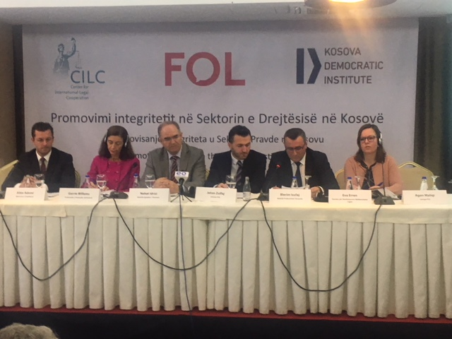
Isufaj: Media and civil society to be partners in strengthening the efficiency and professionalism of the justice system

Pristina, December 14, 2017 - Kosovo Prosecutorial Council Chairman, Blerim Isufaj, today participated in the presentation of the research " Scanning Integrity in the Justice Sector", conducted by CILC, FOL and KDI.

In his speech to the participants, the chairman Isufaj said that "this research will be a good base for the KPC to undertake the necessary actions in strengthening the integrity of the prosecutorial system.

Given that corruption in the prosecutorial system - whether real or perceived - presents a serious threat and undermines enormously public confidence in the justice system, we are very much interested in having civil society as partners in this regard. This is because KPC is very committed to zero tolerance of unethical and improper behaviors within the prosecutorial system said chairman Isufaj.

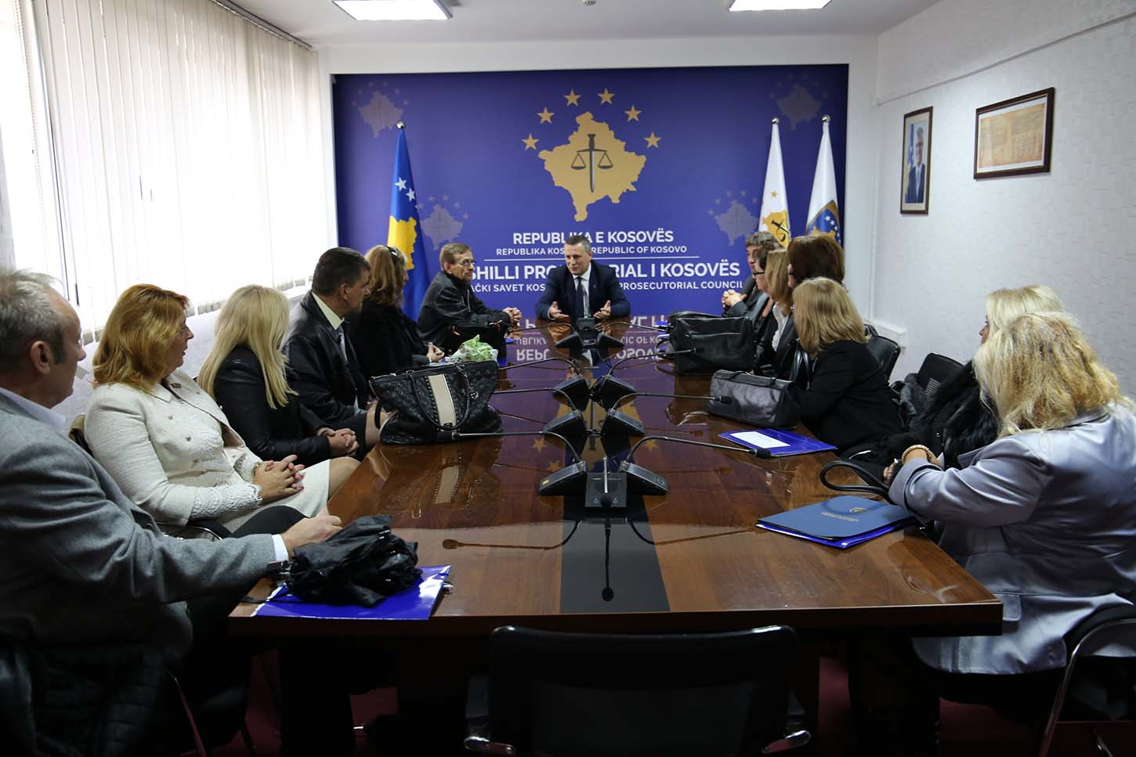

Chairman Isufaj visited the Basic Prosecution of Mitrovica

Mitrovica, 28th December 2017 - Chairman of Kosovo Prosecutorial Council, Blerim Isufaj and the Secretariat Director Lavdim Krasniqi visited the Basic Prosecution of Mitrovica today where they met with Chief Prosecutor Shyqyri Syla and prosecutors of the two communities of this prosecution.
This visit, which was conducted after the integration of Kosovo's prosecutorial system in north Mitrovica, aimed at being closely informed with the prosecution's work, conditions, goals and challenges.

On this occasion, the chairman Isufaj said that Kosovo Prosecutorial Council is committed to creating conditions for work in the Basic Prosecution of Mitrovica, but according to him, will also follow the results of this prosecution.
The Chairman Isufaj also said that Kosovo Prosecutorial Council will continue to work on creation of all conditions for Kosovo Prosecutions in order to increase efficiency in the fight against crime, corruption and other phenomena against law.

Aktivitetet e Komisioneve të Përhershme

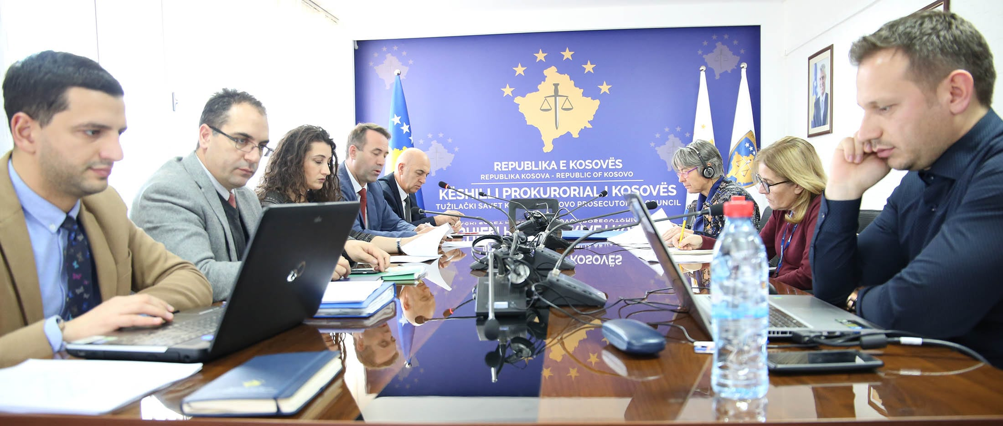

The Commission on Normative Issues held the next meeting

Pristina, 6 December 2017 - The Committee on Normative Issues of the Kosovo Prosecutorial Council, held the next meeting where they discussed the Regulation No. 06/2017 on the use of TIK in the prosecutorial system
This meeting was attended by members of the Commission, representatives of EULEX, Twinning project, and representatives from the administration of Council
The Chairman of the Commission initially informed the participants with the draft of this regulation, citing its purpose, which has to do with the definition of the rules for use of Information Technology throughout the prosecutorial system. This regulation will be implemented by all employees in the prosecutorial system including prosecutors and administrative staff.
The draft Regulation was discussed by the participants article by article and after reviewing all articles, at the end, the members of the Commission unanimously decided this regulation to be proposed to the Prosecutorial Council for approval, in one of the next meetings.

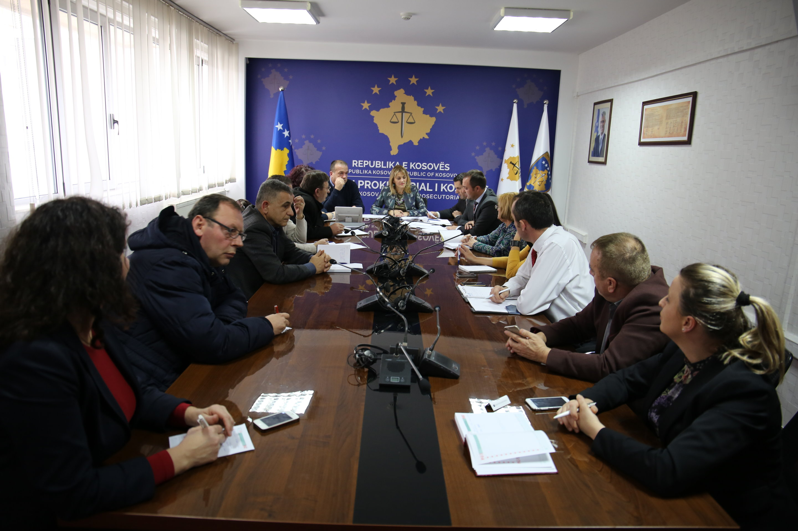

The Commission for Administration of Prosecutions has held a meeting with offices of the registry leaders

Pristina, 19 December 2017 - The Commission for the Administration of Prosecutions held a meeting with the administrators and chiefs of the registry offices of all prosecutions.
This meeting was chaired by the chairperson of this commission, member of the Kosovo Prosecutorial Council - Prosecutor Radica Milic, and was intended to inform the commission on preparing the 2018 work plan by presenting challenges in registry offices of the prosecution offices and proposals for overcoming them.
During this meeting was discussed about evidences of movement of cases, receipt and delivery of mail and the work plans of the registry offices.
Also, the handling of cases by prosecutors, statistical data, security of materials needed for the work and the challenges faced by the registry offices were addressed
.

Aktivitetet tjera
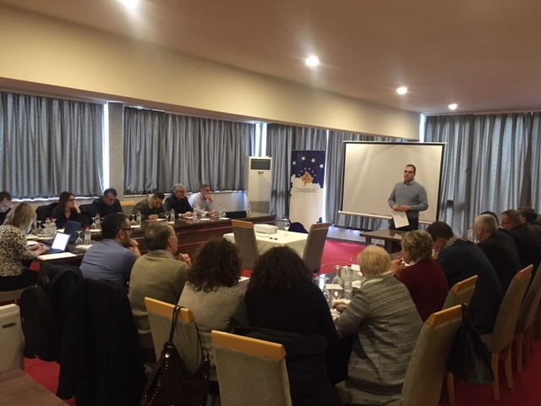

Roundtable discussion about planning for year 2018

Pristina, 22 December 2017 - The Secretariat of the Kosovo Prosecutorial Council has organized a round table on "Planning of Works for 2018"
KPC Secretariat units, Prosecution Performance Review Unit, Office for Victim Advocacy and Assistance and Administrators from prosecutors' offices participated in this round table.
During the roundtable discussion was worked on drafting works plans, which foresees personnel planning, preparation of prosecutions’ organograms, description of work processes, definition of activities and deadlines for management of the prosecutorial system administration.
Finally, the participants presented the planned plans and after the discussions and recommendations given, the work plans of all organizational units of the prosecutorial system were finalized

Activities of the Secretariat of Kosovo Prosecutorial Councils

Secretariat of Kosovo Prosecutorial Council (SKPC), during month of November has executed different activities, with the purposes of implementing rules, regulations and policies related to the management, budget and administration of prosecution offices

Office of the Director of the Secretariat
Office of the Director of the Secretariat with the purposes of coordinating the Secretariat units and meet the objectives, within its legal competencies has taken different decisions, has prepared documents and other bylaws for implementation of rules and policies related to the management of Secretariat and administration of Prosecution.
Legal Office has prepared decisions, documents and sub-legal acts, and has supported the permanent KPC commissions.
The Public Communications Office has followed the activities of the KPC, of the Chairman, of the KPC commissions and other units of the prosecutorial system, whereby has prepared communications which it has issued for media and published on the website of the KPC.
Internal Auditor during month of December has worked on the audit of the Special Prosecution Office of the Republic of Kosovo.

Department for Human Resources, Procurement and Administration
Within this department, human resources have completed the selection process for positions: Legal Officer in the Basic Prosecution Office in Pristina, and Translation Officer in the Secretariat of Kosovo Prosecutorial Council. Have also completed the personnel planning for 2018.
Procurement during this month according to planning has signed the following contract: "Supply with Circulation Pump for Central Heating for Heating Needs of the Kosovo Prosecutorial Council", "Supply with Pellets for Basic Prosecutor in Mitrovica" and "Supply with two photocopies for Kosovo Prosecutorial System ".

Department for Budget, Finances and General Services
Within this department, the budget and finances have sent to the Treasury of the Ministry of Finance the report of obligations for November.
In addition, all the cases that were available for payment were processed for payment.
General Services have taken care of the maintenance of facilities through interventions and have supplied all prosecution offices with expendable materials.
Information Technology Department
Information Technology Department has provided all requested services by the Prosecutions’ staff.

The Electronic System for Management of Prosecutors Files was developed and implemented. Through this system, processes from recruitment of prosecutors, performance appraisal, promotion, transfer, training and disciplinary cases are managed.

A cooperation agreement was signed between the Kosovo Prosecutorial Council and the Kosovo Judicial Council for the joint use of the Data Center at the location of the Palace of Justice.

The second phase of the development of a case management information system has been completed in the prosecution. Within this phase is foreseen the development of the prototype of the system.

The Work Plan for 2018 of the TIK / SMIL Project has been prepared.

Activities of the Prosecutions` Performance Evaluation Unit of Kosovo Prosecutorial Council

The Prosecutorial Performance Review Unit (Unit) of the Kosovo Prosecutorial Council, based on the legal competencies in support of the Council, developed various activities during December.
Office for Prosecutorial Overseeing, Analytics and Vetting
The Office for Oversight, Analytical and Prosecutorial Verification has the preparation of 21 decisions on the proposal of candidates for prosecutors to be decreed from the President and all other procedures foreseen for the decree of the above-mentioned 21 prosecutors.
This office has also drafted a final report on the performance assessment of the 12 original prosecutors.
Office for Statistics
The Office for Statistics has prepared all forms of statistical reports for all characteristic criminal offenses, as follows: Weapons, Drugs / Narcotics, Trafficking in Human Beings, Economic Crimes, Organized Crime, Migrant Smuggling, Corruption and Corruption by Procurement, Money Laundering and Encouraging Hate.
It has prepared reports with statistical data on civil society organizations on the basis of their requests and relying on legal competences.
Office for Trainings

Training Office prepared the policy proposal for professional capacity building for prosecutors and support staff of the prosecutorial system for 2018

